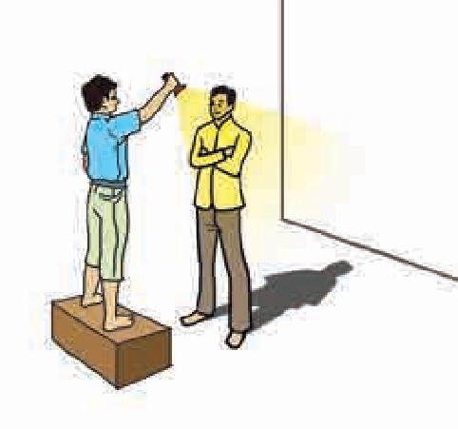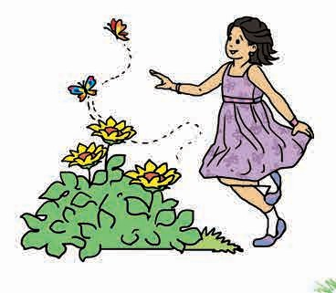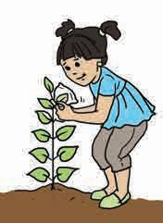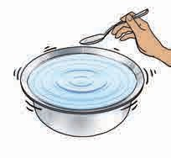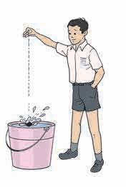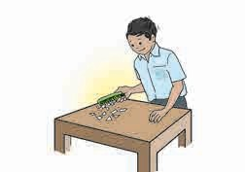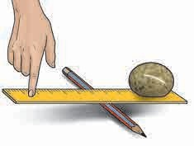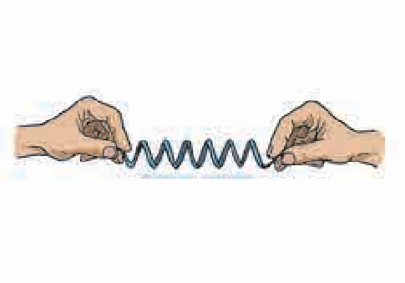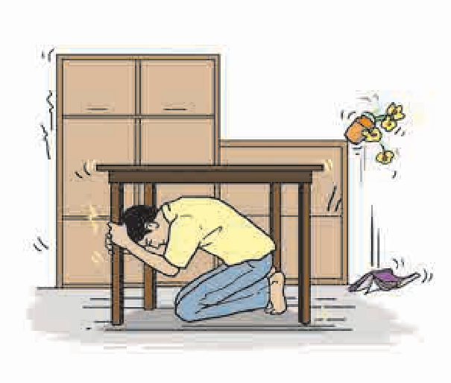



Sanction no. : MSCERT/avivi/sp/Ɵ0ls-l6/l67Ơ Date : 06/04/Ɵ0l6

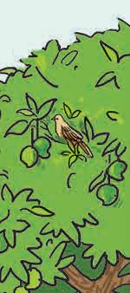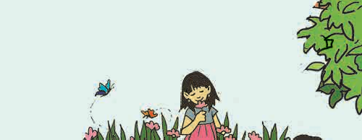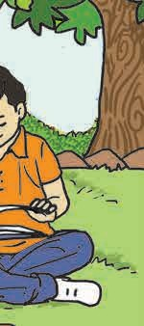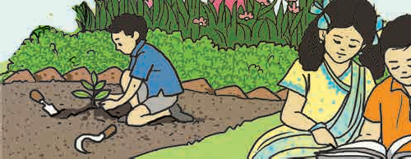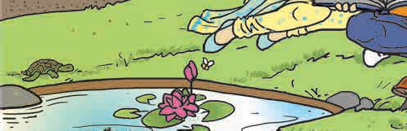

GENERAL SCIENCE

**STANDARD SIX**

**Maharashtra State Bureau of Textbook Production and Curriculum Research, Pune.**

The digital textbook can be obtained through DIKSHA APP on a smartphone by using the Q. R. Code given on title page of the textbook and useful audio-visual teaching-learning material of the relevant lesson will be available through the

Q. R. Code given in each lesson of this textbook.

**First Edition : 2016 © Maharashtra State Bureau of Textbook Production and**

**Third Reprint : 2019**

**Chief Coordinator :**

Smt. Prachi Ravindra Sathe

**Science Subject Committee :**

**Curriculum Research, Pune - 411 004.**

The Maharashtra State Bureau of Textbook Production and Curriculum Research reserves all rights relating to the book. No part of this book should be reproduced without the written permission of the Director, Maharashtra State Bureau of Textbook Production and Curriculum Research, ‘Balbharati’, Senapati Bapat Marg, Pune 411004.

**Coordination : Rajiv Arun Patole**

Special Officer for Science

**Dr Chandrashekhar Murumkar, Chairman**

Dr Dilip Sadashiv Jog, Member Dr Abhay Jere, Member

Dr Sulabha Nitin Vidhate, Member Smt. Mrinalini Desai, Member

Shri. Gajanan Suryawanshi, Member Shri. Sudhir Yadavrao Kamble, Member Smt. Dipali Dhananjay Bhale, Member

Shri. Rajiv Arun Patole, Member-Secretary

**Science Study Group :**

Dr Prabhakar Nagnath Kshirsagar

Dr Shaikh Mohammed Waquioddin H. Dr Vishnu Vaze

Dr Ajay Digambar Mahajan

Dr Gayatri Gorakhnath Choukade Shri. Prashant Panditrao Kolse Smt. Kanchan Rajendra Sorate Shri. Shankar Bhikan Rajput

Smt. Manisha Rajendra Dahivelkar Shri. Dayashankar Vishnu Vaidya Smt. Shweta Thakur

Shri. Sukumar Navale

Shri. Hemant Achyut Lagvankar Shri. Nagesh Bhimsevak Telgote Shri. Manoj Rahangdale

Shri. Mohammed Atique Abdul Shaikh Smt. Jyoti Medpilwar

Smt. Dipti Chandansingh Bisht Smt. Pushpalata Gawande Smt. Anjali Khadke

Shri. Rajesh Vamanrao Roman Shri. Vishwas Bhave

Smt. Jyoti Damodar Karane

**Cover and illustrations :** Smt. Janhavi Damle-Jedhe Shri. Suresh Gopichand Isave Ms. Ashana Advani

Shri. Manoj Kamble

**Translation :**

Dr Sushma Jog

Smt. Manisha Dahivelkar

**Scrutiny :**

Smt. Mrinalini Desai

**Coordination :**

Dhanavanti Hardikar Academic Secretary for Languages

Santosh Pawar Assistant Special Officer, English

**Typesetting :**

DTP Section, Textbook Bureau, Pune

**Paper :**

70 GSM Creamwove

**Print Order : Printer :**

**Production : Sachchitanand Aphale** Chief Production Officer

**Rajendra Vispute**

Production Officer

**Publisher : Vivek Uttam Gosavi**

Controller

Maharashtra State Textbook Bureau, Prabhadevi, Mumbai - 400 025.

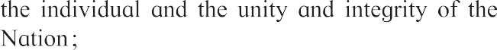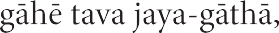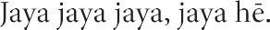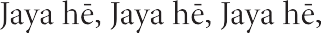

**Preface**

The **‘Primary Education Curriculum - 2012’** was prepared in the State of Maharashtra following the **‘Right of Children to Free and Compulsory Education Act, 2009’** and the **‘National Curriculum Framework - 2005’**. This syllabus approved by the State Government is being implemented serially from the academic year 2013-2014. In the syllabus as well as in the textbooks for Std III to V, General Science is included in ‘Environmental Studies’. However, Std VI onwards, it is included separately. Accordingly, the Textbook Bureau has prepared this textbook of General Science for Std VI. We are happy to place it in your hands.

Our approach while designing this textbook was that the entire teaching-learning process should be child-centred, the emphasis should be on self-learning and the process of education should become enjoyable and interesting. During the teaching- learning process, there should be clarity about the specific competencies that children are expected to achieve at the various stages of primary education. That is why, the expected competencies regarding General Science have been given in the textbook. In keeping with these competencies, the content included in the textbook has been presented in an innovative way. The content, activities and projects have been given under specific headings in each chapter to get the children to observe things carefully, to learn by actually doing something, to compile information, to classify this information or data, to draw conclusions from it, and so on. The supplementary information given in the textbook will help to make children’s learning more effective. At several places, projects have been given to help make teaching as activity-oriented as possible. The main objective of this textbook is to inculcate a scientific attitude among the children. Along with science, an introduction to the use of technology in the surroundings and an emphasis on environmental and social awareness are the important features of this textbook.

This book was scrutinized by teachers, educationists, and experts from all parts of the State, to make it as flawless and useful as possible. Their comments and suggestions have been duly considered by the Science Subject Committee while finalizing the book. The Science Subject Committee and the Study Group of the Textbook Bureau and the artists have taken great pains to prepare this book. The Bureau is thankful to all of them.

We hope that this book will receive a warm welcome from students, teachers and parents.

**Pune**



**Date :** 9 May 2016,

Akshay Tritiya, Indian Solar Year : Vaishakh 19, 1938

**(Dr Sunil Magar) Director**

Maharashtra State Bureau of Textbook Production and Curriculum Research, Pune.

## For Teachers

* We learn many new facts while studying science. So, young children with a lot of curiosity find the subject enjoyable. However, the real objective of learning science is to learn to think about the world and all the events that take place in it, in an objective and rational manner so as to lead a happy confident life. Through the study of science we also expect children to develop social consciousness, awareness about conservation of the environment and adeptness in handling technology.
* We need to have adequate factual information and understanding about our world. However, in a rapidly changing world, the knowledge gained today may not suffice tomorrow. Hence, the skills required for obtaining knowledge must be learnt. These are the very skills that are learnt in the process of studying science.
* Many topics in science are more easily learnt by direct observation than by reading about them. Some abstract phenomena become visible through the effects they have. Hence, we do experiments related to them. They help to learn the skills of inference and verification. While learning science, these skills are learnt and internalized. This is an important objective of learning science.
* That we should be able to articulate what we have learnt, explain it to others, use it for further studies and finally bring about proper changes in our behavior is also an expectation from the learning of science. That is why, it is important to ensure that along with the content of the subject, these skills are also developed.
* **Can you recall?** is a section for reviewing the related topics already learnt, while the purpose of **Can you tell?** is introducing a topic by bringing together what the children might already know about a topic through their own reading or experience. **Try this** is meant to give some specific experience while **Let’s try this** are the parts that teachers must demonstrate to the class. **Use your brain power!** makes children apply the knowledge gained. **Always remember...** gives some important instructions or values. The sections **Find out**, **Do you know?** and **Science watch** are to create an awareness of the vast information that cannot be included in the textbook and to inculcate the habit of doing reference work independently.
* Teachers can see for themselves that this textbook is not meant for reading and explaining but for guiding students to gain knowledge by carrying out the given activities. Reading the textbook **after** the children have carried out the activities and discussed them in the class will make it easy and will also help to bring together and reinforce what they have already learnt. The attractive pictures will support their efforts to learn.
* Teachers should prepare well for discussions under Can you tell?, Use your brain power! etc. and for the various activities and experiments. They should maintain an informal atmosphere during such discussions and activities, encourage everyone to participate and make efforts to organize Science Days, presentations in the class, etc.

**Front Cover :** Experiments included in the textbook. **Back Cover :** Biodiversity on the Kaas Plateau

### English General Science - Standard VI - Learning Outcomes

|  |  |
| --- | --- |
| **Suggested Pedagogical Processes** | **Learning Outcomes** |
| **The learner is to be provided with opportunities in pairs/groups/ individually in an inclusive setup and encouraged to -**   * Explore surroundings, natural processes, phenomena using senses viz. watching, touching, tasting, smelling, hearing. * Pose questions and find answers through reflection, discussion, designing and performing appropriate activities, role plays, debates, use of ICT etc. * Record the observations during the activity, experiments, surveys, field trips/visits, etc. * Analyse recorded data, interpret results and draw inference/make generalisations and share findings with peers and adults. * Exhibit creativity presenting novel ideas, new designs/patterns, improvisation etc. * Internalise, acquire and appreciate, values such as cooperation, collaboration, honest, reporting, judicious use of resources, etc. * Observe the Universe and different facts and different events occurring in the universe. | **The learner —**   * + 1. Identifies materials and organisms such as plant fibres, flowers on the basis of observable features, i.e. appearance, texture, function, aroma, etc.     2. Differentiates materials and organisms, such as, fibre and yarn; tap and fibrous roots; electrical conductors and insulators; on the basis of their properties, structure and functions.     3. Classifies materials, organisms and processes based on observable properties, for example, materials as soluble, insoluble, transparent, translucent and opaque; changes as can be reversible and irreversible, plants as herbs, shrubs, trees, creeper, climbers, components of habitat as biotic and abiotic; motion as rectilinear, circular, periodic etc.     4. Conducts simple investigations to seek answers to queries, for example, what are the food nutrients present in animal fodder? Can all physical changes be reversible? Does a freely suspended magnet align in a particular direction?     5. Relates processes and phenomenon with causes, for example, diseases due to deficiency of diet/deficiency diseases; adaptations of animals and plants with their habitats, quality of air with pollutants etc.     6. Explains processes and phenomenon for example, processing of plant fibres, movements in plants and animals, formation of shadows, reflection of light from plain mirror, variation in composition of air, preparation of vermi compost etc.     7. Measures physical quantities and expresses in SI units, for example, length.     8. Draw labelled diagrams/flow charts of organisms and processes, for example, parts of flowers, joints; filtration, water cycle, etc.     9. Constructs models using materials from surroundings and explains their working, for example, pinhole camera, periscope, electric torch, etc. |

|  |  |
| --- | --- |
|  | * + 1. Applies learning to scientific concepts in day to day life, for example, selecting food items for a balanced diet, separating materials, selecting season appropriate fabrics, using compass needle for finding directions, suggesting ways to cope with heavy rain/drought etc.     2. Makes efforts to protect environment, for example, minimising wastage of food, uses of water, uses of electricity, and generation of waste, spreading awareness to adopt rain water harvesting, care for plants (plantation) etc.     3. Exhibits creativity in designing, making use of available resources, planning etc.     4. Exhibits values of honesty, objectivity, cooperation, freedom from fear and prejudices.     5. Comparative study of star, planet, satellite, Asteroid by observing them in the Universe.     6. Collect information of different concepts, processes by using internet and different ICT technology. |

**CONTENTS**

**No. Chapters Page No.**

* 1. Natural Resources – Air, Water and Land 1
  2. The Living World 9
  3. Diversity in Living Things and their Classification 18
  4. Disaster Management 26
  5. Substances in the Surroundings – Their States and Properties 32
  6. Substances in Daily Use 42
  7. Nutrition and Diet 50
  8. Our Skeletal System and the Skin 57
  9. Motion and Types of Motion 65
  10. Force and Types of Force 70
  11. Work and Energy 76
  12. Simple Machines 84
  13. Sound 91
  14. Light and the Formation of Shadows 97
  15. Fun with Magnets 105
  16. The Universe 112

# Natural Resources – Air, Water and Land

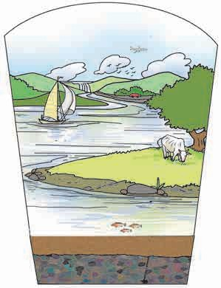

#### Observe.

**Observe the picture alongside and answer the questions.**

1. Where do we see the birds ?
2. Where is the cow grazing ?
3. Locate the trees and the road.
4. Where does the river come from ? How does it flow ?
5. Where is the aeroplane ?
6. Where are the fish seen ?
7. On what is the sailboat floating ?

**Atmosphere**

**Hydrosphere Lithosphere**

### Natural resources

* 1. **: Spheres of the earth**

You can see that some things in the picture are in water, some on land, and some in the sky, that is, in the air. Thus, all things on the earth are associated with air, water and land. Air, water and land are called the earth’s atmosphere, hydrosphere and lithosphere, respectively. Moreover, different living things occupy these three spheres of the earth. These living things and the parts of the lithosphere, hydrosphere and atmosphere which they occupy are together called the biosphere. These spheres have formed on the earth naturally. We have learnt all this in the previous standards.

The atmosphere is the layer of air that surrounds the earth. The surface of the earth comprises water and land, that is, the hydrosphere and lithosphere. Of these, the hydrosphere occupies a much larger part than the lithosphere. Figure 1.2 shows the proportion of land and water on the earth’s surface.

We also look upon these natural components in solid, liquid and gaseous form as resources. In other words, we use them to fulfil our requirements. Let us now study all these three components in detail.

**Air, water and land are the factors important for sustaining the living world on the earth and for fulfilling their basic needs. They are called natural resources.**

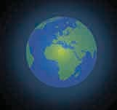

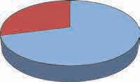

**Land 29%**

**Water 71%**

* 1. **: Proportion of land and water**

**What are the five layers of the atmosphere ?**



**Can you recall ?**

### Air

The air in the atmosphere around the earth contains nitrogen, oxygen, carbon dioxide,

six inert gases, nitrogen dioxide, sulphur dioxide, water vapour and dust particles. The troposphere contains about 80% of the total mass of gases in the air, while this proportion is about 19% in the stratosphere. Further, in the mesosphere and ionosphere, the proportion of the mass of gases goes on decreasing. Gases are not found in the exosphere and beyond.

You can see that air is a mixture of several gases and is the chief constituent of the earth’s atmosphere. Besides these gases, air also contains water vapour and dust particles. The amount of the gases in the air is the greatest near the surface and decreases as we go higher and higher from the surface. That is, air becomes rarer at higher altitudes.

The proportions of the constituents of air and some of their uses are given here.

**Oxygen**

**Nitrogen 78%**

**Other constituents of air 0.07%**

* 1. **: Proportions of the various gases in the air**

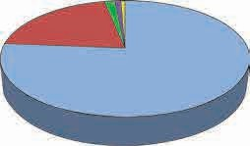

**Argon 0.9%**

**Carbon dioxide 0.03%**

**21%**

### Some uses of gases in air

* + - **Nitrogen** – Helps living things to build the necessary proteins. It is useful in the production of ammonia and in airtight packaging of foodstuffs.
    - **Oxygen** – Necessary for respiration in living things and for combustion.
    - **Carbon dioxide** – Plants use it for producing their food. Used in fire extinguishers.
    - **Argon** – Used in electric bulbs.
    - **Helium** – Used for obtaining low temperature and also for generating lift in airships.
    - **Neon** – Used in decorative lights and for street lighting.
    - **Krypton** – Used in fluorescent tubes.
    - **Xenon** – Used in flash photography.



**Always remember...**

The living world on the earth is sustained due to the balance between various gases and other constituents of air. The atmosphere is a very important filter. It allows the light and heat of the sun to reach the earth, which is necessary for life. But it prevents the harmful elements from reaching the earth. It is in the atmosphere that fog, clouds, snow and rain are produced.

#### What is the similarity in the three pictures below ?

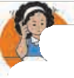

**Use your brain power !**

What would have happened if there were no air on the earth ?



**Observe and discuss.**

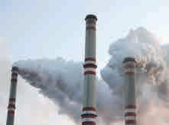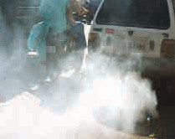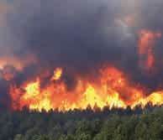

* 1. **: Air pollution**

All the above pictures show large scale emission of smoke through different agencies. This smoke directly mixes with the atmosphere, disturbing the balance between the constituents of air. This is called **air pollution**. Harmful gases are given out through combustion of fuels in vehicles and in big industries and also through incomplete combustion of fuels like wood and coal. As a result, air pollution is increasing day by day.

**Harmful**

**substances**

**released in air through combustion of fuels**

* Nitrogen dioxide
* Carbon dioxide
* Carbon monoxide
* Sulphur dioxide
* Soot

**Ozone layer – the protective shell**

There is a layer of ozone (O3) gas in the lower part of stratosphere. Ozone gas is not directly useful for the survival of living things, yet it is very important for living things to have this layer of ozone at a high altitude around the earth. The ultra violet rays coming from the sun are very harmful for living things. The ozone gas absorbs these rays. As a result, life on earth is protected.

The ozone layer is destroyed if chemical gases like carbon tetrachloride or the chlorofluorocarbons used in air conditioners and refrigerators mix with the air.

**The 16th of September is celebrated as ‘Ozone Protection Day’ all over the world to make everyone aware of the importance of ozone.**

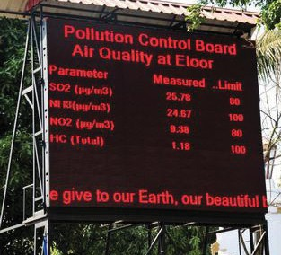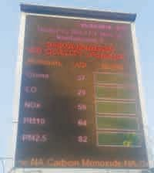

**Do you know ?**

In metropolitan cities like Mumbai, Pune or Nagpur boards are displayed at places of heavy traffic to show the proportions of the various constituents of the air at that place. Due to these boards, we can see the amount of harmful elements in the air.

### Water

|  |  |
| --- | --- |
| **Purpose for which water is used** | **Amount of Water (approx.) in litres** |
| * Bath * Brushing teeth * Washing clothes and utensils * Mopping the floor * Drinking * Cooking |  |
| Total use of water |  |



**Try this.**

Observe how much water is used and for what purposes it is used in your house for a whole day. Record it in a chart like the one shown here. Discuss this data in the class. Divide the total amount of water used in your house by the number of persons to find out how much water each person needs.

You will see that it is almost impossible for us to spend even a single day without water. We need to drink three to four litres of water every day so that all our bodily functions run smoothly. Other living things also require water although the amount of water they need may vary according to the size of their body. Thus, we see that water is very important.

In nature, water occurs in three states. Water does not have colour, taste or odour. Many substances readily dissolve in water. Therefore, water is a universal solvent.

The blood of animals and the sap in plants contain a very high proportion of water. No living thing can survive without water. Therefore it is said that ‘Water is life.’

If hydrogen gas burns in air, it combines with oxygen and water is formed. We have learnt about some characteristics of water in the previous standards.

|  |  |  |
| --- | --- | --- |
| **Water available on earth** | | **Percentage** |
| Seas, Oceans |  | 97% |
|  |  | 2.7% |
| Water available | for |  |
| drinking (fresh water) |  |  |
| Total | | 100% |



**Observe and discuss.**

**Groundwater, ice,**

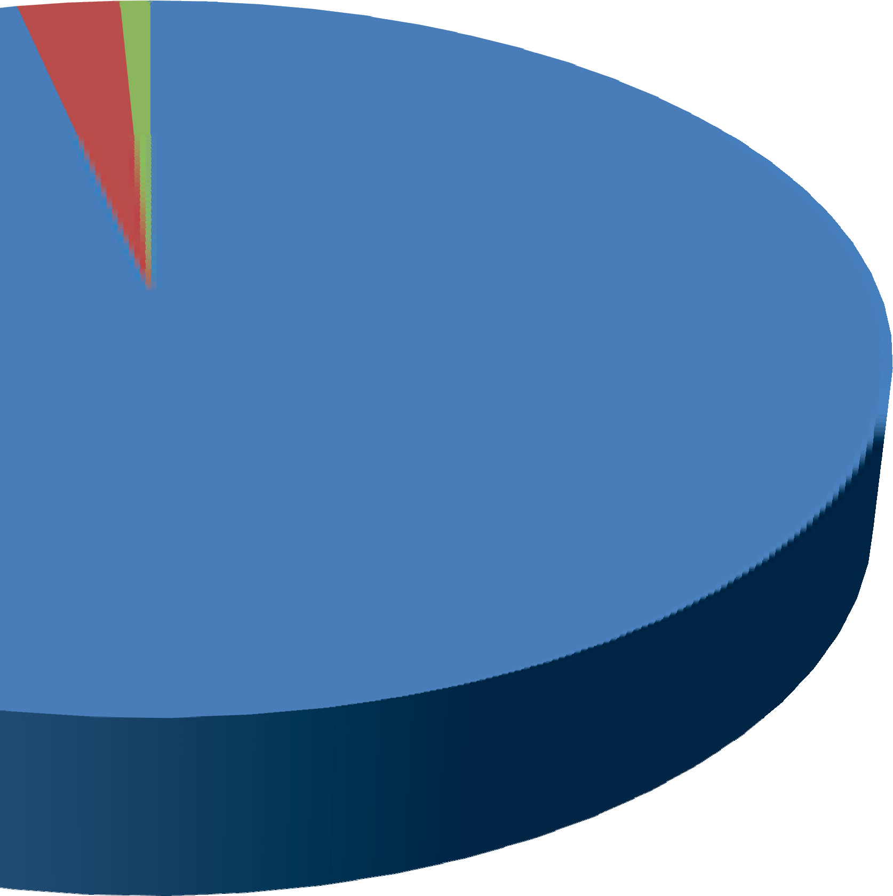

**and water in other forms**

**for drinking**

**Seas and Oceans**

**Water available**

* 1. **: Distribution of water on the earth**

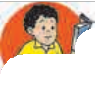

**Find out.**

In what ways is the water in seas and oceans useful even though it is salty ?

We cannot use all the water on earth because seawater is salty. Some water is in the frozen state. A very small quantity of water is available for drinking. Yet it is enough for all living things.

#### Observe and discuss. For which purposes is water being used ?

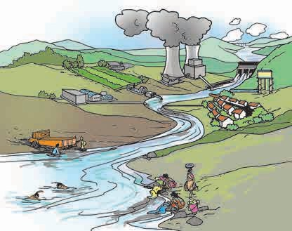

**Do other living things use water like we do ?**

We use water in large quantities. We have learnt that water on the earth is regulated through the water cycle. The water vapour formed from oceans is the main source of water in the water cycle. It gets converted into rain, creating fresh water sources on earth.

* 1. **: Uses of water on the earth**



**Always remember...**

1. Use water sparingly.
2. Block water, let it percolate.

3 Store water wherever possible.

4. Reuse water wherever possible. Remember, stored water does not become stale at once.

We get water from natural sources such as streams, rivers, ponds, springs and lakes. Man also digs wells and borewells to lift ground water. Apart from this, man has also constructed bunds and dams of various sizes on rivers.

Due to the uncontrolled use of water for an increasing population, industry and farming, it is now in short supply. Water scarcity has become a serious problem.

### Land

* + - * What is land made of ?  Is land flat everywhere ?
      * What do you see on land ?  Does man produce soil/land ?



**Can you tell ?**

* + - * What has man created on land ?
      * If a deep pit is dug in the ground, what do you find there?

Land is seen in the form of stones, soil, big rocks. It is not flat everywhere. It is hilly in some places and flat in others. All terrestrial animals including man live on land. Some terrestrials dig burrows in the ground for shelter. This means that they use land for fulfilling their need. We also use land for farming and for building houses and roads. We make use of plants and animals in the forests that grow on land. The minerals, crude oil and natural gas obtained from the earth (land) are very important for us. It means that land is an important resource. Let us see exactly what land is made of.

**Dry leaves Soil**

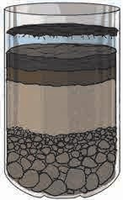

**Let**’**s try this.**

**Sand**

**Small stones Big stones**

* 1. **: Layers of the mixture in the bottle**

The land on earth also looks like this. If a pipeline is being laid in your neighbourhood, observe carefully the pits dug for this purpose. You will see some layers under the land surface, as shown in the accompanying figure.

If the land has mature soil, the topmost layer is formed by the decomposition of the remains of plants and animals. This layer is called ‘humus’. It is usually found in dense forests. The land below this is full of sand, soil, small stones, worms, and insects. Soil and pieces of bedrock are found below this layer of land. This soil is immature. Further below this layer the proportion of soil decreases and that of rock increases. This is the layer of bedrock. The main minerals in the soil are derived from these rocks. That is why, soil in different regions is different. The colour and texture of soil are both determined by the bedrock.

### The process of soil formation

1. Take a transparent plastic bottle, a handful of soil, some stones, sand, some dry leaves and water.
2. Cut off the upper tapering part of bottle. Put the rest of the materials in the lower part and add water.
3. Stir the mixture thoroughly and put it aside.

Observe it the next day and answer.

* + How does the mixture in the bottle look now ?
  + Do you see layers in it ?
  + What is seen in the different layers from top to bottom?

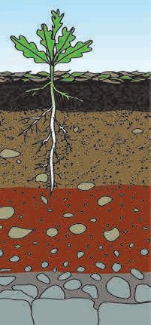

**Humus Soil**

**Immature soil**

**Layer of soil and small rocks**

**Bedrock**

* 1. **: Layers of land**

The soil on the land is formed by a natural process. The abiotic components of soil are supplied through the weathering of the bedrock. Due to the heat, cold and water of the sun, wind and rain respectively, the bedrock breaks down into pieces. Stones, sand and soil are formed from these pieces. Microbes, worms and insects are found among them. Rodents like mice and rats are also found here. The roots of trees growing on the land also help weathering of rocks. The process of soil formation is slow and continuous. It takes about a thousand years for a 2.5 cm thick layer of mature soil to form.

Soil can get destroyed in a short period due to floods, storms and human activities such as mining. That is why, it is necessary to conserve soil and to prevent erosion of land. The best remedy for this is to increase the green cover of the land. Erosion of land is reduced if grass, trees and bushes are grown in it.

Obtain specimens of soil from various places in your surroundings such as your own yard, a garden, hills, river banks, fields and rocky ground. Note the differences in the specimens with respect to colour, feel, texture and the size of the particles.

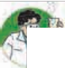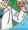

**Try this.**

#### Do you know ?

Humus is the layer formed on soil due to the decomposition of dead plants and animals by microbes. Humus supplies nutrients to the soil. Humus is also important for aerating the soil and for holding water in the soil. The proportion of humus in the upper layer of good fertile soil is about 33% to 50%.

#### Use your brain power !

What are the constituents of soil ? Classify them as biotic and abiotic constituents.

Forests on land got buried underground due to the great upheavals that took place on the earth many ages ago. After that, the process of formation of fossil fuels from the remains of living things took place underground. We get fuels like petrol, diesel, kerosene, paraffin and other useful materials like tar and wax from

the fossil fuel called crude oil.

Living things use land, water and air available on earth and so does man. However, the portions of these resources that are actually put to use are very small as compared to the whole earth. Look at the following table.

**Institutes at work**

India Department

Meteorological

(IMD)

was

established in 1875 for studying the weather in the Indian subcontinent. The main function of this institute is to observe the weather and to make weather

forecasts. conducts changes

This

institute

research

related

also

to

in

weather,

makes

forecasts about rains and studies the developments related to global warming.

|  |  |
| --- | --- |
| Land | 29% |
| Potable water / fresh water | 0.3% |
| Oxygen | 21% |

Even in these small proportions, the resources shown in the above table are sufficient for all living things. Only, it is very necessary for man to control his greed. In other words, he must use these resources judiciously, with the awareness that they are meant for all other living things and not just for mankind.

#### What we have learnt-

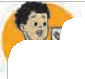

* + - The elements available in nature which fulfil the basic needs of living things are called natural resources.
    - Air, water and land are important natural resources.
    - Soil has both biotic and abiotic constituents.
    - There are many constituents of air such as nitrogen, oxygen, carbon dioxide, inert gases, water vapour and dust particles.
    - The ozone layer is a protective shell of the earth.
    - Natural resources should be used carefully and sparingly.



**Exercise**

#### Fill in the blanks.

* 1. The layer of ozone gas absorbs

………… rays that come from the sun to the earth.

* 1. Of the total water available on the earth, fresh water forms ...... percent.
  2. Both ...…. and constituents

are present in the soil.

#### Why is it said that – ?

* 1. The ozone layer is a protective shell of the earth.
  2. Water is life.
  3. Seawater is useful even though it is not potable.

#### What will happen if –

* 1. Microbes in the soil get destroyed.
  2. The number of vehicles and factories in your surroundings increases.
  3. The total supply of potable water is finished.

#### Match the following.

**Group ‘A’ Group ‘B’**

1. Carbon (a) Generation of dioxide soil
2. Oxygen (b) Rain
3. Water (c) Plants and vapour food production
4. Microbes (d) Combustion

#### Name the following.

1. Constituents of the biosphere
2. Biotic constituents of soil
3. Fossil fuel
4. Inert gases in air
5. Gases that are harmful to the ozone layer

#### True or false ?

1. Land and soil are the same thing.
2. The water in a lake is called ground water.
3. It takes about 1000 years to form a 25 cm thick layer of soil.
4. Radon is used in decorative lights.

#### Answer in your own words.

1. Explain with the help of a diagram how soil is formed.
2. Why is there a shortage of water even though it occupies about 71% of the earth’s surface ?
3. What are the various constituents of air ? Write their uses.
4. Why are air, water and land considered to be valuable natural resources ?

**Activity :**

* Obtain detailed information about the work of the India Meteorological Department.
* Find a remedy for water scarcity.



**List the things seen in the picture. Say whether they are living or non-living things.**

#### Characteristics of living things



**2.**

**The Living World**

**Can you recall ?**

There are many kinds of plants and animals around us. They show some similarities and some differences. Yet, with the help of certain features, we can tell that they are all living things. These features are not seen in non-living things. Such features are said to be the characteristics of living things. Let us study these characteristics.

* 1.** 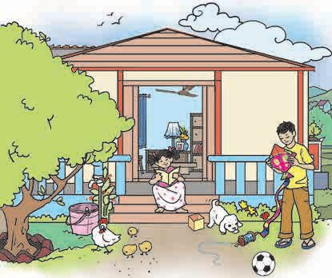: Various things in our environment**

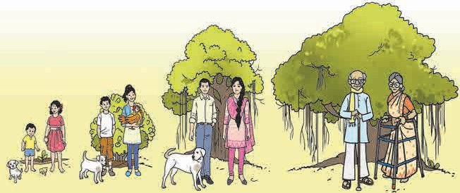

**Can you tell ?**

### Growth

What differences do we see between the young ones and the adults in the picture ?

* 1. **: Growth in living things**

A baby grows up to become an adult person - woman or man. During the period of its growth, the baby gains in height, weight and strength. In the same manner, all animals grow into adults in a certain period. Generally, humans require 18 to 21 years for this growth.

Find out how long it takes for the young ones of hens, cows and dogs to grow into adults.

**Stretched thread**

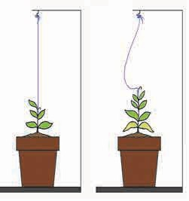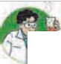

**Try this.**

**Loose thread**

Tie a thread to the tip of a potted sapling. Keep the thread stretched and tie it to a peg or nail above the plant. What do you observe after ten to fifteen days ?

What tells us that the plant has grown taller ?

In all plants, it is mainly the width and height of the stem that grows. As they grow, some plants develop branches while others do not.

Though all living things grow, animals grow only for a certain period. Plants, on the other hand, grow as long as they live. The growth of living things occurs from within the body, which means that growth occurs in all parts of the body.

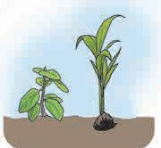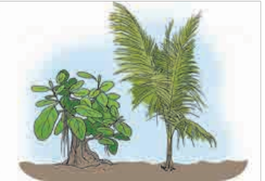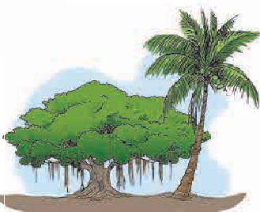

* 1. **: Sapling in a pot**
  2. **: Growth in banyan and coconut trees**

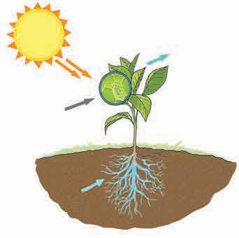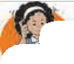

#### Use your brain power !

What differences do you see in the growth of trees like the mango, banyan and peepal and that of the bamboo, coconut and toddy palms.

### Food is necessary for growth

Plants make their own food in sunlight. Plants produce food from water, nutrients in the soil and the carbon dioxide present in the air. This process takes place in the leaves of plants. It is brought about in the presence of sunlight, with the help of the chlorophyll in the leaves. This process of food production is called photosynthesis. During this process, plants give out oxygen. Plants appear mainly green in colour due to the chlorophyll in them.

**Carbon dioxide**

**Water and nutrients**

**Sunlight**

* 1. **: Photosynthesis**

**Oxygen**

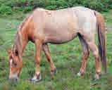

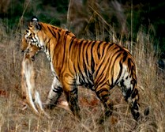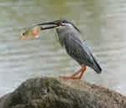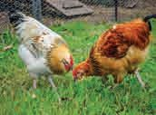

* 1. **: Intake of food by animals**

Animals, however, do not have chlorophyll. They do not produce their own food. They search for food. Animals such as goats, sheep, horses eat grass while wild animals such as tigers and lions meet their need for food by hunting other animals which live on plants.

The intake of food and the resultant growth is an important characteristic of

living things.



**Observe and discuss.**

**Gills**

**A leaf of a plant**

**Nose**

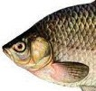

### Respiration

* 1. Hold your hand in front of your nose or keep your hand on your chest. What do you feel ?
  2. If we observe a sleeping dog, what movement of its belly do we see ?

Living things need oxygen in order to live. Inhaling oxygen and exhaling the carbon dioxide formed in the body due to the use of oxygen is called respiration. Animals such as fish, snake, mouse, etc. have specific organs for respiration. On the other hand, plants respire by means of microscopic pores on their stems and leaves.

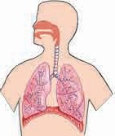

* 1. **: Respiration in living things**

Respiration is a characteristic of living things.

#### Excretion

1. Is all the food we eat used by the body ?
2. 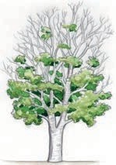What is the unused part of food converted into ?



**Can you recall ?**

Waste substances are formed during the many processes that take place in the bodies of animals. These are called excreta and the process of eliminating them from the body is called excretion. Animals have specific organs for excretion.

Plants, too, excrete. For example, some plants shed leaves in a specific season. Waste substances stored in the leaves of plants are shed along with the leaves.

* 1. **: A tree shedding leaves**



**Try this.**

Take a transparent plastic bag. Tie it over a leaf of a plant as shown in the picture. Observe it after six to seven hours. What do you see ?

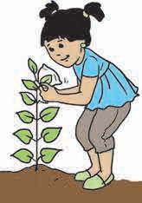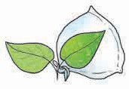

Droplets of water collect on the inside of the bag. It means that, plants excrete water in the form of vapour.

Excretion is a characteristic of living things.

* 1.** 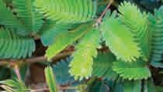: Excretion on the leaves of a plant**

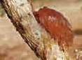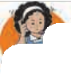

**Use your brain power !**

What is the sticky substance seen on the stems of the babul (acacia) or drumstick trees ?



**Observe and discuss.**

#### Have you experienced this ? What happened immediately after the following actions ?

1. Light flashed suddenly into your eyes.
2. Suddenly you felt a pinprick.
3. The leaves of the mimosa plant were touched.
4. At sunset, lamps on the street or courtyard are lit and insects gather around the lamps.

### Responsiveness to stimuli and movement

Living things act in various ways when responding to a stimulus. If you suddenly enter a cowshed, the cows and buffalos stand up, begin to move, one or two may even start mooing. These are all movements.

A creeper planted in the courtyard leans towards a support. A potted plant placed in a window grows towards sunlight. It means that plants, too, show movement. Living things move of their own accord.

The movement or the change taking place in a living thing at such a time is their response to a stimulus. An event that occurs in our surroundings is a stimulus. The ability of living things to respond to a stimulus is called their responsiveness to stimuli.

**The mimosa**

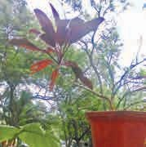

**A potted plant**

* 1. **: Responsiveness and movement**

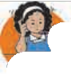

**Use your brain power !**

1. In each of the examples given above, what is the stimulus and what is the response ?
2. What is the main difference between the movements of plants and animals ?

Responsiveness to stimuli

is a characteristic of living things.

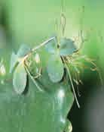What do we learn from these pictures ?



**Can you tell ?**

### Reproduction

Living things produce other living things like themselves. Some animals give birth to their young ones. Some lay eggs. Their young ones hatch out of the eggs. New plants are produced from the seeds, stems or leaves of plants.

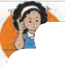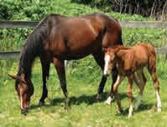

The process by which a living thing generates a new living thing like itself is called reproduction or procreation.

Reproduction is a characteristic of living things.

#### Use your brain power !

**A bird and its eggs**

**A mare and her foal**

**Bryophyllum**

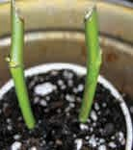

**Rose cuttings**

Why have so many types of plants and animals been able to survive on the earth even today ?

* 1. **: Reproduction**

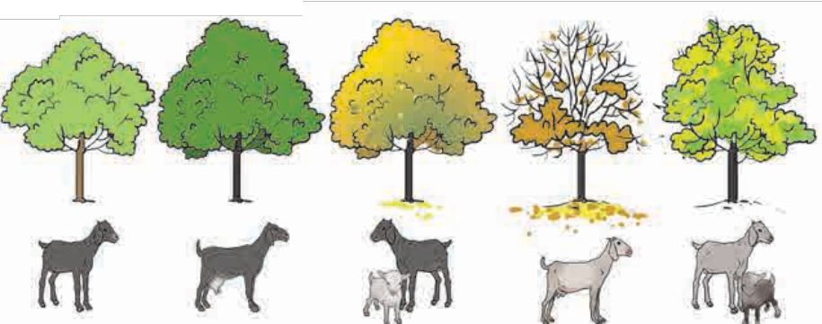

**Observe and discuss.**

### A definite lifespan

* 1. **: Lifespan**

At a certain stage of life, living things become capable of reproduction. Later on in life reproduction stage, their organs become weak and still later, their life comes to an end. In other words, living things die. The lifespans of different animals and plants are different. For example, the lifespan of the dog is about 12 to 18 years, while the ostrich lives for 50 years.

You may have wondered what exactly the living things are, how they came into being, and so on.

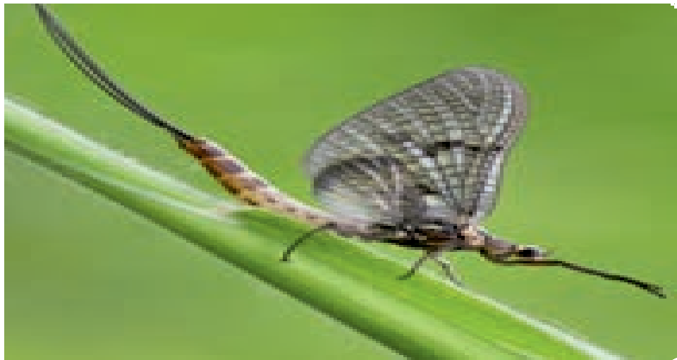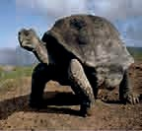

**Do you know ?**

The lifespan of the giant turtle found on the Galapagos Island in South America is about 170 years. On the other hand, the lifespan of the mayfly ranges from 1 hour to 24 hours.

Observe a honeycomb and a wall. What are they made of ?



**Can you tell ?**

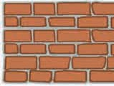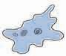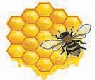You may have seen the small compartments of a honeycomb. These compartments are joined together to form a honeycomb. A wall has bricks. To construct a wall, we firmly join the bricks together.

* 1. **: A wall**

### A cellular structure

**A honeycomb**

Living things are made of small units called cells. All the actions and processes in the bodies of living things are brought about with the help of these microscopic cells.

Some living things are made of a single cell. These are called **unicellular organisms.** On the other hand, the living things that are made of many cells are called **multicellular organisms.** The amoeba and some other microorganisms are unicellular while man, cow, mouse, cockroach, elephants, banyan tree, the onion plant, etc. are all multicellular organisms. All the characteristics of living things are seen in every cell of a living thing, whether it is unicellular or multicellular.

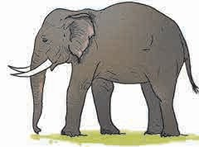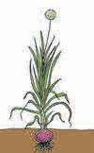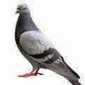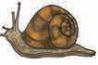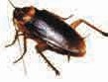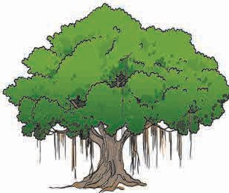

#### Cellular structure is the main characteristic of living things, even though the number of cells may vary.

* 1. **: Various living things**

**Amoeba**

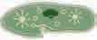

**Paramoecium**

**What they do ?**

**Institutes at work**

TThheeinBsotittauntiecsalthsautrvweoyrkoffoInr dtihae (s1u8r9v0e)y aanndd thcoenZseorovlaotgiiocnaloSf uthrveeyvaorifoIunsdipala(n1t9s16) areantdheaninimstiatulsteisn rdeisfpfeornesnibt lpeafrotsr othfeInsduiraveayreanthde cBonostaenrvicaatiloSnuorvf,eyresopfeIcntidviealy(1, 8p9la0n) ts and animanadls thine Zthoeolovgaircioaul sSupravretsy **of India** .(1In916ca) sreesypoeuctivfienldy. aI**n** cuansfeamyoiluiar plant or animalfiinnd oaunr usnufraromuinlidairngpslaynotuorc **an**icmoaml minunyiocuartesuwrriothunthdeinsges,inysotiutucteasn to obtain informactoiomnmaubnoiucat tiet..with these institutes to obtain more information about it.

In what way are plants and animals useful to us ?

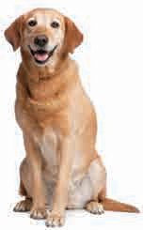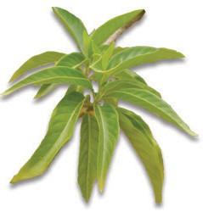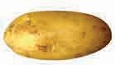

**Vasaka**



**Can you tell ?**

### Useful living things

Plants are used for household as well as industrial purposes. For example, fenugreek (*methi*), potato, okra (*bhendi*), apple, banana are used as food while vasaka (*adulsa)*, *hirada*, *behada*, asparagus are used as medicines.

Animals are also useful to us. Dogs, cats, cows, buffalos are kept for domestic uses. Fish, sheep, fowl are used as food, while animals like horses, oxen, camel prove useful in various occupations. The earthworm is very useful in agriculture.

### Harmful living things

Some animals and plants around us are harmful to man. For example, mosquitoes and flies spread diseases. Cockroaches, mice, rats destroy our food. Lice, ticks also spread diseases. The bites of some poisonous lizards, spiders, snakes and scorpions can even cause death. If wild elephants enter human settlements, they cause a lot of destruction.

Some plants, too, can be harmful, as for example, the dodder, parthenium and other weeds.

Pods of the nettle, colocasia leaves cause itching. Plants like oleander, lantana have strong odours. The *datura* plant is poisonous. Uncontrolled growth of fungi and algae in water pollutes drinking water

* 1.** 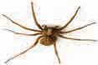: Useful living things**

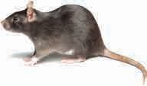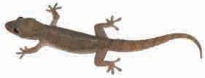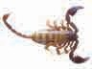

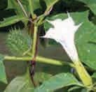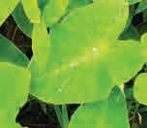and may cause the spread of diseases.

***Datura***

**Colocasia leaves**

* 1. **: Harmful living things**

### Wild animals

Wild animals that hunt other animals for food are called predators, for example, tigers, lions, wolves, leopards. Sometimes, due to deforestation, such animals enter human settlements in search of food and may kill domestic animals or people.



**Find out.**

Watch TV channels such as National Geographic, Discovery and collect information regarding various plants and animals found in our surroundings. Have a class discussion with reference to the collected information.

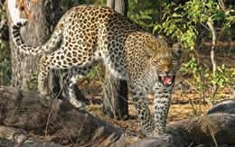

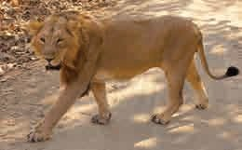

* 1. **: Wild animals**



**Always remember...**

Many plants and animals in nature satisfy our needs. The use of such plants and animals should be restricted only to our needs. We should not pluck leaves, flowers and fruit unnecessarily. Animals should not be hunted. They should not be teased just for fun. It is the responsibility and duty of all of us to protect plants and animals.

#### What we have learnt-



* Growth, respiration, excretion, reproduction, responsiveness to stimuli, movement, a definite lifespan and a cellular structure are the characteristics of living things.
* Animals grow for certain period of their life. Plants, however, grow as long as they live.
* Animals have specific organs for respiration, while plants respire through microscopic pores on their leaves and stems.
* The process of eliminating waste products from the body is called excretion.
* All living things have the ability to reproduce.
* Living things move because of their ability to respond to stimuli.
* Plants show spontaneous movements but they cannot leave their place and go elsewhere as animals do.
* Living things have a definite lifespan at the end of which they die.
* Many animals and plants are useful to us in our daily life. Some animals and plants can be harmful to us.
* The smallest unit of a living thing is the cell.



**Exercise**

#### Write the answers to the following questions in your own words.

1. What are the differences between plants and animals ?
2. What are the similarities between plants and animals ?
3. How is the plant kingdom useful to us ?
4. How is the animal kingdom useful to us ?
5. What makes living things different from non-living things ?

#### What helps them to breathe ?

(a) A fish (b) A snake

(c) A crane (d) An earthworm

(e) Man (f) A banyan tree

(g) A caterpillar

#### Fill in the blanks with the proper words from the brackets.

1. The process by which plants make their own food is called ............ .
2. To inhale ……… and to exhale

. is called respiration.

1. The elimination of waste substances from the body is called

..…....... .

1. The ability to respond to an event is called ….. to …… .
2. On completing their lifespan, every living thing …….. .

(oxygen, dies, excretion, carbon dioxide, responsiveness, photosynthesis, stimuli)

#### Write the uses of these animals and plants.

**Animals :** Honeybees, sharks, yaks, sheep, earthworms, dogs, bivalves, horses, mice.

**Plants :** Ginger, mango, eucalyptus, babul (acacia), teak, spinach, aloevera, turmeric, holy basil, *karanja*, *moh*, mulberry, grapevine.

#### What are the peculiarities of the movements of these living things ? Living things : Snakes, tortoises,

kangaroos, eagles, chameleons,

frogs, gulmohur, sweet potato creeper, dolphins, ants, rattlesnakes, grasshoppers, earthworms.

#### Write in detail about how the plants and animals found in your surroundings prove useful or harmful.



**Activity :**

* Obtain information about the work of the Botanical Survey of India and the Zoological Survey of India by visiting the websites : [**www.bsi.gov.in**](http://www.bsi.gov.in/)[**www.zsi.gov.in**](http://www.zsi.gov.in/)
* Collect information about the lifespan of various animals, make a chart and display it in your class.
* Gather information about the poisonous snakes found in India and present it in a Science Exhibition.





**3.**

**Diversity in Living Things and their Classification**

**Can you recall ?** In which spheres of the earth do living things exist ?

The geographical conditions at different places on the earth are very different. We find that living things exist in all these diverse conditions. When we live in a certain place, we adjust to the conditions there. Various types of living things have survived because of their ability to adjust themselves to the conditions in their surroundings.

**Can you tell ?** Are the plants and animals that you have seen all alike ?

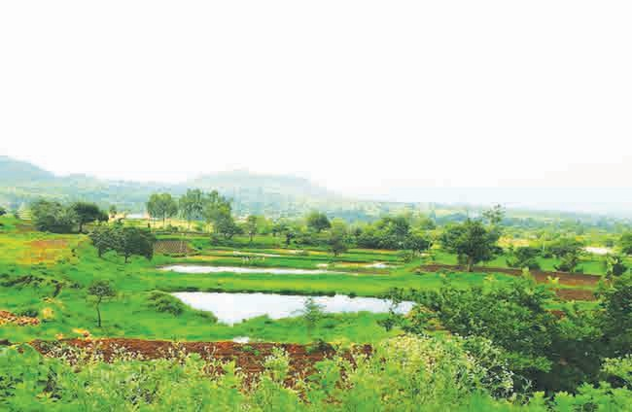

### Diversity in plants

Various types of plants are found in many places around us. Some plants like grass are short, while others are tall and have a canopy. Some plants grow underwater, while some others float on water. We find that some plants grow even in deserts. Moreover, we find that there is a lot of variety in the same type of plant. For example, there are different varieties of rice or wheat, different types of roses, and mangoes of different flavours. Some plants grow even without stems, leaves or roots. These are very different from ordinary plants. Let us study this diversity among plants.

Plants make their own food in sunlight. Such plants are called **autotrophic** plants. For example, the hibiscus, pomegranate, periwinkle, etc. Some plants like funguses, loranthus, dodder use other plants for food and are said to be **heterotrophic**. Plants like the pitcher plant even consume insects. They are **insectivorous**.

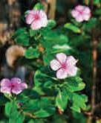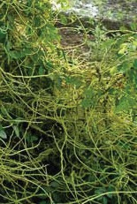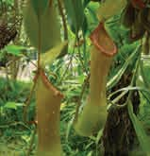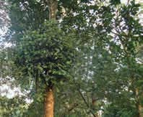

* 1. **: Method of nutrition in plants**

**The structure of a plant**

Plant structure can generally be divided into two parts - the stem which grows above the ground and the root which grows below the ground surface.

The root, stem and leaves are the main parts of plants. From time to time, plants bear flowers for reproduction. Flowers are transformed into fruits.

Fruits have seeds. Seeds give rise to new plants.

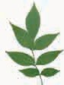**Simple leaf**

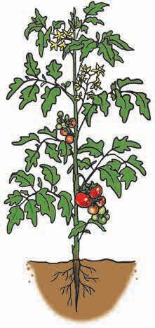

**The stem :** The height, shape and size of a plant depends upon the stem. The stem carries out the functions of production, conduction and storage of food. In some plants, it has the function of reproduction. It gives support to other parts of the plant.

**The leaf :** The leaf is flat. It plays an important role in the production of food. Leaves are mainly of two types : simple and compound leaves.

**The flower :** This is the most attractive part of a plant. It is connected to the stem by a stalk which may be long or short. A flower has a typical colour and shape. The flower is an important means of reproduction.

(Ex. Hibiscus)

**Compound leaf**

(Ex. Rose)

* 1. **: The structure of a plant**

**The fruit**

have Fruits more

different contain

**:** Fruits shapes. one or

seeds. The pods

of beans and peas are actually fruits.

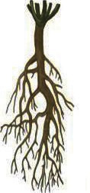 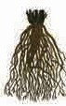

### Need for classification of plants

**Taproot**

(Hibiscus, Banyan)

**The root :** Roots hold the soil firmly and anchor the plant. The main functions of the root are to absorb and transport water and nutrients from the soil. The roots of the carrot and radish also store food. There are two types of roots : taproot and fibrous root.

**Fibrous root**

(Onion, Grass)

Up to now, information about lakhs of plants has been collected. While studying the diversity in plants, they are classified for the sake of convenience on the basis of the similarities and differences in their structure, their organs and their other characteristics.

**The scientist Carolus Linnaeus made the first scientific classification of plants.**

**Initially, it was his method of classification that was used by all.**

Take a round through a garden or in your surroundings and list the plants that you see. Draw their pictures as



**Observe and discuss.**

well. Draw a table as shown below and complete it on the basis of the information you gather. Discuss it in the class.

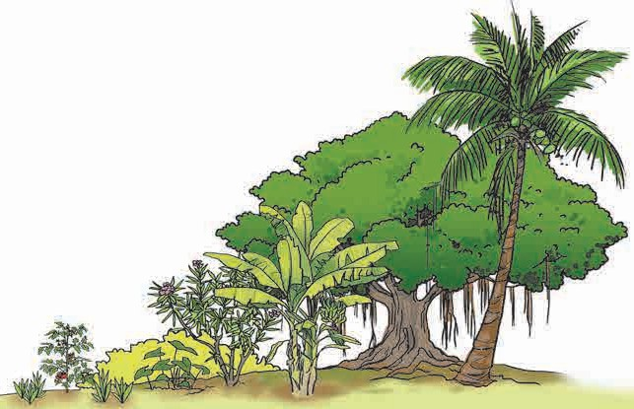

**Classification of plants**

We can easily notice the differences in the shape and height of the plants in our surroundings. It is easy to classify the plants on the basis of this observation.

|  |  |  |  |  |  |  |  |  |
| --- | --- | --- | --- | --- | --- | --- | --- | --- |
| **Name of the plant** | **Where does the plant occur/ grow** | **Nature of the stem** (Circumference, colour, bark, hard/soft, etc.) | **Height** (Short, medium, very tall,  etc.) | **Branches** (Nature, number, etc.) | **Leaves** (Colour, shape, edge, etc.) | **Flowers** (Colour, fragrance, shape, etc.) | **Nature of the fruit**  (Colour, shape, hardness or softness, etc.) | **Uses** (Which part is used.) |
| **Rose** |  |  |  |  |  |  |  |  |
|  |  |  |  |  |  |  |  |  |

* 1. **: Diversity in plants**



**Can you tell ?**

1. What are the similarities between a m a banyan and a tamarind tree ?

ango,

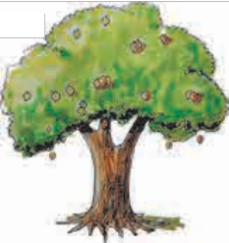

ngo,

**Trees :** Some plants grow tall. Their stem, or trunk, is hard and strong. They have branches at some height above the ground. They bear flowers and fruit for many years. Such plants are called trees. Trees are tall, big and **perennial**, i.e., they live for many years.

1. 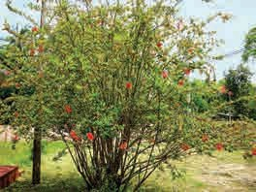What are the similarities between the hibiscus, oleander and lantana plants ?

**Shrubs :** Some plants grow close to the ground. They give out branches very close to the ground. They are shorter and smaller than trees, but they have a thick and hard stem. The oleander, hibiscus, lantana, *koranti* and rose are shrubs that may grow up to two to three metres.

1. What are the similarities between the fenugreek and periwinkle plants ?

**Herbs :** Herbs grow 1 to 1.5 metres tall. The stems of herbs are green and quite flexible as compared to those of trees and bushes. Herbs may live for a few months or up to two years.

#### According to the size and height of their stems, plants can be classified into three types : trees, shrubs and herbs.

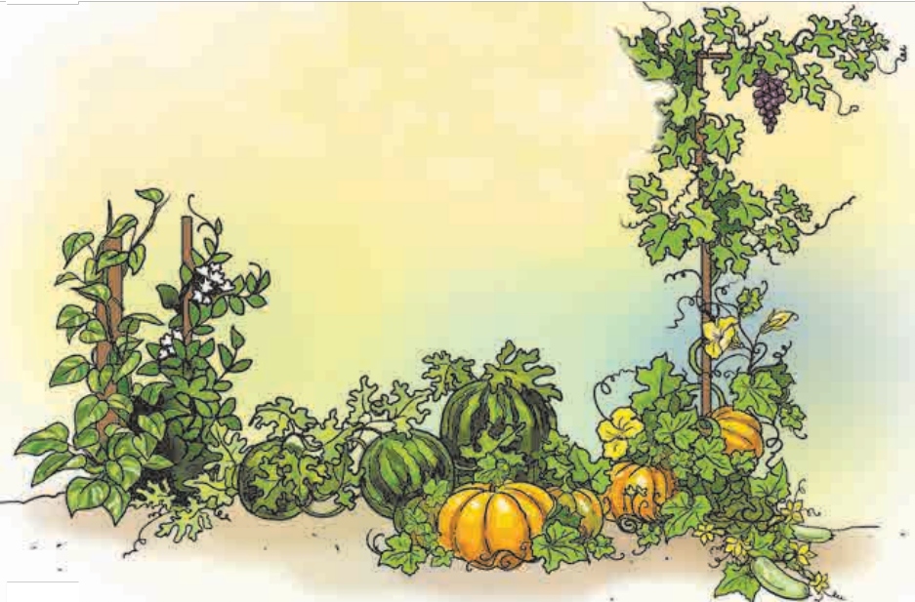

Have you seen vines like the pumpkin, the railroad creeper,

**Can you tell ?** *kavali*, watermelon or the grapevine ? How do they grow ?

**Vines :** Some vines need vertical support for growing, while some others spread on the ground. Climbers like the money plant have aerial roots. Have you seen the cucumber tendrils that look like a spring ? Of what use could they be ? Touch the stem of any vines. What do you feel ?

#### The stem of a creeper is very flexible, soft and green.

**It grows rapidly with the help of a support.**

* 1. **: Various creepers and climbers**

#### Can you tell ?

For how many years do crops like bajra, wheat, corn, radish, marigold live ?

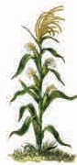The lifecycle of plants like jowar, sunflower is completed in one year. These plants are called annuals. The lifecycle of plants like the carrot, beetroot is of two years. They are called biennials. Shrubs like the hibiscus and oleander and trees like mango and gulmohur live for several years and bear flowers and fruit. They are called perennials.

According to the period of their lifecycle, plants are classified as

#### annuals, biennials, perennials.

To which part of plants are butterflies and insects attracted ?

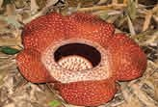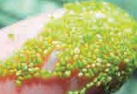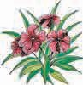

**Can you tell ?**

Plants that bear flowers are called **flowering plants**, while the plants that never bear flowers are called **non-flowering plants**. Non-flowering plants may not have organs like roots, stems, leaves.

#### Do you know ?

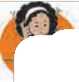

**Use your brain power !**

* What type of plants are toadstools and mushrooms ?
* What type of plant is the fig ?
* Do ferns, algae, money plant bear flowers ?

The world’s largest flower is found in Indonesia. The diameter of the flower of the plant Rafflesia arnoldi is about one metre. The world’s smallest flower is of the plant called Wolffia or duckweed. Its diameter is as small as 0.5 mm.



**Can you tell ?**

1. Where does the pomegranate shrub grow ? 2. Where does the lotus grow ?

3. Where do bulrushes, the railroad creeper grow ? 4. Where does the dodder plant grow ?

We see different plants growing in different places around us. Plants can be classified according to their habitat or the place where they grow. Land, water, marshy areas, deserts and even a big tree are the various habitats of plants.

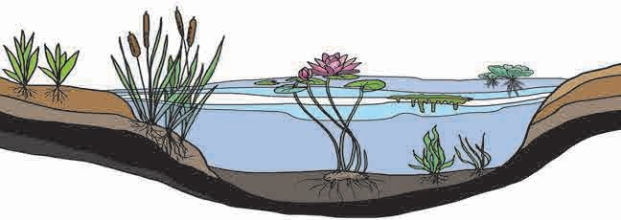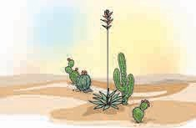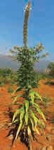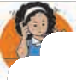

**Water**

**A desert**

#### Use your brain power !

**Land**

* 1. **: Habitats of plants**
     + Why does the water hyacinth float on water ?
     + Why is the stem of the cactus fleshy ?
     + What different criteria are used to classify plants ?

### Diversity and classification in animals

Different animals have developed different shapes to survive in the environment. There is a great variety in the body structure of animals too. The amoeba that cannot be seen with our eyes, the huge elephant, the small snail, the fish that swims in water, a kite that flies high in the sky, butterflies that flit around flowers, a house lizard that crawls on a wall are all animals. Each has different characteristics.

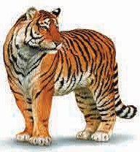Animals have body parts like a head, a neck, a torso, a tail and limbs for movement. They have various organ systems which carry on various functions inside their body. In this respect, too, there is a lot of diversity in animals.

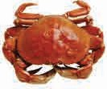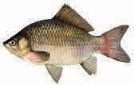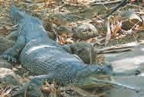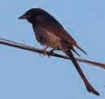

**Can you tell ?**

What are the differences in the body structure of animals like a snake, a lizard, a tiger, a fish, an eagle, a hen, a crab, a housefly, an earthworm, a crocodile and a grasshopper ?

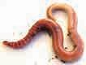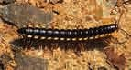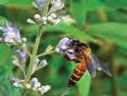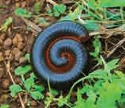We see a variety in animals with respect to their food as well. Since animals depend on others for their food, they are found in places where food is available. Different animals have different methods of obtaining and eating food. This, too, leads to differences in their body structure.

* 1. **: Diversity in animals**

Observe the animals in your surroundings. Make a list of their names. Complete the following table on the basis of the information obtained and discuss it in the class.

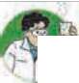

**Try this.**

|  |  |  |  |
| --- | --- | --- | --- |
| **Name of the animal** | **What is their food ? How do they eat it ?** | **Where do they live ?** | **The special feature that you found** |
|  |  |  |  |

You will not see all animals in your own surroundings. Why is it so ? Which are the other animals that you know of, but have not seen ? Collect information about them using the above table. Take the help of websites like [www.earthlife.net,](http://www.earthlife.net/) [www.discovery.com,](http://www.discovery.com/) [www.seaworld.org,](http://www.seaworld.org/) [www.kidsgowild.com,](http://www.kidsgowild.com/) [www.worldwildlife.org,](http://www.worldwildlife.org/) [www.nationalgeographic.com.](http://www.nationalgeographic.com/)

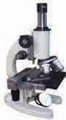Take a drop of water from a puddle and place it on a glass slide. Observe it under a microscope. What do you see ?



**Try this.**

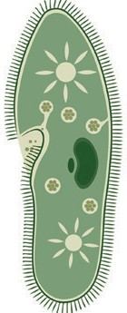When a drop of water from a puddle is seen under a microscope, innumerable microbes can be seen moving about in it.

You will see the continuously moving amoeba. The paramoecium is also a **unicellular** animal like the amoeba.

A horse, a bear, a tortoise are **multicellular** animals.

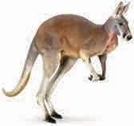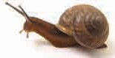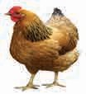

**Can you tell ?**

1. What is the chain of bones in the centre of our back called ?

Animals with a vertebral column and those without it form two groups known as the **vertebrates** and **invertebrates**, respectively.

Snakes, birds, fish and kangaroos as also humans are vertebrate animals. Animals such as snails, cockroaches, earthworms do not have a vertebral column and therefore they are invertebrate animals.

1. Name some animals which lay eggs and others which give birth to their young ones.

We have learnt that producing another living thing like oneself is called reproduction. A hen lays eggs and hatches them. After a few days, the young chicks hatch out of the eggs. A cow gives birth to a calf. Before that, the calf grows within the cow’s body. According to the mode of reproduction, animals are classified into two types, namely, **oviparous animals** which lay eggs and **viviparous animals** which give birth to their young ones.

1. 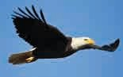Where are the animals, namely, a horse, a bear, a tortoise, an alligator, a fish, a deer and a frog to be found ?

According to their habitat, animals are usually classified into **terrestrial** and **aquatic** animals. However, animals like a frog, salamander, toad live in both places, namely, land and water. Therefore, they are called **amphibious animals**.

A kite, an eagle, a crow, a butterfly, a honeybee all fly in the air, though they live in difference places. These animals are said to have an **aerial mode of life**.

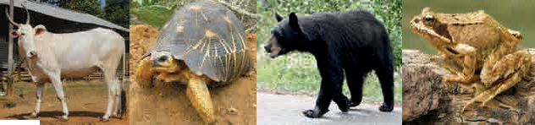

**Use your brain power !** What are the different criteria used to classify

animals ?



**Always remember...**

In the living world, a lot of diversity is seen both in animals and plants. Every plant and animal is unique. We should all make efforts to conserve this diversity in the living world.

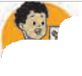

**What we have learnt-**

* Plants are classified on the basis of their height and the shape of stems, period of life cycle and habitat.
* Animals are classified on the basis of the cell structure, vertebral column, method of reproduction and habitat.



**Exercise**

#### Match the pairs.

**A Group B Group**

* + 1. Amphibian (1) A Monkey
    2. Vertebrate (2) A Snake
    3. With scales (3) A Frog

#### Who is the odd one out ?

* + 1. Fungus,mushroom,chrysanthemum, spirogyra
    2. Mango, banyan, palm, chick pea
    3. Grape, orange, lemon, hibiscus
    4. Sunflower, banyan, jowar, bajra
    5. Guava, radish, carrot, beetroot
    6. Deer, fish, man, worms

#### What is the difference ?

* + 1. Flowering plants – non-flowering plants
    2. A tree – a shrub
    3. Vertebrates – invertebrates

#### True or false ?

* + 1. The snail is an aquatic animal.
    2. Amphibians can live in air and in water.
    3. The function of the brain is well developed in vertebrate animals.

(s) The amoeba is a multicellular animal.

#### Write two names of each.

* + 1. A flowering plant
    2. A non-flowering plant
    3. A tree
    4. A shrub
    5. A creeper
    6. An annual plant
    7. A biennial plant
    8. A perennial plant

#### Write answers to the following.

* + 1. What are the parts of a plant ?
    2. What are the functions of the root ?
    3. Why is it necessary to classify living things ?
    4. What are the criteria used to classify living things ?
    5. Tell some characteristics of creepers.
    6. Explain the characteristics of herbs with two examples.
    7. On the basis of which criteria will you classify plants and animals ?
    8. What protects the bodies of animals?

#### Draw figures.

Draw the figure of a plant to show the parts, namely, the root, stem and leaves in it.

**Activity :**

* Visit a plant nursery and classify the plants there.
* Visit a zoo and obtain information about the diversity in animals.
* Write an essay on diversity in plants.
* Collect seeds of various plants during summer and throw them in open spaces (fallow land, moorland, hill, etc.) during the rainy season.



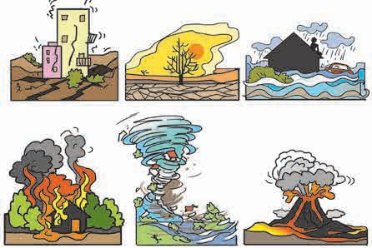

**4.**

**Disaster Management**

**Can you tell ?**

1. What events do you see in these pictures ?
2. What would you have done in these situations ?
3. Have you experienced such a situation yourself ?
4. Why do these events occur ?

### Disaster

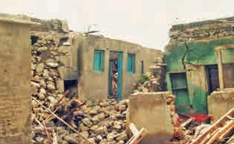

**4.2 : Effects of the earthquake at Killari**

* In July 2014, the whole village of Malin in Ambegaon taluka of Pune district was destroyed in a matter of minutes due to a landslide. Many got buried under the heaps of soil and stone and lost their lives.
* In November 2015, many people died due to the flooding caused by heavy rains in Tamil Nadu.

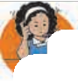

**Use your brain power !**

1. What disasters can occur in school or on the way to school ?
2. According to you, what can be done to deal with such a disaster ?
   1. **: Some disastrous events**

* In 1993, many people died due to the earthquake at Killari in Latur district.
* Even today people of Mumbai shudder at the memory of July 2005 when many people had lost their lives in the deluge caused by heavy rains.

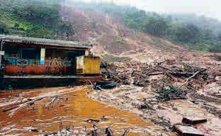

* 1. **: The disaster at Malin village**

**What is a** ‘**disaster**’**?**

A sudden event that causes large scale damage to life, property and social aspects of a nation or society is called a distaster.

### How and why do the following disasters occur ?

Classify the following disasters as man-made or natural : Fire, earthquake, leakage of chemical gases, storms, floods, tsunami, bomb explosion, collapse of a building, war, forest fire.

1. Floods due to heavy rains.
2. An earthquake, lightning, a volcanic eruption, etc.
3. Forest fires
4. Increased risk due to high density of population in a limited area.

|  |  |
| --- | --- |
| **Man-made**  **disasters** | **Natural disasters** |
| Fire | Earthquake |
|  |  |

1. Rampant and irregular constructions.
2. Ecological imbalance.
3. Terrorism, riots and crimes resulting in bomb explosions, assaults, fire and accidents, etc.

**Disasters are of two main kinds - man-made and natural.**

#### Earthquakes

Movements in the interior of the earth release tremendous amounts of energy. This causes seismic waves leading to movements of the earth’s surface like tremors, shaking, cracking up, etc.

Such vibrations or quaking in the earth’s crust is known as an earthquake. It is believed that besides other causes, man-made causes like mining and construction of big dams can also lead to earthquakes.

**Floods**

#### Effects of earthquake

* + Destruction of infrastructure, i.e., buildings, bridges, roads, railway tracks, etc.
  + Change in the direction of the flow of rivers.
  + Huge loss of life and property.

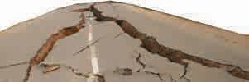

A frequently occuring natural disaster in all parts of the world is ‘floods’. Due to excessive rains in the same place, a river overflows its banks causing a flood. The water drainage system in big cities falls short when there is heavy rainfall, resulting in choking of gutters and drainage lines. Water overflows on to the roads and surrounding areas and even enters nearby

houses.

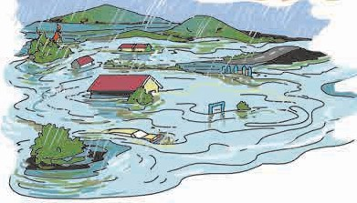

**4.4 : A flood**

#### Effects of floods

* + - Huge loss to life and property.
    - Soil erosion.
    - Destruction of standing crops.
    - After - effects of floods, like spread of diseases and epidemics affecting the health of the people.

**Storms**

The formation of high and low air pressure belts in the atmosphere causes changes in weather resulting in strong winds or storms.

#### Effects of storms

* Great damage in the storm affected region.
* Tremendous losses to life and property.
* Disruption of electric supply.
* Disruption of transport and communication.

**Forest fires**

A forest fire is an uncontrolled fire in a forest, pasture or grassland due to natural or man-made causes. Forest fires spread at a tremendous speed.

#### Effects of forest fires

* + Great damage to natural wealth and biodiversity.
  + Pollution of air.

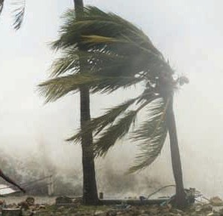

* 1. **: A storm**

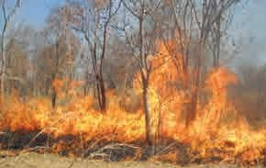

* 1. **: A forest fire**
     1. How many children are there in your class at present ?

**Institutes at work**

The National Disaster Management Authority was established in 2005.

It undertakes planning and implementation of disaster management work.



**Can you tell ?**

* + 1. What would happen if five times this number sat in your class ?
    2. Which kind of disaster can occur in an extremely crowded place ?



**Disaster management**

Community participation and disaster management are closely related. Taking steps to prevent disasters, making plans to face disasters and developing the capacity for that, is called disaster management.

To prevent or reduce damage caused by natural or man-made disasters, emergency planning and management is required.

**Always remember...**

During a disaster, helping and supporting each other is our moral responsibility.

**Contact them for disaster management**

**Police : 100, Fire Brigade : 101, Ambulance : 102, Disaster management cell : 108**

### Remedial and preventive measures

Let us see what precautions we can take before or in the event of a natural or man-made disaster. 1. Keep watching TV and radio news and

bulletins.

1. Use battery operated radios and mobiles.
2. Heed the warnings issued by the Meteorological Department carefully.
3. Use the website [www.imd.gov.in](http://www.imd.gov.in/)
4. Landslides occur in hilly areas due to a cloudburst or heavy rains. On such occasions, do not take shelter at the foot of a hill.

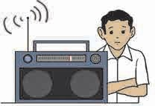

1. During floods, do not linger in houses or areas on river banks. Seek shelter in other safe places. Move to safer places at a greater height. Do not step into the water currents or drive a vehicle into them.
2. During an earthquake, roads split open, the ground cracks, railway tracks get uprooted. Hence, when moving from one place to another, ensure that the road is safe further on.
3. Take shelter in relief camps as they provide medicines, food packets, drinking water, first aid, etc.
4. To get protection from fire, use fire extinguishers in public places like schools, hospitals, railway stations, etc.

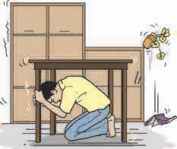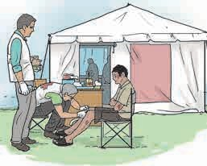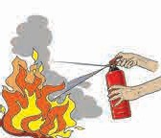

* 1. **: Remedial and preventive measures**

### First aid

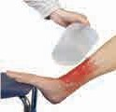

In day-to-day life, sometimes, we have to face disasters or accidents of varying proportions. On such occasions, it is necessary to give some immediate aid even before medical treatment becomes available.

#### External bleeding

If a person is bleeding, first make him sit or lie down comfortably. Keep the bleeding part of the body above the level of the heart and clean it with water.

* 1. **: Bleeding**

#### Burns and scalds Minor burns

* + The injured part should

be washed with water or held under water.

* + Give the victim water to drink.
  + Clean the wounds using a cotton swab soaked in an antiseptic solution.
  + Do not apply oily ointments.
  + Cover wounds using dry dressings.

#### Serious burns

* + - 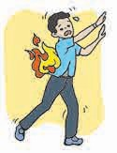Give emotional support.
    - Cover the wounds with sterilised cloth.
    - Remove jewellery, shoes, etc. if easily possible.
    - Do not touch or burst the blisters on the skin.

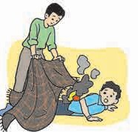

●

●

●

●

Do not apply oily ointments.

Do not try to remove the cloth if it is stuck to the burnt skin.

If the patient is conscious, give water to drink but avoid tea or coffee or other stimulating drinks. Get medical aid at once.

* 1. **: Immediate steps for burns**

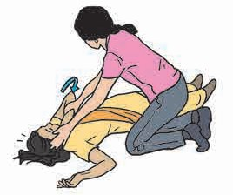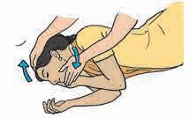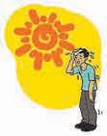

#### Sunstroke

When we work in the sun continuously for a long time, the body loses a lot of water and minerals. That is the reason for sunstroke.

#### Remedial measures

* + Take the patient to a cool place or in the shade.
  + Sponge the whole body with cold water.
  + Place a cloth soaked in cold water on the neck.
  + Give plenty of water or liquids like sherbets to drink.
  + If the patient feels like vomiting make him lie prone, i.e., on his/her abdomen with the head turned to one side.
  + Get medical help or shift the patient to a hospital.

#### Snakebite

* 1. **: First aid for sunstroke**

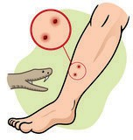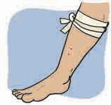There are nearly 2000 species of snakes. Of these, only a few, like cobras, kraits, vipers and sea snakes are poisonous. Therefore, all snakebites are not fatal. However, fear causes severe psychological shock which can result in death. If you come across a snake, contact a ‘Sarpa-mitra’ rather than killing the snake at once.

#### Remedial measures

* Wash the wound with water
* Give emotional support to the patient.
* Tie a cloth tightly above the wound.
* Get immediate medical help.

**4.11 :**

**First aid for snakebite**

#### Dog bite

In a dog bite, there is a risk of infection through the blood, hence first aid and medical help are necessary.

#### Remedial measures

* + Wash the wound with a solution of potassium permanganate or other antiseptic.
  + Cover the wound with a clean and dry cloth.
  + Get a doctor’s help and an injection of the anti



rabies vaccine.

**What we have learnt-**

* A sudden calamity is known as a ‘disaster’.
* Disasters can be man-made or natural.
* Alertness and immediate action are necessary on such occasions.
* Effective disaster management and use of remedial measures can help reduce the losses.
* Every person should know about safety precautions and first aid.

Page 26 : Photographs of Killari earthquake and Malin landslide - Courtesy : Lokmat Library, Aurangabad



**Exercise**

#### What are the emergency contact numbers of the following ?

* 1. Police Control Room
  2. Fire brigade
  3. Ambulance
  4. National level single emergency number for disaster relief.

#### What first aid will you provide in the following situations ?

* 1. Dog bite
  2. Scratches/ bleeding
  3. Burns/scalds
  4. Snakebite
  5. Sunstroke

#### Write the causes of the following :

* 1. Floods
  2. Forest fires
  3. Land slides/building collapse
  4. Storms
  5. Earthquakes

#### Answer the following questions.

* 1. What is meant by ‘disasters’ ?
  2. What are the types of disasters?
  3. What is meant by ‘disaster management ’?
  4. Which are the main components of disaster management ?

#### Find out about the work of a ‘Sarpa-mitra’.

1. **Find out what a first aid kit/box contains.**
2. **Suggest remedial measures for dealing with natural or man-made disasters.**

|  |  |  |  |
| --- | --- | --- | --- |
| **Disaster** | **Remedy** | **Disaster** | **Remedy** |
| Fire |  | Earthquake |  |
| Building collapse |  | Deluge |  |
| Road accident |  | Storm |  |
| Flood |  | Tsunami |  |
| War |  | Drought |  |
| Bomb explosion |  | Landslide |  |

**Activity :**

* Compile information about measures taken for disaster management in your school.
* Make posters, advertisements, banners about disaster management.
* Find out the people/organisations that provide aid during a disaster. Obtain their phone numbers, addresses, etc.





**5.**

**Substances in the Surroundings – Their States and Properties**

**Can you recall ?**

Name the solid, liquid and gaseous states of water.

### Change of state of substances

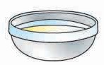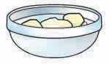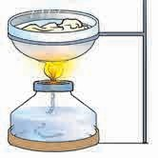

**Pieces of wax**

**Melting wax**

**Spirit lamp**

**Wax in the solid state**

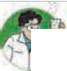

**Let**’**s try this.**

Take pieces of wax in a bowl and heat them on a candle or spirit lamp.

1. How do the pieces of wax change ?
2. What was the initial state of wax ?
3. What did it get converted into ?

Now keep the same bowl in cold water. What happens ?

* 1.** 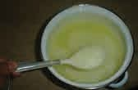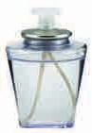: Change of state of wax**

When a substance changes from one state to another, the process is called

**change of state of the substance**.



**Can you tell ?**

Read this list of substances : Spirit, camphor, petrol, ghee, coconut oil, naphthalene balls, ammonium chloride (*navsagar*).

1. Which ones freeze in winter ?
2. Which liquid have you seen change into a vapour ?
3. Which solids directly change into the gaseous state ?

What do we learn from this ?

**In the past...**

In the 19th century, the scientist

J. Willard Gibbs showed that the characteristic properties of a substance depend on its physical state and the arrangement of particles in it.

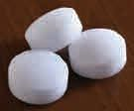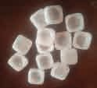

* 1. **: Various substances**

The state of a substance changes if it is heated or cooled. Every substance in our surroundings,

is found in either the solid, liquid, or gaseous state.

|  |  |  |  |
| --- | --- | --- | --- |
| **Points** | **Solids** | **Liquids** | **Gases** |
| **Example** | A piece of iron | Water, spirit, oil | Air |
| **Shape** | Has a shape of its own. Retains shape, no matter how it is kept. | Does not have a shape of its own. Takes the shape of the container. | Does not have a shape of its own. Occupies all the available space. |
| **Volume** | Has a definite volume.  Solids like sugar, sand when poured on a flat surface, form a heap. | It has a specific volume. Occupies definite portion of a container. Spreads on a flat surface on pouring. Flows downwards along a slope. | Does not have a definite volume.  On changing the pressure on a gas in a closed container, its volume also changes. |

### Heat and change of physical state

You have learnt that change in the physical state of a substance is an effect of the amount of heat in it. On gaining heat the substance changes from solid to liquid and liquid to gas. On the other hand, when the substance cools, or loses heat, it changes from gaseous to liquid and liquid to solid state.



**Can you tell ?**



**Changes of state**

on heating Solid

on cooling

on heating

Liquid

Gas

on cooling

### The temperature and a thermometer

Does water change into vapour the moment we place the vessel on a stove ? Does water kept in fridge change at once into ice ?

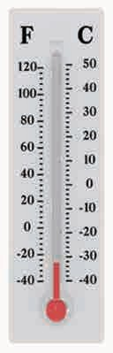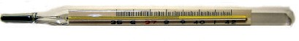

When a substance gets heat, it becomes warm and then hot. We put our hand or finger in the water to judge how hot it is, but that is not an accurate measure. Besides, if the substance is very hot, we could get scalded.

A

measure

thermometer

is used to

temperature.

Degrees

Celsius (oC) is the unit of measuring temperature. There are

types of thermometers

several available.

Nowadays digital thermometers are frequently used.

**Mercury**

**5.3 : Thermometer**

A specific amount of heat must be gained or lost before the state of a substance can change. The change in physical state is determined by how hot the substance becomes on gaining heat, or how cold, on losing it.

How do we tell how hot or cold a substance is ?

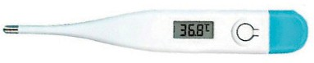



**Let**’**s try this.**

Take a thermometer from the laboratory. The bulb at its lower end is filled with mercury. The mercury rises to a certain level in the capillary tube above the bulb. You will see a scale next to the mercury column. Reading the figure near the level of the mercury tells us the temperature of air around the bulb of the thermometer.

Hold the thermometer in water so that the bulb is completely immersed in the water and read the temperature of the water. Repeat the activity taking some hot water in one vessel, and cold water or ice in another. Note the temperatures.

#### Some examples Temperature

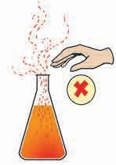

Boiling water 100 0C

Freezing water 0 0C

Air (winter night) <15 0C Air (summer afternoon) >35 0C Inside a fridge < 5 0C

Inside the freezer < -18 0C

**Thermometer**

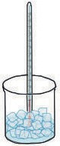**Ice**

* 1. **: Recording the temperature**

Body temperature Approx. 37 0C

**Do be careful !**

### Boiling

Water is continuously evaporating. We know that water spilled on the floor dries up slowly on its own. This evaporation occurs from the surface of the water. What happens when water boils? As the water gets heated, its temperature increases and it evaporates

at a faster and faster rate.

When water kept on a stove attains a particular temperature or level of heat, then evaporation takes place in all parts of the body of water. Then we see water bubbles rising at faster and faster rates to the surface and steam mixing in the air. This is called **boiling of water** or **ebullition**. At sea-level, pure water boils at 1000C. This is the boiling point of water. When water vapour cools, it is converted into water again. This process is called **condensation**. Condensation of steam also takes place at 1000C. It means that the boiling point and condensation point of water are one and the same.

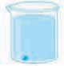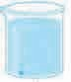



**500C**

**200C**

**Thermometer**

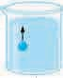

**1000C**

**Boiling water**

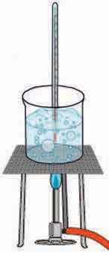

**Burner**

* 1. **: Boiling**



**Let**’**s try this.**

Take some water in a beaker and place a thermometer in it. Heat the beaker on a spirit lamp. Note the boiling point of water. Repeat the activity, adding salt or sugar to the water and note the boiling point again. What do you infer from it?



**While gaining heat**

**Boiling Melting**

**Gas/ Vapour**

**Liquid**

**Solid**

**Condensation**

**Freezing**

**While losing heat**

### Freezing

The water kept in a fridge or on ice becomes cooler and cooler, that is, its temperature falls. At a certain temperature, water does not get any cooler, but starts freezing and forms ice. The temperature at which this happens, is called the freezing point of water.

The temperature of a substance can fall below 00C, e.g., the temperature of air in the freezer of a refrigerator is around

-180C. It is read as ‘minus 18 degrees Celsius’.

When ice gets heat, it starts melting or changing into the liquid state again. Ice melts at 00C. It means that the freezing point and melting point of water are one and the same.

Each substance has a specific boiling point which is also its condensation point. Each substance has a specific melting point which is the same as its

freezing point.

The temperature at which

a substance boils while heating is the same as the temperature at

which it condenses when it is cooled. Similarly, the temperature at which a substance freezes while cooling

is the same as the temperature at which it melts when it is heated.

|  |  |  |
| --- | --- | --- |
| Substance | Freezing point | Boiling point |
| Candle | 600C | 3500C |
| Plastic | >2500C | 9540C |
| Iron | 15350C | 28620C |

### Various uses of changes in physical state



**Use your brain power !**

The chart given below shows the boiling point and freezing point of some substances. State whether these substances are solid, liquid or gaseous at room temperature.

1. Candles are made by melting paraffin wax.
2. Solid carbon dioxide (dry ice) is used to make ice cream and to keep it frozen.
3. Liquid nitrogen is used in animal husbandry.
4. Sand (silica) is melted to make glass.
5. Metals like gold and silver are melted to make ornaments.
6. Iron is melted to make tools.

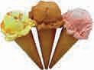 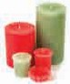 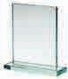

Take some sand in a crucible. Put a few iodine crystals on it.



**Let**’**s try this.**

Place the crucible on a tripod to heat it. Block the stem of the funnel with a cotton plug and place it inverted over the crucible. Light the burner and heat the mixture in the crucible. Observe the changes.

**Cotton plug**

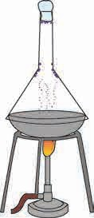

**Iodine**

**particles Funnel**

**Burner**

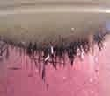

**Actual particles of iodine seen during the experiment in the laboratory**

Why does this happen ?

### Sublimation

Iodine crystals do not melt on heating but change directly to the gaseous state. When the fumes of iodine hit the walls of the funnel they cool to form solid crystals of iodine and stick to the funnel walls. Thus, on heating, iodine does not melt and change to a liquid but directly changes to the gaseous state.

The change of a solid substance directly into a gas or vapour without

* 1. **: Sublimation**

#### Use your brain power !

first changing into a liquid is called

#### sublimation.

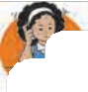

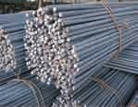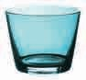On opening a box of camphor, its smell spreads all around. Why does this happen ?



**Can you tell ?**

* 1.** 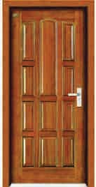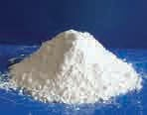: Identifying various substances and objects**

How will you identify the following?

* A glass : Is it made of plastic, steel or glass ?
* A rod : Iron or aluminium ?
* A door : Wooden or glass ?
* A white powder : Salt or chalk powder ? To answer the above questions, you considered their properties, e.g., their

transparency, hardness, weight, colour,

the sound produced from it, solubility in water, etc. Substances can be identified by studying their properties. They can be put to use according to their properties.

Let’s study the properties of substances in greater detail.

### Properties of substances.



**Let**’**s try this.**

* + What will happen if pressure is applied on substances like chalk, brick, alum, glass or a *rajgira wadi* ? These substances break into small pieces or particles. Such substances are said to be brittle. This property of substances is called **brittleness**.
  + Take an iron nail. Try to pierce a cardboard sheet, wet mud and a piece of wood using the nail. What happens ? The nail easily pierces wet mud, but not the piece of wood. It can pierce the cardboard sheet with some effort. Why does this happen ? The **hardness** of a substance is determined by how much resistance it offers to the substances being pushed through it.

Which is the hardest known substance ?

* + Stretch a rubber band and let it go or apply pressure on a piece of sponge and release it. What do you see ? The rubber band and the sponge go back to their original shape. Some substances change their shape when a force is applied on them but return to their original shape and size when the force is removed. This property is called **elasticity**.
  + Take a flat metal sheet of the size of a notebook. Holding it at an angle, put a drop of water, honey and gum at different places on the board. Observe how they flow down the slope. Liquids flow downward on a sloping surface. This property is called **fluidity**. The fluidity of any liquid is determined by how easily it flows.

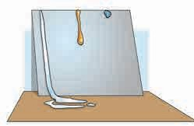

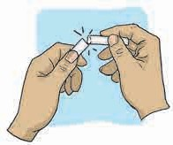

* 1. **: Brittleness**

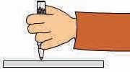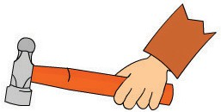

* 1. **: Hardness**

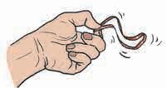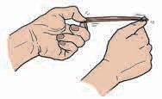

* 1. **: Elasticity**
  2. **: Fluidity**
  + If two blocks of the same size, one wooden and the other of iron, are weighed in a balance, how would they compare? The mass of different substances having the same volume can be different. This difference is because of the difference in their **densities**. Between substances of the same volume, the ones with greater density are heavier than the those of lesser density.
  + 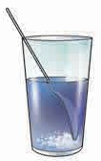Take a glass of water. Add some salt, fine sand and sugar to it and try to dissolve them. Repeat this, replacing water with kerosene. What do you observe ? Some solid substances dissolve in a particular liquid. If a solid does not dissolve in a liquid, it is said to be insoluble in that liquid e.g. salt is soluble in water, but insoluble in kerosene. You know of many beverages, made by using water and soluble substances. The property of a substance of getting dissolved, is called its **solubility**.
  + When we can look through a substance and see things on the other side, then that substance is said to be **transparent**. This property of the substance is called **transparency**. Glass, some types of plastic, clean water and air are transparent substances.



**Can you tell ?**

Identify the objects shown in figure 5.14. From which substances are they made? What are these substances called as a group ?

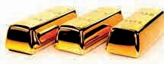**Metals :** Substances like copper, gold, iron, aluminium are called metals. Metals are found in the form of minerals deep inside the earth. Minerals from the earth’s crust are processed to obtain the metal. In daily life, metals have various important uses. Let us study some common properties of metals.

### Properties of metals



**Let**’**s try this.**

Take a piece of copper or aluminium wire or a small nail. Hammer it repeatedly. What do you observe ?

On hammering repeatedly, the wire becomes flat, i.e., it forms a thin sheet. Metals can be converted into sheets by hammering. This property of metals is called **malleability**.

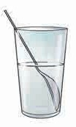

**Kerosene Water**

* 1. **: Solubility**

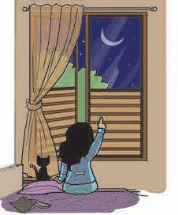

* 1. **: Transparency**

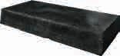

* 1. **: Metals**

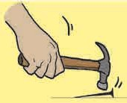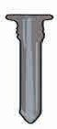

* 1. **: Malleability**



**Observe and discuss.**

Hot iron is hammered and made into thin sheets. Visit a blacksmith’s shop to observe how this hammering causes it to stretch. Iron bars made to revolve continuously while being hammered become longer. The iron can be drawn into a wire.

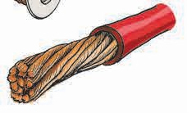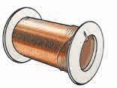

**5.16 : Ductility**

Metals can be stretched and drawn into wires. This property of metals is called **ductility**. Metals like silver, gold, copper, platinum can be drawn into fine wires.

* + 1. Why are the electric boards fitted on the wall made of plastic or wood ?



**Can you tell ?**

* + 1. The handle of a cooker is made of plastic. Why ?

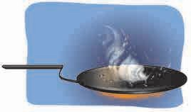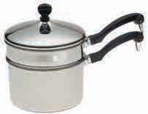

Electricity flows through metals. All metals are conductors of electricity to a greater or lesser extent. This property is called **electrical conductivity.**

Even when a piece of a metal is heated at one place, the whole of it becomes hot. It shows that metals allow heat to flow through them. This property is called **thermal conductivity**.

Metals have a typical shine or **lustre**. Every metal has a **characteristic colour** by which it can be identified.



**Try this.**

1. Pluck the string of a musical instrument like

**5.17 : Thermal conductivity**

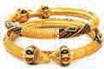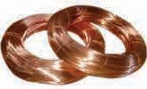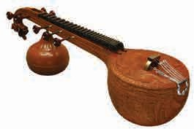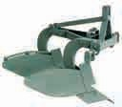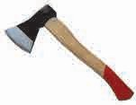

a *tanpura* or *veena*, ring a bell or hit a steel box with a metal spoon.

2. Strike a wooden table or a marble floor with a wooden stick.

Note the difference in the sounds produced in the two cases.

Metals produce a ringing sound. This property is called the **sonority** of metals.

**5.18 : Uses of metals**



**Always remember...**

During the rainy season or at any other time, do not touch the exposed electric wires or metal parts.

Keep all electric lamps or other appliances switched off when not in use. For example, even when the TV is switched off by remote control, do not forget to put off the main switch. It helps to save electricity besides protecting us from any possible danger.

Ask your seniors at home to check the electric wiring and fittings in the house periodically.

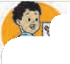

**What we have learnt-**

* Solids, liquids and gases are the three

states of substances.

* The temperature of a substance, (how hot or cold it is), can be measured with the help of a thermometer.
* Heat is the cause of the change of state of substances.
* Substances have various properties like hardness, elasticity, brittleness, fluidity, density, solubility and transparency.
* Metals form a separate group of substances.
* Metals have some common properties like malleability, ductility, thermal conductivity, electrical conductivity,

sonority, colour.

lustre,

and characteristic

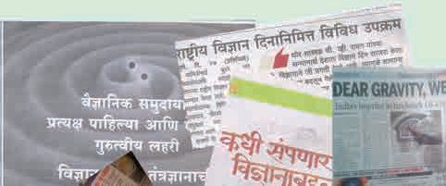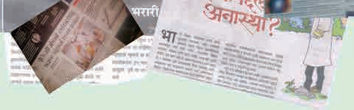

**Science watch ...**

Science is developing continuously. How much do we know of it ? Research work goes on at the State, national and global level. If we wish to keep ourselves informed about it, we must be aware of the various happenings around us. Make newspapers your friends, read newspapers daily. Read and collect articles on science. Discuss and share them with others.



**Exercise**

#### In the paragraph below, write ‘solid’, ‘liquid’ or ‘gas’ in each of the brackets depending on the substance referred to just before.

On a bright sunny day, Riya and Gargi are playing with a ball ( ) in the park. Gargi feels thirsty. So, Riya brings tender coconut water ( ) for her. At the same time, a strong breeze ( ) starts blowing and it also begins to rain ( ). They run back into the house ( ), change their clothes ( ) and then their mother gives them a cup ( ) of hot milk ( ) to drink.

#### Discuss.

* 1. Riya pours some water from her bottle into another bottle. Does it change the shape of the water ?
  2. Halima picks up a small stone from the ground and puts it in the water in a dish. Does the shape of the stone change ?

#### Write the properties of these substances.

Water, glass, chalk, iron ball, sugar, salt, flour, coal, soil, pen, ink, soap.

#### What is sublimation ? Write the names of everyday substances that sublimate.

1. **What is it made from? Why?**
   1. A sickle to cut sugarcane.
   2. The sheets used for roofing.
   3. A screwdriver
   4. A pair of tongs.
   5. Electric cables.
   6. Ornaments.
   7. Pots and pans.

#### 6 What will happen if….? And why ?

1. Nails are made of plastic.
2. A bell is made of wood.
3. Rubber is not fitted on a pair of tongs.
4. A knife is made of wood.
5. An axe is made of rubber.

#### Who am I ?

* 1. I**’**m found in a thermometer, I measure your temperature.
  2. I make things hot or cold.
  3. I have no shape whatsoever !
  4. I dissolve in water, but not in kerosene.

#### Why does this happen ?

* 1. Coconut oil thickens in winter.
  2. Kerosene left open in a dish disappears.
  3. The fragrance of incense sticks lighted in one corner of a room spreads to the other corner.
  4. 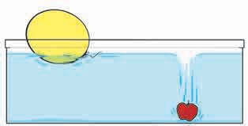What you see in the picture.

**Activity :**

* Find out how the big statues of wax are made.
* Visit a jeweller’s shop and find out how ornaments are made.





**6.**

**Substances in Daily Use**

#### Can you recall ?

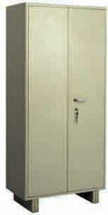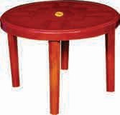

1. Which three objects do you see in the picture ?
2. How did you identify them ?
3. What material are they made of ?
4. Can any one of these materials be used to make all the three objects?

### Substances and objects

* 1. **: Different objects**

All substances are made up of very small particles. Objects are made up of substances. Objects have a specific shape, their parts have a specific arrangement, by which we identify them. We use wood, plastic or steel, to make a table, chair or cupboard. These substances have the strength required to make these articles. Also, these substances can be given a desired shape. It means that we consider the properties of substances to use them for making things.

The same substance or material can be used to make many objects. Let us study some such examples.

Cotton - cloth, fibre or thread, sarees, handkerchiefs, quilts, mattresses, pillows, etc.

Iron - construction steel bars, griddles, (*tawa*), parts of automobiles, electric poles, tables, cupboards, etc.

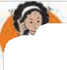

**Use your brain power !**

Make a list of objects, each of which can be made from several substances.

Aluminium-kitchen utensils , electrical cables,

etc.

By studying the properties of substances, we can select substances suitable for our purposes. The substances in everyday use are of two main kinds - natural and man-made substances.

Make a list of various objects in your house and note down the substances they are made of.



**Try this.**

**Classify.**

Classify the following substances according to their uses.

Substances - sand, soap, wool, window glass, bamboo, cotton, bricks, silk, leafy vegetables, cement, fruits, water, sugar.

* + 1. 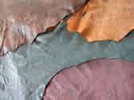What is the difference between 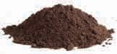 these two groups of natural

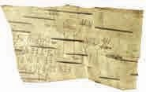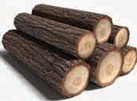

**Can you tell ?**

substances - leather, jute, wool, cotton and water, soil, metals.

### Natural substances

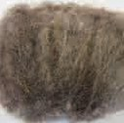Substances available in nature are called **natural substances**. Of these, the substances of the first group are obtained from living things. Substances obtained from living things are called **biotic substances**. Air, soil, water are substances that are not obtained from living things. They are called **abiotic substances**.

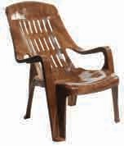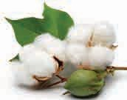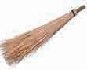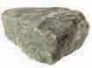

* + 1. 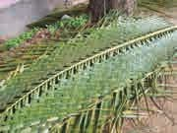How are leather and wool different from jute and cotton ?

Leather and wool are obtained from animals. They are of **animal origin**, whereas jute and cotton are substances of **plant origin**.

* + 1. 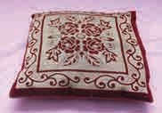Do we find plastic, nylon, brass or cement in nature ?

### Man-made substances

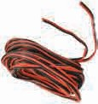It is human nature to strive for newer things and to try to make life more comfortable. As a result of his efforts, man not only learnt to use natural substances but also began to process them to make new substances. Several such substances are easier to use and can be made available in plenty at a low cost. Therefore, these substances came to be used on a large scale. There are a great many such man-made substances in use today.

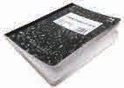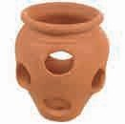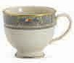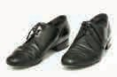

New substances produced by processing naturally available substances are called **man-made substances**.

Earlier *irlis* or capes made of grass or sackcloth were used for protection from rain. Then cloth umbrellas came into use. Nowadays, the raincoat, school bags and the book covers you use can all be made from plastic.

Delicate articles, perishable fruits, etc. require packing. To pack TV sets, refrigerators, etc. big cartons and thermocol are being used. All these are man-made substances. These substances are water proof or water resistant, lightweight and easy to transport. That is why, they are being used increasingly.

**Classify.**

Classify the various substances available in the house as natural and man-made substances.

### Examples of man-made substances

|  |  |  |
| --- | --- | --- |
| **Area of use** | **Natural substances** | **Man-made substances** |
| Construction | Bamboo, stone, soil, wood, coconut fronds, lime | Brick, cement concrete, galvanized sheets, clay tiles, plastic/ asbestos sheets |
| Writing material | Tree bark, leaves, *bhurjpatre*, pens made from reeds, *dhulpatya*, stone slates, stone walls in caves, soil and colours made from plants | Pens, pencils made from plastic and metal, paper, notebook, etc. |
| Threads / Fibre / Yarn | Cotton, silk, wool | Nylon, rayon |



**Use your brain power !**

Complete the table below, showing how substances of daily use are classified.

Substances in daily use

Leather

Plant origin

Abiotic

Man-made

Glass can be made from sand and calcium carbonate. However, sand and calcium carbonate cannot be obtained again from glass.

You must have observed green chillies or tomatoes turning red after some time.

Have you ever seen or heard of red tomatoes becoming green again ?

While making man-made substances, the properties of the constituents undergo a change. This change occurs due to certain chemical reactions. These changes in the properties are permanent, that is, the original constituent substances cannot be obtained again from the new substances. Such changes are called **irreversible changes**.

**Production of substances**

रासायनिक नरिया व

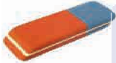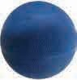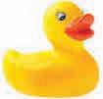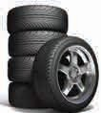

**In the past...**

Charles Goodyear spilled a mixture of rubber and sulphur on a burning stove. After the stove was extinguished, he noticed that the rubber had become harder and less elastic. He repeated this experiment in

systematic way

a and

invented the process of ‘vulcanization’. Hard and tough tyres of rubber made thenceforth brought about a revolutionary change in transportation.

#### Rubber

Rubber is of two types, natural and artificial.

Natural rubber is obtained from the gum or sap of trees. This sap is called ‘latex’. Rubber has a peculiar odour and it is white in colour.

**Vulcanization of rubber**

In this process, rubber is heated with sulphur for three to four hours. To give hardness to the rubber, sulphur is mixed in it. The proportion of sulphur in the mixture is determined by the purpose for which the rubber will be used.

Erasers, rubber balls, rubber toys all have varying proportions of sulphur in them. In rubber bands, the proportion of sulphur is very small.

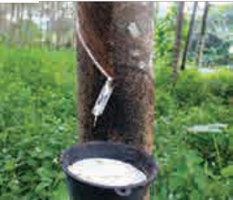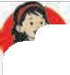

**Do you know ?**

Rubber is a natural substance obtained by collecting the latex of a certain tree. Rubber trees are found in abundance in Brazil. Later, these trees were planted in other countries too. The botanical name of this tree is ‘*Hevea brasiliensis*’. In India, the maximum production of rubber is in Kerala.

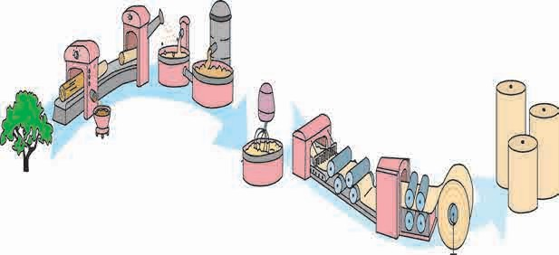

**Manufacturing paper**

**Adding dyes**

**Logs of wood**

**Paper**

**Trees**

**Peeling the logs**

**(De-barking the logs)**

**Pressing the pulp with rollers**

**Pulp**

**6.2 : The process of manufacturing paper**

**Winding the paper on reels**

#### Paper

**Always remember...**

1. Do not tear up blank pages of a notebook. Do not throw away old notebooks with blank pages.
2. The blank sides of advertising pamphlets, inner side of postal envelopes, the blank sides of of calendars pages and other such writable surfaces can be used to make notes, lists, to cover books, etc. Do not throw away or burn up such paper until it has been fully utilized like this.
3. Whenever possible, try to use a pencil and slate.
4. Cooperate with people who collect paper from garbage or buy scrap paper. These people help in the proper recycling of resources.

Paper is the substance or material formed due to the intertwining of the cellulose fibres in grass, wood, rags or waste paper. Thus, paper is a kind of network of cellulose fibres.

#### How is paper made ?

Coniferous trees like pine are used to make paper. The bark of the logs of these trees is first removed and the wood is broken into small pieces. The mixture of these pieces and some chemicals is kept soaking for a long time. It helps to form pulp. When the chemical process is completed, the fibrous substances from wood pulp are separated, and some dyes are added. The pulp is then passed through rollers, dried to form paper and finally wound on reels.

Paper and wood are closely related. To save trees, it is necessary to use paper sparingly.



**Do you know ?**

In India, the first factory to manufacture newsprint (paper to be used for newspapers) was established at Nepanagar in Madhya Pradesh in 1955. Paper is also manufactured at Songardh in Gujarat. In Maharashtra, there is a paper factory at Ballarpur near Chandrapur.

#### Synthetic fibres or threads



**Can you tell ?**

1. From which substances in nature can we get threads or fibre?
2. What are clothes made from ?

**Find out.**

1. Where was the process of making paper invented ?
2. What kind of paper is used for our textbooks. What size is it ?
3. How is paper for currency notes manufactured ?

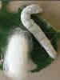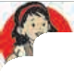

**Do you know ?**

Silk is a natural thread or fibre obtained from the

cocoons of silk worms. From one cocoon, 500 metres to 1300 metres of thread can be obtained. It

is said that silk was first produced on a large scale in China.

From the time it was first thought that artificial yarn could be produced to meet the clothing needs of an increasing population, much research and progress has taken place in this field. Innumerable kinds of synthetic or artificial threads are now available. Nylon, dacron, terylene, terene, polyester, rayon are the names of various synthetic threads.

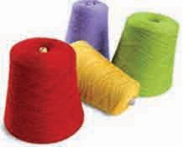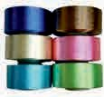

**6.3 : Artificial threads**

#### Rayon

Almost all the articles made from natural fibres in the olden days can now be made from synthetic threads.

Nylon, rayon, terylene, acrylic are all synthetic threads and many articles in our daily use are made from them.

#### Nylon

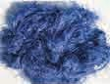These threads were invented at the same time in New York and London. Therefore the initials NY of New York and LON from London were combined to name them NYLON. Nylon threads have a shine and are strong, transparent and water resistant. They are used to manufacture clothes, fishing nets, ropes, etc.

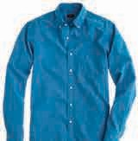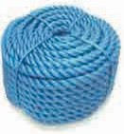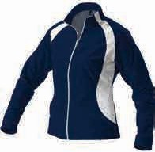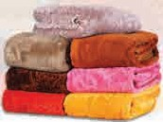

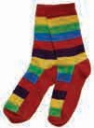Cotton and wood pulp is dissolved in a chemical called sodium hydroxide to make a solution. Threads are obtained from this solution with the help of machines. As these threads have shine and strength, they are said to be ‘synthetic silk’. They appeared to be shining bright like the sun’s rays. Hence they were named ‘Rayon’.

#### Dacron, Terylene, Terene

Various hydrocarbons obtained from mineral oils are used to make polymer chains. A solution of such a polymer is pressed through a strainer with fine holes. The fibres formed after cooling, are long and unbroken threads. These threads are twisted to obtain yarn.

Different types of chemicals are used to make threads of various properties. These different threads have been named variously as dacron, terylene, terene, etc.

**6.4 : Uses of artificial threads**

**New words**

1. **Hydrocarbons :** Substances obtained from mineral oil.
2. **Polymer chains :** Long continuous chains formed by small, interlinked chemical units.

### Advantages and Shortcomings of Synthetic Fibre

#### Advantages

1. These fibres can be manufactured on a mass scale.
2. They cost less.
3. They are strong and durable.
4. They can be used for a long time.
5. They are water repellant, hence, do not rot or get wet. They dry easily.
6. They are lightweight and comfortable to wear.
7. As they have a shine, they enhance the appearance of the wearer.
8. Clothes made from these threads are wrinkle-free and scratch-free.

#### Shortcomings

1. They are water repellant. Hence, do not absorb sweat from the skin.
2. Continuous use of clothes made from these threads keep the skin moist, which may cause skin diseases.
3. Synthetic clothes are uncomfortable to wear especially in summer.
4. Synthetic fabric catches fire easily.
5. If they catch fire, the cloth sticks to the skin and causes serious injuries.
6. These fibres are not decomposed by micro-organisms.



**Always remember...**

* Save trees to save nature; save paper to save trees. Use paper properly and economically. Make full use of it and recycle the used paper.
* Although there are some disadvantages in using synthetic fibres, they can be useful if they are used in the proper way. They reduce the load on the use of natural resources.



**What we have learnt-**

* We use two types of materials - natural and man-made. Natural materials may be biotic or abiotic. Biotic materials are either of plant origin or animal origin.
* Rubber, paper and synthetic fibres are important man-made materials in our daily use.
* Man-made materials are obtained by using certain processes.

**Science watch ...**

While studying science, we do verify whatever we learn, but what about others ? It is necessary to explain to everybody that there is science behind every phenomenon. Let us explain to them what we have learnt and let us act on the basis of our knowledge.



**Exercise**

#### Fill in the blanks using proper words.

* + 1. Rubber made by vulcanization is a …… material.
    2. Man-made materials are made by ………. natural materials.
    3. ….......... thread was developed simultaneously in New York and London.
    4. Rayon is also known as …………

#### Answer the following questions.

* + 1. Why did the need for man-made materials arise ?
    2. Which are the natural materials obtained from plants and animals ?
    3. What is vulcanization ?
    4. Which natural materials are used to obtain fibres ?

#### What are we used for ?

* + 1. Soil
    2. Wood
    3. Nylon
    4. Paper
    5. Rubber

#### How is paper manufactured ? Write in your own words.

* 1. **Give scientific reasons.**
     1. We must use cotton clothes in summer.
     2. We must observe economy in the use of materials.
     3. Saving paper is the need of the hour.
     4. Man-made materials have more demand.
     5. Humus is a natural material.

#### Find out.

1. How is lac obtained from nature ?
2. How are pearls obtained ?

**Activity**

* Visit a rubber, paper or textile industry in your area and collect information about it.
* Collect various samples of paper and note their uses.
* Use blank pages from old note-books and make a new one.





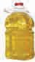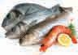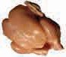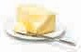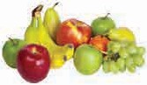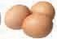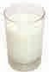

**7.**

**Can you recall ?**

**Nutrition and Diet**

Which are the various groups of foodstuffs ? Name the ones you see in the pictures. Which main constituents of food do we get from them ?

**7.1 : Foodstuffs**

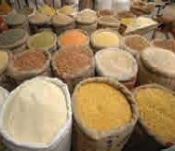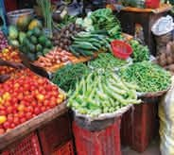Living things take food and water and use them for

In living things, the process of taking in food and water and using it for growth and other purposes is called ‘nutrition’, and

the constituents of food useful for these purposes are called ‘nutrients’.

a variety of purposes such as :

 Obtaining energy  Growth of the body

 To carry out day to day functions of the body  To fight diseases

### Nutrients and foodstuffs

There are six main nutrients in our food : Carbohydrates, fats, proteins, fibre, vitamins and minerals. These nutrients are present in the different food items we eat in differing proportions. Let us learn more about some of them.

#### Energy-giving nutrients - Carbohydrates

Our main need is of energy. It is fulfilled by carbohydrates. Hence, our diet includes a large proportion of cereals in the form of rice, chapatti or roti, bhakri and bread which contain carbohydrates. Cereals are our staple food.

**7.2 : Cereals**

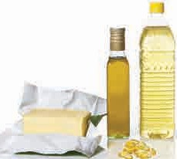

**7.3 : Fatty foods**

#### Fats

Some part of our energy requirement is also fulfilled by fatty foods such as oil, ghee and butter.

We get energy in the form of heat from the food we eat. Heat is measured in kilocalories. Hence, the energy in food items is also measured in kilocalories (Calories).

Children of growing age need to get approximately 2000 to 2500 Calories from the food they eat.

#### Proteins

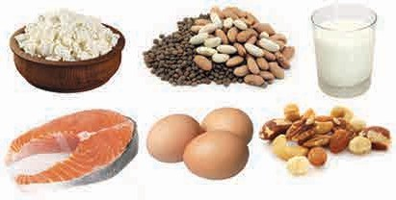

**7.4 : Proteins**

We need proteins for the purposes of growth, repairing the wear and tear of the body and for other life processes. We get proteins from the sprouts, milk and milk products, meat and eggs in our food.

#### Minerals and vitamins

To improve the body’s resistance to disease and for other life processes the body needs vitamins, minerals and fibre in the diet. We obtain these nutrients mainly from vegetables and fruits.

We require vitamins and minerals in small quantities, but their deficiency can lead to various diseases. Let us learn more about them.

The body needs several inorganic substances. They are called **minerals**. The table below gives examples of some minerals and provides information about their functions in the body, the various sources of the minerals as well as the diseases caused by their deficiency.

|  |  |  |  |
| --- | --- | --- | --- |
| **Mineral** | **Functions** | **Sources** | **Deficiency Diseases** |
| Iron | Carrying oxygen to all parts of the body. | Meat, spinach, apples, raisins | Anaemia |
| Calcium and phosphorous | Strengthen bones and teeth. | Milk and milk products. Green leafy vegetables, meat. | Bad teeth, brittle and weak bones. |
| Iodine | Controls growth, speeds up chemical reactions in the body. | Raisins, beans, fish, sea food | Goitre |
| Sodium and potassium | Maintains the body’s water balance and functioning of the muscles and the nervous system | Salt, cheese, leafy vegetables, fruits, pulses | Inefficiency of muscles |

#### Vitamins

**Water soluble vitamins :**

Vitamin B and Vitamin C dissolve easily in water. So they are called water soluble vitamins. They are thrown out of the body through the water in sweat and urine. Hence, a regular supply of these vitamins is essential.

B1, B2, B3, B6 , B9 and B12 are the important types of Vitamin B.

**Water insoluble vitamins :** These vitamins are insoluble in water but are soluble in fatty substances. They get stored in the body. Vitamins A, D, E and K are fat soluble vitamins.

### Vitamins - Sources and functions

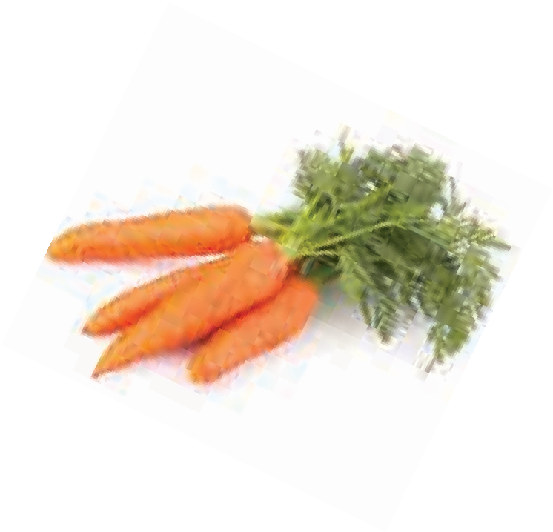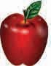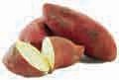

|  |  |  |  |
| --- | --- | --- | --- |
| **Vitamin** | **Helps in** | **Sources** | **Deficiency Diseases** |
| A | Protects eyes. Helps to keep skin, bones and teeth healthy. | Carrot, milk, butter, dark green vegetables, sweet  potatoes, deep yellow fruits and vegetables | Night blindness (inability to see in dim light), Xeroderma (dry skin) |
| B1 | Helps in proper functions of nerves and heart. | Milk, fish, meat, cereals, nuts, pulses | Beriberi  (Nerve disorder), Muscle weakness / inefficiency |
| B9 | Growth of the body. | Deep green vegetables, papayas, kiwis | Improper growth, anaemia, forgetfulness, slow movements |
| B12 | Formation of red blood cells. | Meat, milk products | Anaemia |
| C | Protects body tissues; formation of collagen - a protein essential for gums, teeth, bones and skin. | Amla, kiwi, oranges and other citrus fruits, cabbage, tomatoes, green leafy vegetables. | Scurvy (bleeding of gums), thyroid malfunction, delay in healing of wounds. |
| D | Absorbs calcium and phosphorous for healthy bones and teeth. | On exposure to sunlight vitamin D is made in the human body from some substances in milk, fish, eggs and butter | Rickets (softening of the bones, causing pain and fractures) |
| E | Smooth functioning of Metabolism inside the cells, reproduction, maintaining efficiency of muscle cells. | Wheat germ, green leafy vegetables, tender leaves, vegetable oils | Weak muscles, obstruction in reproduction, skin disorders |
| K | Helps in clotting of blood. | Green leafy vegetables, green cabbage, broccoli, sprouted pulses, yellow of eggs | Excessive bleeding after an injury |

#### Group activity : The information in the above chart should be enacted through role play.

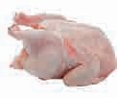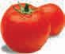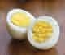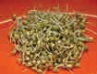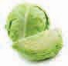

* 1. **: Vitamins**

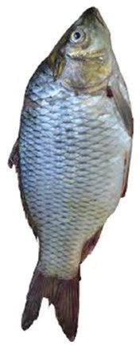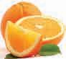

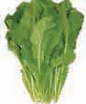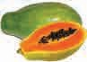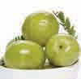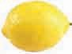

**Always remember...**

Some vitamins are very sensitive to heat and light. For example, Vitamin C is easily destroyed during cooking. Therefore, Vitamin C rich foods should be eaten raw.

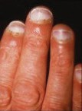

**Scurvy**

**In the past.....**

Casimir Funk was a scientist who belonged to Poland in Europe. In a scientific article, he read that people who ate brown rice were less likely to get beriberi than those who ate fully milled rice.

He was able to identify and isolate the substance which prevents this disease. He named it ‘vitamine’. He also proposed that other disorders like scurvy, pellagra and rickets were also caused by a deficiency of various vitamins.

**Probiotics**

You know that the useful micro-organisms which convert milk into yoghurt are present in yoghurt and in buttermilk. They are called ‘probiotics’. Lakhs of micro-organisms reside in our intestines. Their presence in such large numbers is essential for our health. Hence to maintain them in our body, we should include probiotics such as yoghurt and buttermilk in our daily diet.

When we suffer from loose motions and vomiting, we throw out micro-organisms along with intestinal water. Some medicines can also kill them. Therefore, we need to take extra yoghurt/

buttermilk numbers.

to

restore their

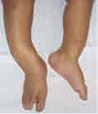

**Rickets**

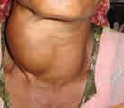

### A balanced diet

All that we consume during the day is together called our ‘diet’. A diet containing adequate quantities of all nutrients is called a Balanced Diet.

To build a strong and healthy body, you need all nutrients in the right proportion and in sufficient quantities in your daily diet.

Significance of a balanced diet :

* An increased capacity to work.
* Good physical and mental health.
* Increased capacity to fight / resist diseases.
* Helps in proper growth of the body.

**Goitre**

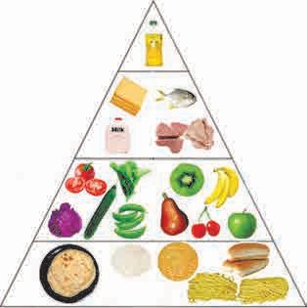**Fatty substances (oil, ghee, butter)**

**Milk products, meat, fish, eggs**

**Fruits and vegetables**

**Cereals and pulses**

* 1. **: The balanced diet pyramid**

Apart from having a balanced diet, we also need to exercise regularly to keep ourselves fit and healthy.

### How to get a balanced diet ?



**Always remember...**

If our need for nutrients is met through the food we eat, the nutrients are better utilised in our body. Hence, the best way to good health is taking a balanced diet and avoiding the deficiency of any nutrient.

To ensure that we get a balanced diet from the food we eat, we can make a food pyramid. All food which we eat is classified into various groups. The space allotted to each food group in the pyramid, depends upon the proportion in which it should be included in our diet. Hence, we can choose foods from each group daily according to the space allotted to it in the pyramid.

If we choose some items from each group in the right proportion according to the pyramid shown on page 53, we can make sure that we are getting a balanced diet.

#### Fibre

If we select a daily diet which includes vegetables, fruits, sprouts and cereals according to the pyramid, we will also get fibre in sufficient quantity.



**Can you recall ?**

What trouble do we have to face if we do not get enough fibre from our daily diet ?

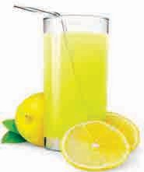What care must be taken to make sure that fibre is not lost or removed from the food we eat?

#### Water

Alongwith all the other nutrients, the body also needs an adequate supply of water. For this purpose, we must drink milk, buttermilk, lemon juice, sherbets, fruit juices and plenty of water.

### Malnutrition

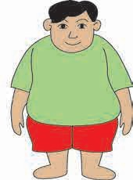

**Malnutrition** occurs when all the nutrients that the body needs are not obtained in the proper proportions from the diet. This happens when a person does not get sufficient food or when the diet is not balanced. If one’s diet exceeds one’s need, it is called **overnutrition**.

* 1. **: Malnutrition and overnutrition**

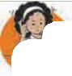

**Use your brain power !**

Choose a balanced diet for one day according to your preferences.

### Adulteration of food

In order to earn more profits, cheaper substances of low quality are mixed with the foodstuffs. These substances are called adulterants and adding them to foodstuffs is called **adulteration of food**. Adulterants may even be poisonous or harmful to health. Such adulterated food is impure and harmful and so unfit for consumption.

#### Adulterants

Adulterants used to adulterate food are such that they will remain unnoticed even when mixed with the food.

### How to avoid obesity ?

✓

**Junk food**

Chocolates, noodles, burgers, pizzas, chips, bottled soft drinks, attractively packaged snacks as also ready fried foodstuffs available in the market such as *wadas, pakodas,* etc. are very tasty and we like them very much. However, these foodstuffs contain refined flour, sugar, oil in large proportions. When refined flour, is made from wheat or when sugar is made from sugarcane, many nutrients in the wheat or sugarcane are lost in the process. Hence, all we get from these foods is energy and our hunger is satisfied.

Naturally, if we eat a lot of junk foods, we will get insufficient quantities of the items from other food groups. If this happens frequently, our body soon experiences a shortage of proteins, vitamins and minerals and that may lead to malnutrition.

Junk food eaten frequently also causes obesity. Obesity is not good for our health.

As such foods do not supply all the necessary nutrients, they are called **junk foods**.

* Have a balanced diet.
* Eat whole grains. Eat fruits and vegetables with their skins.
* Increase use of bicycles
* Play more outdoor games

✗

* Do not eat if you are not

hungry.

* Do not watch TV while eating.
* Do not use motor vehicles for travelling a short distance.
* Avoid precooked, packaged foods.
* Pepper corns Papaya seeds
* Ice-cream Washing soda,

paper pulp

* Rice Small white stones
* Peanuts Reddish pebbles/stones

Water, chemicals like urea, starch

Brick powder,

powdered pumpkin

* Milk
* Chilli powder

**Adulterants**

**Food Items**



**Always remember....**

Adulteration of food is a crime. Do not eat adulterated foods.

#### What we have learnt-



* Nutrition is the process of taking food and water and using them to obtain energy, and for the purposes of growth and other bodily functions.
* A diet containing all nutrients in the right quantity is called a balanced diet.
* Carbohydrates, fats, proteins, vitamins, minerals and fibre are the nutrients in food. A balanced diet includes all

nutrients in the right quantities.

* The food pyramid helps us to choose a balanced diet.
* Whether a person is malnourished or has deficiency diseases depends upon the proportions of food taken.
* Junk food gives us energy but not other nutrients.
* Adulterated food is impure and harmful to health.

1. **Fill in the blanks.**

**Exercise**

**3. Choose the correct alternative.**

* 1. The process of intake of food and

utilising it for all life processes is called ………. .

* 1. All the substances in our food which are useful for various bodily processes are called ………. .
  2. Carbohydrates and provide

… to our body.

* 1. In a balanced diet, all the nutrients are present in the proportion.
  2. In the food pyramid, cereals are given the maximum space because they fulfil our requirement.
  3. Intake of more food than necessary causes ………. .

#### Spot the following in the table of

**vitamins and minerals.**

* 1. The nutrient present in citrous fruits.
  2. Vitamins / minerals present in milk.
  3. Causes and symptoms of night blindness, scurvy, rickets, beriberi.
  4. Foods required to prevent the above diseases.
  5. Causes of anaemia.
  6. Essential mineral for healthy bones and teeth.
  7. Sensory organ affected due to the deficiency of Vitamin A.

1. Pulses are a very good source

of ………. .

* 1. carbohydrates (2) proteins

(3) fats (4) minerals

1. ………. provide maximum energy to the body.
   1. Cereals (2) Leafy vegetables

(3) Water (4) Amla

1. Goitre is caused by a deficiency of the mineral ………. .
   1. iron (2) calcium

(3) iodine (4) potassium

1. is a type of junk food.
   1. Orange (2) Milk

(3) Bhakri (4) Chocolate

#### Use the food pyramid to select food items of your choice for three days. Conditions :

* 1. The diet for all three days should be balanced.
  2. There should be variety in the items chosen for the three days.

**Activity :**

* Obtain information on simple methods of spotting the adulteration in foodstuffs and try them out.





**8.**

**Our Skeletal System and the Skin**



**Can you recall ?**

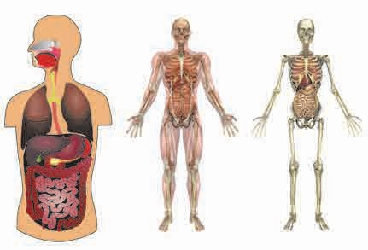Which organ systems do you see in the figure alongside ?

In the previous classes, we have learnt about some organ systems, their functions and their locations in our body. With the help of that, complete the following table.

|  |  |  |
| --- | --- | --- |
| **Name of**  **the organ** | **Function of**  **the organ** | **Body**  **cavity** |
| Heart |  |  |
| Lungs |  |  |
| Intestines |  |  |
| Brain |  |  |

Sometimes when we fall while playing or have an accident, a bone in our arm or leg may get broken. This is called a **‘fracture’** of the bone.

A fracture in a bone causes severe and unbearable pain and the part with the broken bone swells immediately.



**Can you tell ?**

Your friend meets with an accident and a bone in his leg is fractured. How will you help ?

* 1. **: Organ systems and the human skeleton**

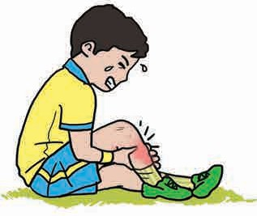

The various organs are safe within the body cavity. The human skeleton is a protective shell for all the internal organs.

* 1. **: A boy with a fractured bone**

After an accident, prevent any movement of the fractured part. Immobilize it and get immediate medical help. After going to the hospital, an ‘X-ray’ image is taken of the part which is swollen.

‘X-rays’ were discovered by Wilhelm Conrad Roentgen.

**A fractured bone**

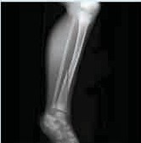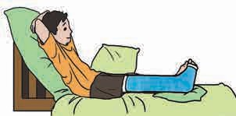

**Plaster**

* 1. **: An X-ray image**



**Let**’**s try this.**

An X-ray image shows whether a bone is broken and also the exact spot where it is broken. This helps in providing the proper treatment.

Let’s identify our bones.

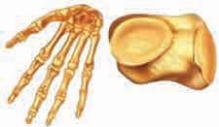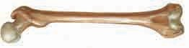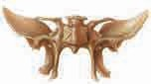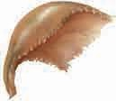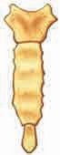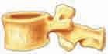

**Types of Bones :** Bones of our body

are classified into four types.

**1. Flat bones**

**2. Small bones**

**3. Irregular bones**

**4. Long bones**

1. Place your hand at the centre of your chest and your friend’s back.
2. What is the name of the hard part you feel on placing your hand on your chest ?
3. Do you feel some hard bumps on the back ? What are they called ?
4. What difference do you notice between the bones of the back and those of the chest ?

### The human skeletal system

All the bones in our body are not of the same shape. Every bone is different. All the bones together form a framework or skeleton. The skeleton gives a shape to the body.

All the bones of the body along with cartilage together form the skeletal system.

Bones are hard. They are not flexible. Bones are composed of two main constituents. Bone cells are biotic, while calcium carbonate, calcium phosphate, minerals and salts are the abiotic constituents of bones. Calcium imparts strength to the bones.

The system which gives a definite shape to the body, provides support and protects the delicate organs inside the body is the skeletal system.

Can you identify the animals from the pictures of their skeletons ?



**Can you tell ?**

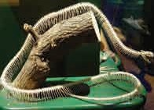

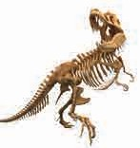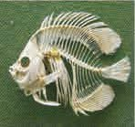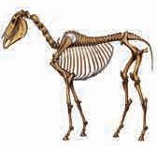

* 1. **: Skeletons of various animals**



**Try this.**

Take a measuring tape and measure the length of the bones of your arms and legs. Do the same for your friend/ sister/ brother. Record the measurements in the table below and compare them.

|  |  |  |  |  |
| --- | --- | --- | --- | --- |
| Bones | Length of bones in cm. | | | |
| Self | Friend | Brother | Sister |
| 1. Arm   bones   1. Leg   bones |  |  |  |  |

The human skeletal system can be divided into two parts : the axial skeleton and the appendicular skeleton.

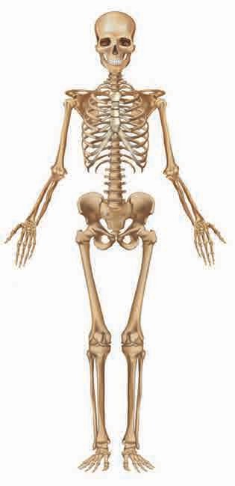

**Skull**

**Rib cage**

**Spine**

**Arm**

**Leg**

**8.5 : Parts of the human skeletal system**

The axial skeleton consists of the skull, the spine and the rib cage. These are situated symmetrically along the central vertical axis of the body.

The appendicular skeleton is made up of the bones of the upper and lower limbs (arms and legs) on either side of the central axis.

As our body grows, the size and length of our bones increases. Such changes in size and length can be seen in children according to age. However, the body

continues to grow only up to a certain limit. The bones of taller people are longer.

### The axial skeleton

**Skull :** The skull is formed by the bones of the head and face. The bones of the skull are flat and strong. There are altogether 22 bones in the skull, 8 in the head and 14 in the face. Except for the lower jaw, none of the bones of the skull can move.

Which organs of our body does the skull protect ?

**Rib cage :** Feel the left and right sides of your chest with your hand or finger. How many bones can you feel altogether on the two sides ?

Check in the centre. How many bones do you feel ? The cage-like structure in the chest is calld the **rib cage**. In the chest, there is one vertical, flat bone called the **sternum**. Twelve pairs of flat bones called ribs are joined to it sideways. These 25 bones form the rib cage.

It is joined to the spine at the back.

**The Spine (Backbone or Vertebral Column) :** The spine is formed by padlock-shaped bones placed straight one above the other. There are altogether 33 bones in the spine, each called a vertebra. These bones are arranged one above the other flexibly. The spine protects the spinal cord that originates from the brain.

What would have happened if we didn’t have a

**Skull/ Cranium**

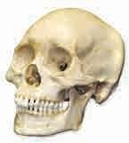**Lower jaw/ Mandible**

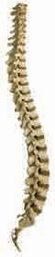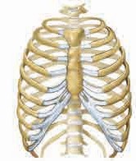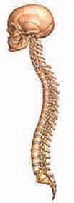

**Rib cage**

**Back bone/ Vertebral column**

backbone ?

### The appendicular skeleton

**Vertebrae**

The human body has two arms and two legs. The different parts of the arms and legs have several bones, which are connected together by joints.

* 1. **: Skull, rib cage and spinal column**

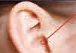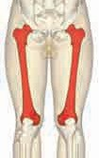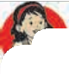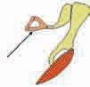

**Do you know ?**

There are three bones in each of the ears. Of these, the stirrup is the smallest bone in our body. It is as small as a grain of rice and is hollow. Its shape is like that of a stirrup.

In the human body, the longest and strongest bone is the thigh bone or the **femur**.

**Stirrup**



**Observe and discuss.**

Observe a human skeleton in your school laboratory or a picture of the skeleton and classify the bones in our body into four types. Discuss the functions of these bones.



**Try this.**

Move the different parts of your body from the head to the toes and observe the different places at which they can bend or turn.

The bones in our body are connected to each other by means of ligaments.

**Joints :** Joints are the places where two or more than

two bones are connected to each other. Joints are of two types.

### Joints

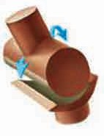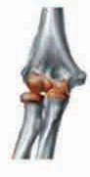⭣ ⭣

**Movable Joint** Bones can move. Examples : bones of arms and legs

**Immovable Joint** Bones cannot move. Example : bones of the skull.

(Other than the lower jaw)

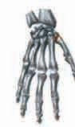

#### Types of joints

Let us study some types of movable joints.

* 1. **Hinge joint :** This type of joint allows the movements of bones only in one direction. It moves in a 1800 angle. Examples : the elbow and knee joints.
  2. **Ball and socket joint :** In this type of joint, the bones can move in two or more directions - in a 3600 angle. Examples : shoulder and hip joints.
  3. **Gliding joint :** In this type of joint, the bones can only slide over each other. Examples : wrist and ankle joints.

**Hinge joint**

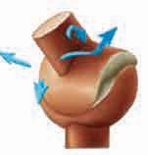

* 1. **: Some types of joints**

**Gliding joint**

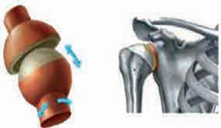

**Ball and socket joint**



**Can you recall ?**

Which organ helps us to sense whether something is hot or cold, rough or smooth, etc. ?

**Functions of the skin**

1. Protecting the internal parts of the body like muscles, bones,

organ systems, etc.

1. Help preserve the moisture in the body.
2. Synthesizing vitamin ‘D’.
3. Releasing sweat to regulate body temperature.
4. Giving protection from the heat and cold.
5. The skin functions as the sensory organ of touch.

### The skin

The skin is an important and large organ of all living things. The skin has hair. There are nails on the skin at the tips of the fingers and toes. The skin gives us the sense of touch. The skin is an important sensory organ of the body.

**The outermost covering of the body is called skin.**

#### The structure of the skin

Human skin is made up of two main layers. The outermost layer is called the **epidermis** and the layer below it is called the **dermis**. Below the dermis, there is a network of blood vessels and nerve fibres. The subcutaneous layer under this network maintains normal body temperature. The epidermis has various layers.

**Epidermis Dermis**

**Subcutis**

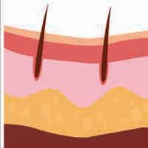

(Hypodermis)

* 1. **: Structure of the skin**



**Can you tell ?**

What happens when we walk or play in the hot sun ?

**Melanin**

A pigment called melanin is present in the cells of the epidermis. The melanin is synthesized in certain glands in the skin. The percentage of melanin decides the fairness or darkness of the skin. The colour of

the skin also depends on the climate. Melanin protects our skin and the inner parts from ultraviolet sunrays.

When we walk or play in the sun, we get tired, but at the same time our skin becomes wet. This is because of **sweat**. In the skin, there are glands which secrete sweat. They are called **sweat glands**.



**Use your brain power !**

1. Which colour of the skin will give greater protection from the sun’s rays ?
2. How does sweating help to lower the temperature of the body ?

After playing in the hot sun or after hard physical labour, the temperature of the body rises. Then sweat is released. It helps to reduce the temperature of the body. Our body temperature usually remains constant at approximately 370C.



**Observe and discuss.**

Observe your skin and the skin of your grandmother, grandfather or any old people in the house.

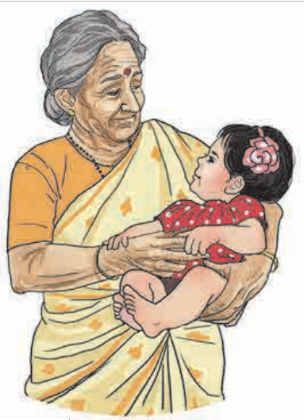

**Always remember...**

For the health of our skin, it is important to keep it clean.

Discriminating between people based on their skin colour is unscientific and wrong. Avoid the temptation of using artificial means to become fair.

What difference do you notice ?

As we grow older, the proportion of fat beneath the skin reduces. However, the previously taut skin does not shrink. This causes wrinkles on the skin of older people.

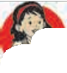

**Do you know ?**

It is melanin that determines the colour of our hair, too. Jet black hair is due to pure melanin, while brown, lighter hair is due to sulphur in the melanin and reddish hair, due to iron in the melanin.

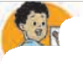

**What we have learnt-**

* All the bones in the body along with the cartilage together form the skeletal system.
* The skeleton gives shape and support to the body.
* The outer covering of the body is called the skin.
* The skeletal system and the skin perform the important function of protecting the body and the internal body parts.
* We must take care of our skeletal system and skin.
* The skull, the rib cage, the backbone and the bones of the arms and legs are the main parts of the human skeletal system.
* Epidermis and dermis are the two main layers of the human skin.



**Exercise**

#### Fill in the blanks with the proper word.

* 1. The place where two or more bones are connected is called a .............. .
  2. Cells of the epidermis contain a pigment called .............. .
  3. ...................... and ......................

are the two layers of the human skin.

* 1. The human skeletal system is divided into parts.

#### Match the pairs.

**‘A’ ‘B’**

1. Ball and socket joint (a) Knee
2. Hinge joint (b) Wrist
3. Gliding joint (c) Shoulder

#### Right or wrong ? If wrong, write the correct sentence.

* 1. Bones are soft.
  2. The human skeleton protects the internal organs.

#### Put a ☑ mark at the proper places.

* 1. The system which gives a definite shape to our body.
     + Excretory system
     + Respiratory system
     + Skeletal system
     + Circulatory system
  2. The ................ joint is seen in fingers and toes.
     + Hinge joint
     + Ball and socket joint
     + Immovable joint
     + Gliding joint

#### Answer the following questions in your words.

* 1. What are the functions of your skin ?
  2. What should you do to keep your bones strong and healthy ?
  3. What are the functions of the human skeletal system ?
  4. Which are the various reasons due to which our bones might break ?
  5. What are the different types of bones ? How many types are there ?

#### What will happen if - ?

* 1. There are no joints in our body.
  2. There is no melanin pigment in our skin.
  3. Instead of 33 vertebrae in our body, we had one single and straight bone.

#### Draw diagrams.

* 1. Types of joints
  2. Structure of the skin

**Activity :**

* Collect pictures of the different parts of the human skeletal system and paste them on chart paper. Write the functions of each, too.
* Collect the pictures, newspaper cuttings, etc. which show the skeletal systems of various animals and observe the differences between them.



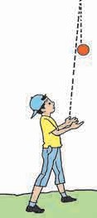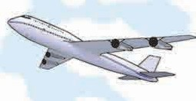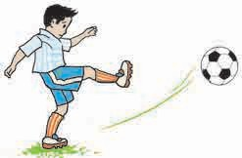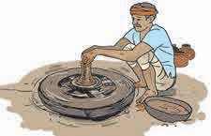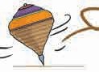

**9.**

**Motion and Types of Motion**

**Observe and discuss.**

**9.1 : Objects in motion**

In our day-to-day life, we see many moving objects. Moving objects are said to be objects in motion. Discuss which objects in the above pictures are in motion. What differences are seen in their motion ?

### Motion

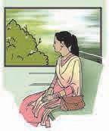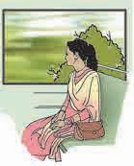While waiting for a bus at a bus-stop, other vehicles appear to be in a state of motion. On the other hand, when you are in motion yourself, a still object appears to be moving. For example, the trees are seen to run backward while you are travelling in a train. If an object is seen by an observer to change its place continuously, the object is said to be in motion. Change

of place of an object is called displacement. An object in motion continuously undergoes displacement.

**9.2 : Backward motion of object**

**The continuous displacement of an object is called motion.**

### Types of motion

#### Linear motion

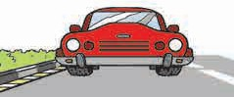

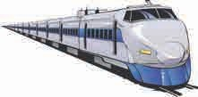**9.3 : Linear motion**

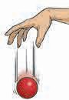A train or a moving vehicle on a road may travel in a straight line or in the same direction. This motion of an object is called linear motion. An object in linear motion shows displacement along a straight line.

If you stand on a chair and release a ball from your hand, it falls to the floor. What do you conclude from this ?

Compare the motion of soldiers on parade and a girl coming down a slide.

The motion of soldiers in a parade is the same. During that period, not even a slight difference is seen. However, the motion of the girl coming down the slide does not appear to be uniform. The girl comes down faster and faster. The speed of her motion goes on increasing continuously.

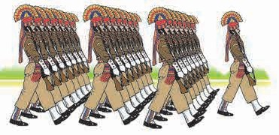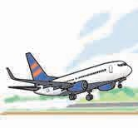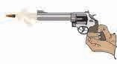

**9.4 : Comparing linear motion**

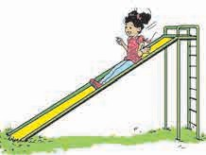The motion of the marching soldiers is ‘uniform linear motion’, because in this motion no change is seen. On the other hand, the motion of the girl coming down the slide is ‘non-uniform linear motion’.

These are the two main types of linear motion.

#### Uniform linear motion

When the distance traversed by an object along a straight line in unit time is continuously the same, the motion is called uniform linear motion.

#### Non-uniform linear motion

When the distance traversed by an object along a straight line in unit time keeps on changing, the motion is called non-uniform linear motion.

1. **Non-linear motion :** The motion of an object that does not move in a straight line is called ‘non-linear motion’. Non-linear motion may be of the following types.

What kind of movement does a swing in a park show ?



**Can you tell ?**

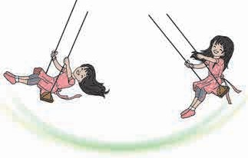The swing always comes back from one end to the other end. It takes about the same time for each swing or oscillation. This movement of a swing is called **oscillatory motion**. Similarly, the movement of the pendulum of a clock, the wings of a bird, the needle of a sewing machine, the vibrating diaphragm of a *tabla* or drum are also examples of oscillatory motion.

**9.5 : Oscillatory motion**

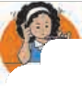

**Use your brain power !**

In which musical instruments can you see oscillatory motion ?

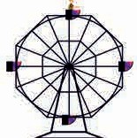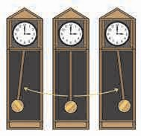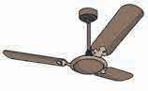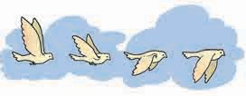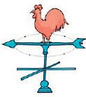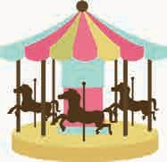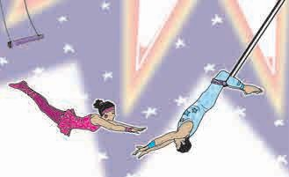

The motion of a body that is oscillating, i.e., swinging back and forth, is called oscillatory motion.

**Observe and discuss.**

**9.6 : Examples of non-linear motion**

The hands of a clock move in a circular manner. Similarly, a fan, a giant wheel, and a merry-go-round complete each round along a circular route. In our day-to-day life we come across many examples of objects that trace a circular path.

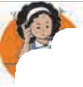

The motion of an object which passes through a certain point again and again after a fixed period is called periodic motion.

**Use your brain power !**

Which types of motion are seen when a girl rides a bicycle as shown here ?

The motion of an object along a circular path is called circular motion.

Which other examples of circular motion can you give ?

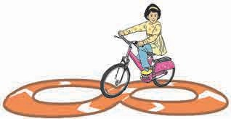We see from these examples of oscillatory motion and circular motion that some objects complete one round or one oscillation in a fixed period of time. For example, the minute hand of a clock completes one round in exactly

60 minutes every time, while a merry- go-round also completes every round in the same period of time. Such motion is called **periodic motion**.

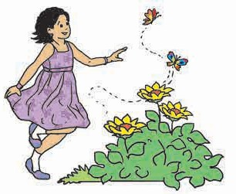 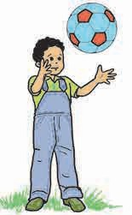

**9.7 : Children playing in a garden**



**Can you tell ?**

While chasing a butterfly in a garden, do you run along a definite path or in the same direction all the time ? Not really.

**The motion that changes its direction and speed continually is called random**

**motion.**

A butterfly constantly flits from one flower to another. There is no definite direction to its motion. Such motion is called **random motion**.

The motion of the players in a game of football is also of this type. The motion of a crawling baby or a wandering animal is also random motion.

### Speed

**The distance traversed by an object in unit time is called the speed of that object.**

Distance traversed

Speed =

Time required for traversing the distance

**Unit of speed :** kilometre/hour, metre/second

A bus covers the distance of about two hundred kilometres from Solapur to Pune in five hours. How much distance does the bus cover in one hour ?

While solving this example, we take the ratio of the distance traversed and the time required to traverse that distance.



**Always remember...**

A moving object may not have only one type of motion.

From this ratio, we come to know the distance traversed by the bus in one unit of time.

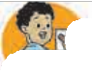

**What we have learnt-**

* Objects in motion are those that change their position continuously.
* The various types of motion are linear, uniform linear, non-uniform linear, oscillatory, circular, periodic and random motion.
* The distance traversed by an object in unit time is called its speed.
* The time required to traverse a certain distance depends on the speed of the object.



**Exercise**

#### Identify the types of motion.

* 1. Movement of the earth around the sun : …….... .
  2. Movement of a ceiling fan : ……....
  3. A meteor falling from the sky :

…….... .

* 1. A rocket launched from the ground : ……....
  2. A fish swimming in water : ……....
  3. The plucked string of a sitar : …....

#### Fill in the blanks.

* 1. If a ball is released from the terrace of a building, it comes down in …........ motion. On the other hand, it reaches the ground in

… motion if it is thrown with

force away from the terrace in a direction parallel to the terrace.

* 1. The motion of an aeroplane on the runway before take-off is…....... .
  2. The kite looking for its prey flies with motion in the sky.
  3. Children sitting in a rotating giant wheel have motion, while

those sitting in a merry-go-round have a motion.

(Linear, non-linear, circular, uniform linear, non-uniform linear, uniform circular, non-uniform circular, random)

#### How are we different ?

* 1. Oscillatory motion and linear motion.
  2. Linear motion and random motion.
  3. Random motion and oscillatory motion.

#### Explain in your own words, giving one example each.

* 1. Linear motion
  2. Oscillatory motion
  3. Circular motion
  4. Random motion
  5. Periodic motion

#### 5 Answer the following questions in your own words.

1. Which types of motion are seen in birds flying in the sky ?
2. Write in detail about your experience of various types of motion while riding a bicycle on a road.

#### Complete the puzzle using words for types of motion :

* 1. a spring is stretched and one end is released
  2. a minute hand
  3. a see saw

(4-5) children in a march past

(6) a stone rolling down a hillside.

1

2

3

4

5

6

**Activity :**

* Make a list of various moving objects in the environment, and discuss the types of motion seen in them.





**10.**

**Force and Types of Force**

* 1. **: Various actions**

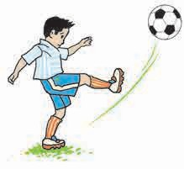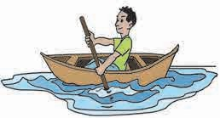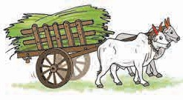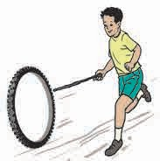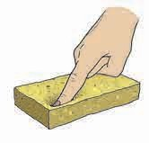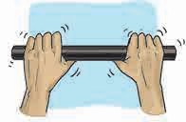

**Observe and discuss.**

1. Will a boat move ahead unless pushed with the help of an oar ?
2. Who exerts force to move a bullock-cart forward ?
3. What makes the ball move during a game of football ? How does its direction change?
4. Will the wheel go forward if it is not pushed with a stick ?

When we kick the football coming in our direction, towards the goal, we apply force. In day-to-day life, we do many actions such as lifting, pulling, riding a bicycle and stopping it at times, pushing a load, squeezing or bending something and driving vehicles. It is necessary to apply force for doing all these actions. Force is applied to an object to pull it or push it in any manner.

**No object changes its position on its own. Force is required to move an object.**

**Force is used to change the direction of an object in motion, or to stop it.**

#### Can you tell ?

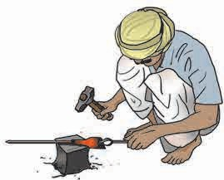

1. What happens when you hold the two ends of a spring and pull them apart ?



1. What happens when a blacksmith hammers a red hot piece of iron?

#### Force is necessary to change the shape an object.

* 1. **: Changing the shape of on object**

### Types of force

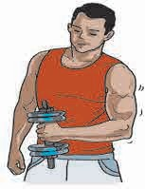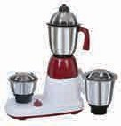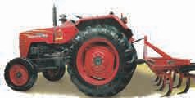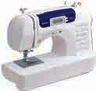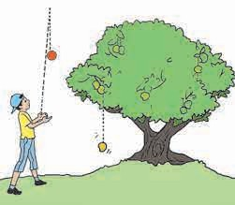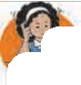

#### Muscular force

In all the actions shown in the picture 10.1, the movements take place with the help of the bones and muscles in the body. The person in the picture alongside is lifting the weight by using muscular force.

**The force applied with the help of muscles is called muscular force.**

#### Use your brain power !

For which tasks in your day-to-day life do you use muscular force ?

#### Mechanical force

We use different machines for doing many tasks. Muscular force is used for running some machines. Some machines are run by using electricity or fuel. Machines like the latter are called ‘automatic machines’, because a mechanical force is used here. For example, sewing machine, electric pump, washing machine, mixer, etc. Make a list of other such machines.

#### The force applied by means of a machine is called mechanical force.

* + 1. **Gravitational force**

If an object is thrown upward by applying force, it reaches a certain height and comes down again. Why is this so?

Why do fruits on trees fall to the ground ? The earth pulls all the objects towards itself.

* 1. **: Lifting a weight**
  2. **: Machines**
  3. **: Falling down of a ball and a mango**

**The force applied by the earth to pull objects towards itself is called gravitational force.**

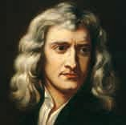

**In the past ...**

Sir Isaac Newton discovered gravitation in the 17th century. The earth’s gravitational force acts in a direction opposite to that of an object moving upwards. Hence, the speed of that object goes on decreasing till in the end it becomes zero. Then the object starts falling down instead of going up any further. While falling, its speed goes on increasing all the time due to gravitational force.



**Let’s try this.**

1. Take a small stone and a bucketful of water. Drop the stone into the water from a height of about 20 cm. You will hear the sound of the stone dropping in the water. Now drop the same stone into the water from a height of about 100 cm. You will hear its sound again.

What is the difference in the sounds in the two actions above ? What can we conclude from this ?

1. The actions of lifting a sack are shown in the picture. One sack looks empty, the other one is full. What difference do you notice in the way the two sacks are lifted ?

The gravitational force on the empty sack is less, that is to say, it weighs less.

The gravitational force on the bigger sack is greater. In other words the bag weighs more.

#### Greater force must be applied to lift a greater weight.



**Do you know ?**



**Find out and discuss.**

To weigh an object, it is hung from the hook of a spring balance.

The suspended object is pulled downwards

* 1. **: Dropping a stone in water**

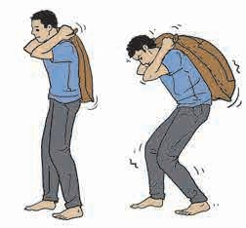

* 1.** 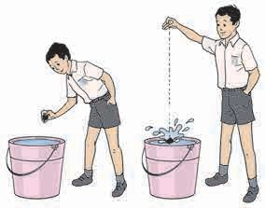: Carrying a load**

The gravitational force operates

by the force of gravity. At the same time, the force of the tension in the spring constantly pulls the object upwards.

The object comes to rest when the tension in the spring and the gravitational force on the object become equal. In this position, the scale on the spring balance shows the gravitational force acting on the object which is the weight of the object. The gravitational force acting on an object is called the weight of that object.

#### 4. Magnetic force

between the sun and the planets in the solar system. Because of this, the planets revolve around the sun. At the same time, gravity also operates between planets and their satellites. Then, why don’t all the planets and satellites fall towards the sun ?

#### Use your brain power !

Which forces are acting upon an aeroplane taking off into the sky ?

Place a magnet on a table. Take a big iron nail towards the magnet. It sticks to the magnet. Now hold the magnet upright in the air, away from the nail. What happens ?

**The force exerted by a magnet is called magnetic force.**

#### Frictional force

* 1. **: Frictional force**

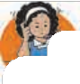

#### Use your brain power !

Why is powder sprinkled on the carrom board while playing carrom ?

When a carrom piece is flicked lightly, it slides over the carrom board, but stops at a certain distance.

A ball rolling over a flat ground stops at a certain distance. Why does this happen ?

When two surfaces rub against each other, the force of friction comes into play. It always acts against the direction of motion.

When a brake is applied while riding a bicycle, it stops after running a short distance. How does the brake work ? Between which parts is friction produced ?

#### Try this.

Take two pieces of smooth paper and two of sandpaper and rub them against each other. What do you notice ?

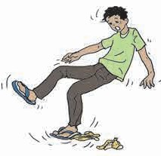The smooth surfaces can be easily rubbed against each other because the force of friction between them is less, while rough surfaces cannot be easily rubbed against each other because the force of friction between them is much greater.

It is possible for us to walk on the ground only because of the force of friction. If there is no friction, we would slip and fall. For example, we are very likely to slip while walking on an oily or wet floor.

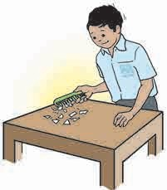Why is a wooden plank laid down for pulling out a car which is stuck in mud?

A force of friction is generated between the wheel and the wooden plank laid down under the car. Hence, it can be pulled out from the mud. In short, the force of friction can either be decreased or increased as desired.

#### Electrostatic force

1. Spread small pieces of paper on a table. Rub a piece of thermocol or an inflated balloon against silk cloth and bring it near these pieces.
2. Rub a plastic comb against dry hair and repeat the above activity.
3. Rub a peacock feather between two pages of a notebook and bring it near your fingers. What do you see ?

In the above activities, the pieces of paper, hair, and the peacock feather are seen to move. Why does this happen ?

* 1. **: Electrostatic force**

Static electricity is produced on materials like rubber, plastic and ebonite due to friction. The force exerted by such electrically charged materials is called **electrostatic force**.

**Combined forces :** While an action is taking place, various types of forces act on the object in question. You might have seen a roller coaster or the juggling of a sail board on the seashore. A variety of forces act together in these cases. To obtain more information about these, type the words ‘Trick Science’ in Google search on the Internet.



**A little fun !**

Cut out fish shapes from coloured plastic sheets. Fix a pin on one side of the fishes. Take water in a big deep plate. Release the fishes in it. They will float on the water. Take a magnet and move it around over the water.

Can you make other games like this ? What makes such games possible ?

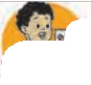

**What we have learnt-**

* Force is required to bring about any action. Force is necessary for making an

object move, to change the direction of motion and also to change the shape of an object.

* There are various types of forces such as muscular force, mechanical force, gravitational force, magnetic force, frictional force and electrostatic force.



**Exercise**

#### Choose the term to fill in the blanks.

(a) …… has to be applied to change

#### Match the following :

**Group ‘A’ Group ‘B’**

the ….. of a …… object. (moving, direction, force)

* 1. When an elephant drags a wooden log over the land, the forces that are applied on the log are …… ,

……. and …….. .

(muscular force, mechanical force, gravitational force, frictional force)

* 1. A ball was set rolling on a large table. If its …… is to be changed,
     1. An ox pulling a cart
     2. Lifting a heavy iron object with a crane
     3. Weighing with

a spring balance

* + 1. Applying brakes to a bicycle
    2. Picking up pieces of paper with a plastic scale

1. Magnetic force
2. Electrostatic force
3. Muscular force
4. Gravitational force
5. Frictional force

a will have to be applied on

it.

(force, motion, gravitation)

* 1. The force of friction always acts

… the motion.

(along, against)

#### One or more forces are acting in the following examples. Name them.

1. An object falling from a tall

building ….

1. An aeroplane flying in sky ….
2. Squeezing sugarcane juice with a squeezer ….…. .
3. Winnowing foodgrain ……. .

#### Explain in your own words giving one example each.

Muscular force, gravitational force, mechanical force, electrostatic force, the force of friction and magnetic force.

#### Why ?

* 1. Machines are oiled from time to time.
  2. An object thrown upwards comes down after reaching a point.
  3. Powder is sprinkled on a carrom board.
  4. The ramp at a railway station has a rough surface.

#### In what way are we different?

* 1. Muscular force and mechanical force.
  2. The force of friction and gravitational force.

#### Write answers to the following questions in your own words.

* 1. What are the things that can be done by applying force ?
  2. What is meant by weight ?
  3. Which machines run on muscular force ?

#### Solve the following crossword puzzle.

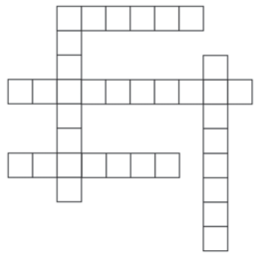

1

2

3

4

**Down :**

1. force is to be applied to push a

scooter that has failed.

1. force can be used to pick up

scattered pins.

#### Across :

(1) A pulls an iron nail towards

itself.

1. .......... force was used when the farm was ploughed with a tractor.
2. It is due to the force of that

raindrops fall to the ground.

**Activity :**

* Collect more information about the various forces that are used in our day-to-day life.
* Make a list of such actions where many forces are applied simultaneously.



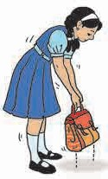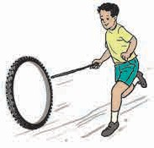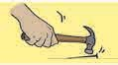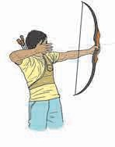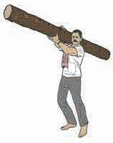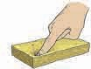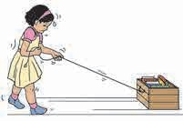

**11.**

**Work and Energy**

**Observe.**

1. What actions are seen in the picture ?
2. Is a force being applied while doing each action ?
3. In the various actions in the picture, has the object changed its original position ?

**11.1 : Various actions**

In the above picture, we see that the position of some of the objects has changed.

That is, these objects are displaced.

When an object is displaced by applying a force on it, work is said to be done.

### Work

* 1. Tie a string to an empty box, as shown in the picture.
  2. Pull the box through a distance of 10 metres along a straight line.



**Try this .**

* 1. Now fill the same box with 20 books.
  2. 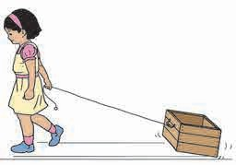Pull the box again through a distance of 10 metres in a straight line. What was your experience this time ?
  3. Now pull this loaded box through a straight distance of 20 metres.
  4. When did you feel that more work was done ?



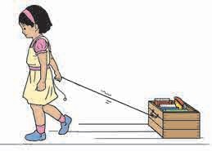

* 1. **: Pulling a box**

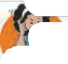

More work is done for the same displacement, when more force is applied to do the work. If the same force is

applied for more displacement, more work is done by the force.

**Use your brain power !**

1. In the above activity, which are the different forces acting on the box ?
2. Is a displacement possible without a force ?
3. If a force is applied with both the hands on a wall, will there be a displacement ?
4. If no displacement occurs on applying a force, what does it indicate ?



**Let’s try this.**

Take a pulley. Fix it at a height. Draw a string over the pulley. Tie a load of two kilograms at one end. Hold the other end of the string and pull it downwards to lift the load, first up to a height of one metre, and then up to a height of four metres. When is more work done ?

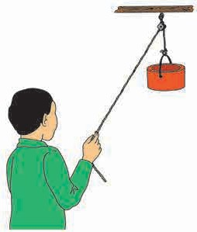

**4m**

**2m**

* 1. **: Using a pulley**

When the applied force is the same, more work is done when there is greater displacement. In other words, for

measuring the work, both the force and the displacement must be considered.

### The relationship between work and energy

The boy in the picture has applied a force to the toy car. Work has been done because the force applied to the car has caused displacement. In other words, transformation of the boy’s energy into work has taken place through the applied force.

Run around the ground with your friends. Can your friends run as many rounds as you can?

Do all the friends have the same capacity for running?

Your friends will complete either more or less rounds than the number of rounds you complete. The number of rounds will not be the same. Some will get tired on completing two rounds, while others will get

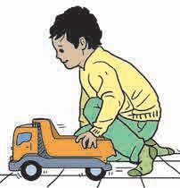

* 1. **: A boy pushing a car**

tired on completing three or four rounds. That is to say, each one’s capacity to complete rounds is not the same. You can complete only as many rounds as you have the capacity for. The capacity to do work is called energy.



**Use your brain power !**

1. Why do you get hungry after physical exercise ?
2. From where does our body get energy ?
3. Why do we get tired ?



**Do you know ?**

The units of work and energy are the same. Work and energy are both measured in the unit named Joule in

S.I. (System International) units.

### Forms of energy

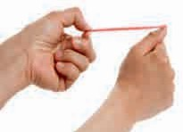

* + 1. **Mechanical energy**



**Can you tell ?**

#### What will happen as a result of the action in the picture ?

* + - 1. The rubber band is released after stretching it.
      2. A stone is held in the rubber of a catapult, the rubber is stretched and released.

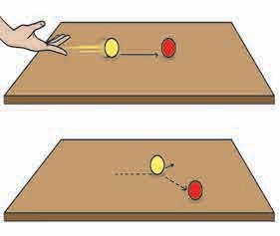In the above examples we see that when the rubber of a catapult is stretched and released, it comes back to the original state and the stone flies off. Similarly, when the spring of a toy is wound and then released, the toy starts playing. When water stored at a height is made to fall on a wheel, the wheel starts rotating. In each of these actions, displacement takes place, which means that work is done. From where is the energy obtained to do this work ? The energy which is stored in an object due to a specific state or position of that object is called **potential energy**.

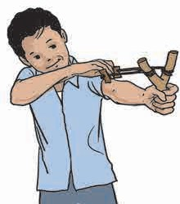

* 1. **: Potential energy**



**Let’s try this.**

1. Take two balls. Let one of them stand stable at the centre of a table.
2. Place the second ball on the table and push it so that it hits the first ball.
3. What happens when the second ball hits the first one ?
4. From where did the second ball get the energy to set the first ball in motion ?
   1. **: Kinetic energy**



**Can you tell ?**

1. In the game of marbles, from where does one marble get energy to set another marble in motion ?

The energy used for doing mechanical work is called mechanical energy. There are two types of mechanical energy, namely, potential energy and kinetic energy. Potential energy is obtained due to position and kinetic energy, by motion.

1. While playing carrom, from where does the striker get the energy to make the pieces move ?

We give energy to the marble or the striker and set them in motion. The energy obtained from motion is called **kinetic energy**.

* + 1. **Heat energy**

The earth receives heat in proper quantities from the sun. That is how an atmospheric temperature favourable to the living world is maintained. Heat is a form of energy. Sunlight contains heat energy.

Heat is produced by burning of fuel. Heat energy is used in the kitchen all the time. Heat is measured in the unit ‘Calorie’.

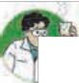

**Let’s try this.**

1. Take a convex lens and hold it over a sheet of paper in sunlight.
2. Now, move the lens in such a way that there is a tiny spot of light on the paper.
3. Hold the lens in this position for a while. What happens ?
   * 1. **Light energy**



**Collect information.**

1. Generally, grapes which appear in the market during December and January are sour. However, in March-April the grapes are sweet. Why is this so ?
2. How does a picture appear on the screen of a TV, mobile, laptop and a cinema theatre ?

We have learnt that plants make their own food with the help of sunlight. It means that light energy is transformed into the energy in food. Plants and animals use this food for doing their work. It means that light is a form of energy.

* + 1. **Sound energy**

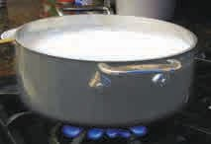

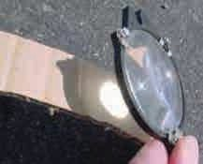

* 1. **: Heat energy**

You might have seen the glass panes of windows crack due to a loud noise. Similarly, sound is used to control the movements of some toy cars. This means that some work is done by sound. It tells us that **sound is a form of energy**.

* + 1. **Chemical energy**

When wood burns, we get heat and light. Sometimes, we hear a crackling sound as well. What makes this happen ? The energy stored in wood is emitted in various forms through chemical action. Also, it is due to the chemical action in the lead acid

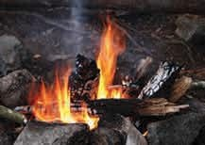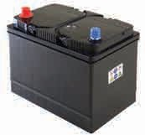

battery that electrical energy is produced.

**11. 8 : Chemical energy**

**The energy obtained through chemical action is called chemical energy.**

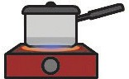



**Observe and discuss.**

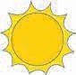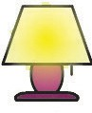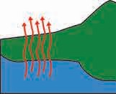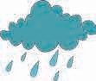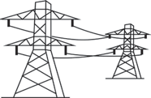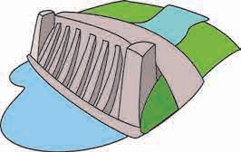

**Use your brain power !**

1. In which form is energy stored in plant food ?
2. How is energy obtained from cooking gas ?

Mechanical energy, heat, light, sound, chemical and electrical energy are the various forms of energy.

Observe the working of the various appliances we use such as the fan, lamp, mixer, TV, radio, refrigerator, washing machine, clothes iron. In which form is energy supplied to them to make them work?

**11.9 : Transformation of energy**

### Transformation of energy

Transformation of energy takes place when work is done. Let us consider one chain of transformation of energy.

In the course of the water cycle, water evaporates due to the heat of the sun. This water vapour forms clouds that give rain. Rainwater flows into rivers and is stored in reservoirs on dams. These are at a height and therefore their water has potential energy, which is transformed into kinetic energy as the water falls downwards. When the water falls on the blades of turbine, its kinetic energy is transferred to the turbine. The turbine rotates producing electrical energy. This electricity gets transformed into various other forms of energy.

Electrical energy is used in our houses for various purposes. It is transformed into light energy on lighting a bulb, into kinetic energy on starting a fan, into sound energy while playing a music system, and into heat energy in an oven.

Thus we see that we are indirectly utilizing nothing but solar energy in all these transformations of energy. **In other words, the sun is the most important source of all energy**.

### Energy resources

The resources used for getting energy can be classified into two types.

#### Conventional energy resources or non-renewable energy resources.

The energy resources which man has been using for centuries are called **conventional energy sources.** Conventional energy resources include coal and

fossil fuels such as petrol, diesel and natural gas. We

cannot replenish these resources. Wood also cannot be replenished easily.

#### Non-conventional energy resources or renewable energy resources

These resources have not been used traditionally. They are inexhaustible and continuous and can be used in various forms again and again.

* 1. 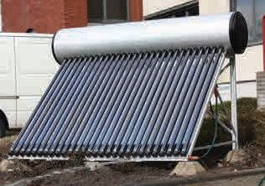**Solar energy :** The energy obtained from the sun is continuous and enormous. Solar energy is at the root of all energy available on the earth. A variety of devices have been developed for making use of solar energy. For example, the solar cooker, solar water heater, solar drier, solar cell, etc.

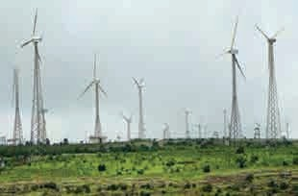In the first three devices mentioned above, heat energy obtained from the sun is utilized to cook food, heat water and to dry grain. In a solar cell, electrical energy can be obtained from solar energy. Solar electric plants have the capacity to produce electricity on a large scale. A solar plant consists of many solar cells.

* 1. **Wind energy :** Electricity is generated by means of windmills using strong winds. A windmill is also used for drawing water from a well.

Due to the increasing population and increasing usage of energy resources, there is a danger that the limited reserves of coal, petrol, diesel, crude oil and natural gas will get exhausted.

Therefore, it will be better to use alternative and supplementary resources instead of the conventional ones.

* 1. **: Solar energy**
  2. **: Wind energy**

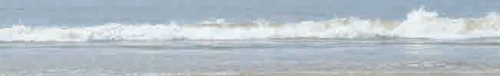

**C. Tidal energy :** A wall is constructed at a narrow region of a creek. Due to waves generated by high and low tides, the turbine of the generator fitted in the wall starts rotating and electricity is generated.

**D. Hydroelectric or hydel power :** The water stored in a dam at a height is brought down through a tunnel and the turbines of the generator are rotated. The place where electricity is generated in this way is called a ‘hydroelectric or hydel power’ plant. The Koyna project in Maharashtra is a well-known hydel project. There are also other smaller hydroelectric plants located at other dam sites.

**E. Energy obtained from oceanic waves :** While sea waves move forward in a certain direction, the water moves up and down regularly at a position. This, too, can be used to generate electricity.

**F. Atomic energy :** The serious crisis of electricity shortage can be eased by generating electricity by means of atomic energy. The heat liberated during the fission of atoms of heavy elements such as uranium, thorium is used to generate electricity.

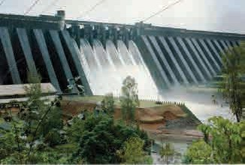

* 1. **: Hydel power**



**Use your brain power !**

There is energy in every substance in the universe. It is present in non-living things as well as in living things. Why, then is energy not visible to us ?

**Think over it !**

Note the amounts of your electricity bills of the last eight months and think about the consumption of electricity during each month.

**Energy saving and green energy** In a way, saving energy is as good as generating energy. There are several

ways of saving energy such as putting

off lamps when not needed, making maximum use of sunlight, etc. Saving energy and energy resources is very necessary. Otherwise, we will have to face a serious calamity like global warming.

The energy resources which do not produce smoke and carbon gases such as carbon dioxide or carbon monoxide are called ‘Green energy resources’. Greater use of such resources is the need of the hour.



**What we have learnt-**

* Work is done when an object undergoes displacement on application of a force.
* Energy is the capacity to do work.
* The various forms of energy are mechanical energy, heat energy, light energy, sound energy, chemical energy and electrical energy.
* Something that can be used to obtain energy is called an energy resource.
* Energy resources are of two kinds: conventional (non-renewable) and non-conventional (renewable) energy resources.



**Exercise**

1. **Fill in each blank with the appropriate term from the brackets.**

83

1. A bucketful of water is to be drawn from a well. will be done when

a is applied to do this, because

there will be a of water.

(displacement, work, force)

1. If a ball is dropped on the sloping roof of a house, it acquires …… and falls on the ground. That is, transformation of …….. energy into energy

takes place.

(kinetic, potential, motion)

1. You might have seen some beautiful fireworks during Diwali. It is an example of transformation of ……. energy into… energy.

(light, atom, chemical, solar)

1. The solar cooker is an application of the …… energy of the sun, while solar cells, solar lamps are applications of the …… energy of the sun.

(light, chemical, heat)

1. One labourer carried four pans of road metal through a distance of 100 metres. If he carries two pans of road metal through a 200 metre distance

......... work will be done. (equal, more, less)

1. The capacity that an object has for doing work is called ….... .

(energy, displacement, force)

1. **Match the pairs.**

**Group ‘A’ Group ‘B’**

1. Rolling object (a) Heat energy
2. Food (b) Atomic energy
3. Stretched bow (c) Kinetic energy
4. Sunlight (d) Potential energy
5. Uranium (e) Chemical energy
6. **Can you tell ?**
7. When can we say that displacement has taken place ?
8. What should be taken into account for measuring work ?
9. What are the various forms of energy ?
10. Describe one natural chain of transformation of energy.
11. Why should we save energy ?
12. What is ‘green energy’ ?
13. What are the non-conventional energy resources ?
14. Which forms of energy from the sun are used in solar energy devices ?
15. Why should we maximise the use of non-conventional energy resources ?
16. **Who is the odd-one-out ?**
17. Diesel, crude oil, natural gas, wind
18. A running car, hauling a log, a book kept on a table, picking up the school bag.
19. Sunlight, wind, waves, petrol
20. Leaving the fan on in a vacant room, leaving the TV on while working, using AC during winter, putting off the light when going out.
21. **Find out the types of energy from the following puzzle.**

|  |  |  |  |  |  |  |  |  |
| --- | --- | --- | --- | --- | --- | --- | --- | --- |
| z | s | q | p | y | m | w | n | e |
| p | o | t | e | n | t | i | a | l |
| l | l | s | u | h | v | n | x | i |
| t | a | o | j | e | v | d | z | g |
| q | r | u | l | a | b | a | d | h |
| k | i | n | e | t | i | c | q | t |
| r | w | d | h | k | l | w | y | f |

**Activity :**

* How can you save energy at home and in school ? Discuss this with your friends and list all such measures. Put them into practice.
* Find out about energy saving devices available in the market.





**12.**

**Simple Machines**

#### Observe and discuss.

In the following pictures, certain devices are used to accomplish certain tasks more easily. Name the devices and discuss how they help.

Such devices which are used to get more work done in less time and less effort are called **machines**.

The nail cutter, the bottle opener, the wheel used to push the load shown in the picture are all machines. They have only one or two parts and a simple and easy structure. Such machines are called **simple machines**. Simple machines can be handled easily, and there are less chances of these machines breaking down or getting damaged. We use many such machines in our day-to-day life.

* 1. **: Various kinds of tasks**

#### Can you tell ?

Observe the machines shown in the following pictures. For what purposes are they used ? Can you name some other machines of this kind?

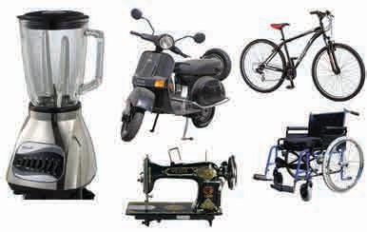

* 1. **: Various machines**

These machines have many parts which carry out many processes for completing a task. For this purpose, the parts are joined to one another. Therefore, these machines are called **complex machines**. Some of the parts of such complex machines are actually simple machines. The structure of complex machines is complicated.

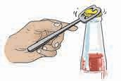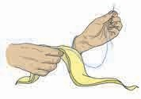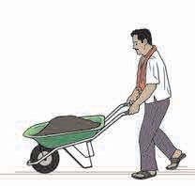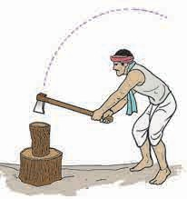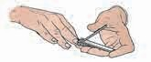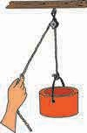

In our day-to-day life, we use simple or complex machines depending upon the task to be carried out and the time and efforts required to do it.

**Let us learn about some simple machines.**

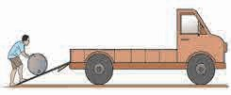

**A**

## An inclined plane

A heavy drum is to be loaded onto a truck. Ravi chose the plank A while Hamid chose the plank B. Rahi did not use a plank at all.

1. Who would find the drum heaviest to load ?

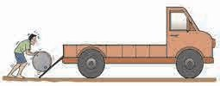

**B**

1. Who would find it lightest ?

Which one of the planks A and B is longer ? Which one has a steeper slope ?

What can we conclude from this ?

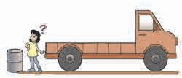If a slanting plank is used to lift a weight, we have to bear less of the weight and lifting it becomes easier. Such a plank is called an ‘inclined plane’. The more gradual the slope, the lesser is the weight we bear. But, such an inclined plane is longer. The steeper the slope, the shorter the inclined plane. But

we have to bear a greater weight. **12.3 : Loading a drum onto a truck**



**Let’s try this.**

* 1. **: The screw as an inclined plane**

Cut out a triangular piece of paper ABC. Draw a red line along the edge AC. Roll this paper around a pencil as shown in the picture. What do you see ?

The inclined side AC of the triangle descends gradually from A to C.

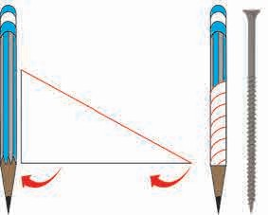

**A**

**B**

**C**

The threads on a screw are made in the same way. That is why, when a screw is fitted in wood it goes in as if it is going down an inclined plane. Therefore, less force is required to fit a screw than to hammer a nail. In other words, a screw is like a rolled up inclined plane made of an iron strip.

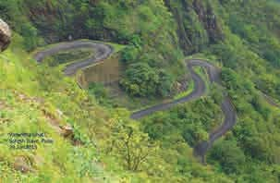A winding road or ghat that goes up a mountain is also like an inclined plane wrapped around the mountain. It helps big vehicles to climb up and down the mountain easily.



**Observe and discuss.**

* 1. **: Ghat**

Two routes, namely, a pathway and a road are available to climb the mountain shown in the picture. Compare the time and strength and your convenience required to reach the mountain top.

85

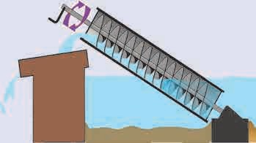

**In the past...**

The Greek scientist Archimedes invented the machine shown in this picture. That is why, it is called the **Archimedes’ Screw**. It was used to lift water from the hold of a ship. Archimedes used a round pipe fitted with a rod inside it. The pipe was placed at an angle of 450 with one end inside the water and the rod resting on a flat surface. When the rod was turned, water got lifted in this device.

**Archimedes’ screw**

### A wedge

An axe is used for cutting wood. A sharp tool is formed on joining two inclined planes. Such a tool is called a **wedge**. A wedge in used for breaking an object into two pieces or to seperate objects stuck together. An axe, a knife or a chisel are some examples of this simple machine.

A needle and a nail are also kinds of wedges.

* 1. **: Wedges**



**Use your brain power !**

A needle is required for stitching cloth. We use a knife for cutting fruit. If the tip of a needle or the

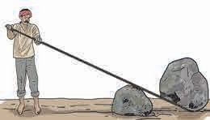edge of a knife becomes blunt, then the needle does not penetrate the cloth and the knife does not cut into the fruit. Why is this so ?

### A lever

A farmer is using a strong crow-bar to remove the big stone bogged down in the farm. Such a machine is called a **lever**.

A lever has three parts, namely, effort, load and fulcrum.

1. The support at which the rod of a lever is rested is called the ‘fulcrum of a lever’. The lever rotates about the fulcrum.
2. The weight lifted by a lever or the force against which the lever acts is called the ‘load’. The arm of the lever from the fulcrum to the load is called the ‘load arm’.
   1. **: Removing a large stone**
3. The force applied on the other end of the rod to lift the load is called the ‘effort’. The part of the lever from the fulcrum to the effort is called the ‘effort arm’.



**Use your brain power !**

Which tasks can be done using a lever ?

* 1. Place a pencil on a table. Place a ruler on it at right angles with it. Put a paperweight on one end of the ruler. Press the other end with your finger to lift the weight. Which are the

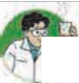

**Let’s try this .**

effort arm and the fulcrum of this lever ?

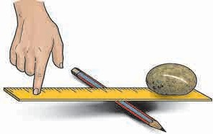

load arm, the

**Effort**

**Load**

**Fulcrum**

Now, go on increasing the distance between the paperweight and the pencil by four centimetres every time and see whether the paperweight can be lifted when placed at each of those distances.

What do you find ?

As the effort arm becomes longer and

* 1. **: Lifting a paperweight**

longer compared to the load arm, less and

less force is required to lift the paperweight. Such a lever is called a lever of the first order.

* 1. The picture shows how we use an opener to remove the cap of a sauce bottle. Try to do the same yourself. To remove the tight-fitting cap, the opener is rested on the cap and we apply a force on the opposite end of the opener to pull it upwards. The cap also gets pulled up as the opener rotates about the fulcrum. Where are the fulcrum, load and effort in this case ?
  2. How do we lift an object using tongs ?

The weight or the load is at one end of the arms of the tongs. We apply effort in the middle of the arms. It means the effort is applied in the middle of the lever, while the fulcrum and the load are at the opposite ends.

#### There are three types of levers depending upon the positions of the effort, the fulcrum and the load.

**Fulcrum**

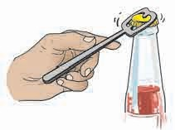

**Load**

**Effort**

* 1. **: Removing the lid**

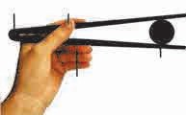

**Fulcrum Effort**

**Load**

**Effort**

* 1. **: Picking up an object**

87

|  |  |  |
| --- | --- | --- |
| **Lever of the first order**  The fulcrum is in the centre, the load is at one end while the effort is at the other end.  **Load Effort**  **Fulcrum** | **Lever of the second order**  The load is in the centre, the fulcrum on one side, and the effort, on the other side.  **Load**  **Fulcrum**  **Effort** | **Lever of the third order**  The effort is in the centre, the fulcrum on one side, and the load on the other side.  **Load**  **Fulcrum Effort** |

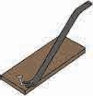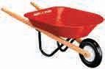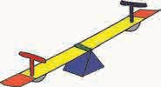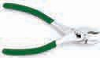

**Use your brain power !**

Some machines we use in our day-to-day life are shown in the picture. What is the type of lever in each of these ?

**Let’s try this.**

**A pulley**

Take a pencil, some sticking tape, an empty reel of thread, half a metre of thick thread, a weight such as an eraser that can be tied to the thread, play dough.

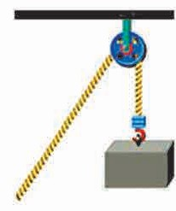

**12.11 : A pulley in everyday**

Place the pencil on the table so that it juts over the edge of the table. Fix it firmly to the table using the sticking tape. Insert the reel over the part of the pencil that juts out. Put a lump of the play dough on the tip of the pencil so that the reel does not come off. Draw the thick thread having the weight at one end over this reel. What happens when the loose end of the thread is held and pulled down? The weight tied at the other end gets lifted up.

Such a device with a grooved wheel and thread designed to lift weights is called a **pulley**.

How does it help to use a pulley ?

**life**

If we use a pulley, force can be applied in the downward direction for lifting the weight in an upward direction. This is convenient and easy. You must have seen some examples of pulleys in day-to-day use. Make a list of these.

### A wheel and axle



**Can you tell ?**

1. All of you must have enjoyed sitting on a giant wheel. What makes the giant wheel go round ?

The giant wheel is fitted to a rod at its centre. This rod is called an ‘axle’. When the axle starts rotating with the help of electricity, the wheel fitted to it also starts rotating. This combination of an axle and a wheel is a simple machine. We see innumerable examples of its use.

1. When the pedal of a bicycle is rotated, the wheel starts rotating. How does this happen ?

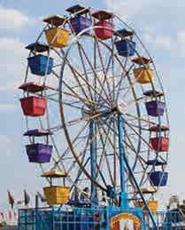

**12.12 : A giant wheel**

### Maintenance of machines

Parts of machines rub against one another when they are used. Soiled, dusty parts create more friction. Some parts, affected by the weather, rust and erode. Machines get damaged, or become useless due to such wear and tear. To avoid this, it is very important to take care of machines.

During the maintenance of a machine, all its parts are wiped clean. Oil or lubricant is released betweem parts that rub against each other, so that there is less friction between them and the wearing is reduced. Machines are covered when not in use to prevent dust settling on them. To prevent the effect of weather, metallic parts in a machine are painted externally, and the machines are always kept dry.

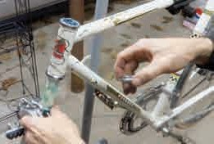

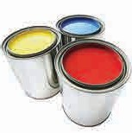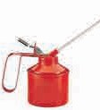

**12.13 : Maintenance of machines**



**Do you know ?**

Big factories have a separate

department for of machines.

the

maintenance

Factories are closed at regular, fixed periods for the maintenance of machines.



**Always remember...**

If machines are not properly maintained they will be of no use when we actually need them.

Before we use a machine, we must learn how to handle it properly so that there are no accidents.

#### What we have learnt-



* Machines are used for reducing efforts, and doing more work in less time.
* Some machines are simple while others are complex.
* The wedge, the lever, the inclined

plane, the pulley and the wheel and

axle are simple machines.

* There are three types of levers based on the positions of effort, load and fulcrum.
* Machines should be maintained properly to keep them in good working condition.

**Science watch ...**

To carry out a task efficiently, sometimes we have to use a trick. The trick can be effected with a machine. Try to make a useful machine from old, unused, junk material.

* Find an old fountain pen and use it to devise a machine.



**Exercise**

#### Classify the following as a lever, a pulley and an inclined plane :

A wedge, a needle, a staircase, a slide, the wheel of a flagpole, nutcrackers, scissors, an opener, an axe, a crane, a knife.

#### Fill in the blanks using the proper word and complete the statements.

1. The ……. in the centre, the ………. on one side and the …… on the other side make a lever of the first order.
2. The ….. in the centre, the on

one side and the on the other

side make a lever of the second order.

1. The ………. in the centre, the ……. on one side and the……..on the other side make a lever of the third order.

#### Which machines will you use to do the following work ? Write their types.

1. To remove the lid of a tin.
2. To lift bricks to the top of a tall building.
3. To cut vegetables.
4. To draw water from a well.
5. To hold a papad for roasting it.

#### Write the answers to the following questions in your own words.

1. What is meant by simple machines ?
2. Mention the advantages of using a machine.
3. What is meant by complex machines ?
4. What is a lever ? How are the orders of the lever determined ?

#### Why is this so ?

1. Traveller’s bags have wheels.
2. Machines have to be maintained.
3. A bicyle is said to be a complex machine.

#### Name the levers mentioned in the following passage. Identify the fulcrum, load and effort of each and say which type of lever it is.

Ravi and Savita sit on a sea-saw in a garden. In the mean time, a gardener is trimming trees in the garden. He puts the leaves and other garbage in the wheelbarrow. Later, Ravi gets thirsty and he buys lemon sherbet. The sherbet seller cuts the lemon and squeezes it using a lemon squeezer. He puts small pieces of ice in the glass with the help of the tongs.

**Activity :**

* Make a list of the various machines used in your home and neighbourhood and write their types.
* Go to a bicycle repair shop, observe how a bicycle is repaired, and note down the information.





**13.**

**Sound**

Some sounds are depicted in the pictures below.



**Can you tell ?**

Have you heard these sounds ? Put a tick mark (🗸) in the box if you have, and cross (🞩) if you have not. What words are used in your locality to denote these sounds? Write them below the pictures.

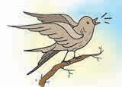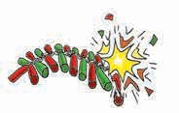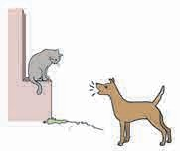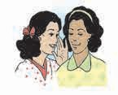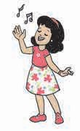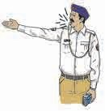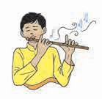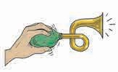

**13.1 : Examples of various sounds**

* 1. Which sounds do you hear during the recess in the school ?

Some sounds are loud and are heard easily while some others are very soft and cannot be heard unless we listen attentively. We like some sounds. On the other hand, we get annoyed by some other sounds.

* 1. When there is silence in the classroom, close your eyes and sit quietly. Which sounds in your surroundings can you hear now ?

Prepare a common list of all these sounds and discuss them. You will see that there is a lot of diversity in the innumerable sounds that we hear. Classify these sounds in two ways - soft/loud and pleasant/unpleasant.

### How are sounds produced ?

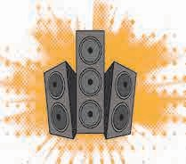

**13.2 : Speakers**



**Try this.**

1. When a song is being played on a radio or a music system in the house, place your hand on its speaker. What do you feel ?

Put off the music. What do you feel now ?

1. 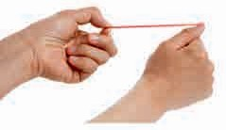Take a rubber band and stretch it as shown in the picture. Pluck the stretched band.

Apart from the movement of the rubber band, what else did you notice ?

* 1. **: Tabla**

**13.3 : A stretched rubber band**

1. 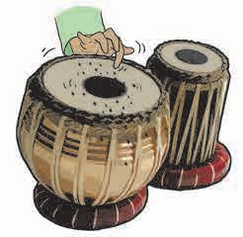Spread some sawdust or mustard seeds or sand on the diaphragm of a tabla. Knock on the diaphragm lightly with a finger.

What do you see happening so long as the tabla makes a sound? What happens when the sound stops ?

What do we understand from these observations ?

The objects that produce sound, that is, the diaphragm of the speaker, the rubber band, the diaphragm of a tabla, show a certain movement. That is, they have a certain kind of motion. They oscillate rapidly. In other words, they vibrate.

The vibration of an object is necessary for the production of sound. As long as the object vibrates, the sound is heard. When the

vibration stops, the sound also stops.

**The object due to which sound is produced is called the source of that sound.**

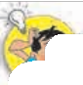

**Use your brain power !**

When a metal dish falls on the floor, it makes a loud noise. What do we do to stop the noise ? What is the effect of that action ?

**Try this.**

#### Do you know ?

**Acoustics :** The science of sound,

The sounds of a sitar, a bell, water that drops from a tap, a saucer that breaks on falling down - what is it that vibrates when these sounds are produced ?

resonance, including the production, **Voice box / Larynx**

propagation and effects of sound is

called acoustics. The intensity of sound is measured in a unit called decibel (dB).

The vibration of the vocal cords in our larynx or ‘voice box’ also produces sound. The voice box is located in our

**Vocal cords**

throat. The quality of the sound produced in the larynx depends upon the tautness of the vocal cords.

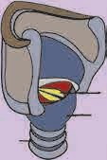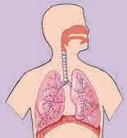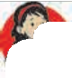

**Trachaea**

**Voice box / Larynx**



**Let’s try this.**

Take a pot filled with water. Strike it lightly on its rim.

What do you see ?

Why are waves formed on the water in the pot ?

### How sound is heard

* 1. **: Vibrations in the water and production of sound**

There is air around a source of sound. As the source of sound begins to vibrate, the layer of air nearest to the source also vibrates. A wave of vibrations of that sound spreads in all the directions from the source of sound. Such a wave is called a sound wave. The sound waves reach our ears. There is a delicate diaphragm or eardrum in the cavity of our ears. It starts vibrating, too. The sensation produced by these vibrations are passed on to the brain through the nerves in the ears and we hear the sound.

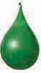

**Water balloon**

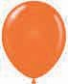

**Air balloon**



**Let’s try this .**

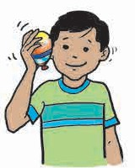

* 1. **: Propagation of sound**

### Propagation of sound

1. Take two balloons. Fill air in one and water in the other. Press the balloon filled with air against your ear as shown in the picture. Rub a finger on the balloon and listen to the sound.

Repeat the same activity with the balloon filled with water.

Through which balloon do we hear a clearer sound ?

1. 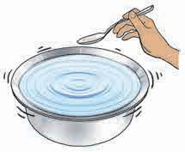Stand at the end of a big table and make a friend stand at the other end. Ask the friend to knock lightly on the table. You will hear a faint sound.

Now you press your ear to the table and ask the friend to repeat the knock. What difference do you notice ?

Sound travels in the form of waves through air, water or through a solid and reaches our ears. Sound is propagated more clearly through a liquid than through air. It is heard most clearly through a solid. Why is this so ?

**New words**

**Propagation of sound** Sound is said to be propagated when sound waves spread in all

directions from a source of sound.

**The medium of propagation of sound**

The substance around a source of sound through which sound waves spread is called the medium of propagation of sound.

Transmission of sound occurs at a different speed through different mediums.

Transmission of sound is faster through a liquid than through a gas, and faster through a solid than through a liquid.

#### Use your brain power !

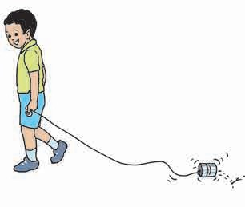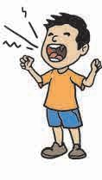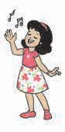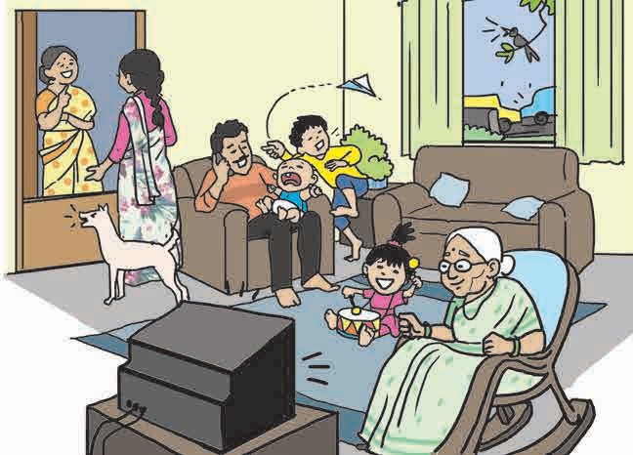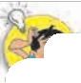

If a bell is hung in a vacuum container, will its sound be heard outside ?

### New word

Vacuum means an empty space from where air is partially removed.

#### Observe and discuss :

1. Which of these sounds is pleasant ?
2. Which sounds are a nuisance to people ?

### Noise pollution

A loud sound is harsh to the ear. Such sounds produce noise.

* 1. **: Various sounds**
  2. **: A noisy scene**

1. Make a list of all the sounds implied in the picture.
2. How would this atmosphere affect a person who is not feeling well ?
3. Would you be able to study in these conditions ?

The situations shown in the two pictures on page 94 are often seen around us. Some of the sounds they depict are pleasant while others are harsh. Very loud or continuous noise has adverse effects on the people of that locality. Their hearing may get impaired which can even lead to deafness. It can also cause restlessness, irritability and mental exhaustion. One cannot work with concentration. This kind of continuous noise which may have ill effects is called noise pollution.

**Measures for preventing noise pollution**

1. As far as possible, we should avoid blowing the horn.
2. The volume of the TV or radio in the house should be restricted to those watching the programmes.
3. Vehicles should be maintained properly to reduce the unnecessary sounds they produce.
4. Factories, airports, railway stations and bus stands should be located at the proper distance, away from residential areas.

**Noise pollution occurs when we hear one or many sounds harmful to the ear.**



**Always remember...**

Some of the sounds that we enjoy can be a nuisance for others.

**Believe it or not !**

Birds like the robin and the woodcock can recognize the sound of an earthworm in the soil, and find their prey. This is because their hearing organs are very sensitive.

Some species of grasshopper produce a sound by rubbing their legs together while flying in the air. The flapping of the wings of the bee or the mosquito

produces a humming sound . Have you heard

such sounds ?

#### What we have learnt-

* + Vibrations are required for the production of sound.

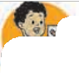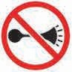

* + A medium is required for the propagation of sound.
  + Sound is propagated through gaseous, liquid and solid mediums.
  + Noise is disagreeable, irregular and loud.
  + Noise pollution occurs due to continuous noise. Noise pollution has adverse effects on our health.
* Heavy traffic and industrial areas cause the maximum noise pollution.
* Noise pollution is a social problem.
* It is necessary that everybody takes measures to prevent noise pollution.
* Blowing the horns of vehicles is prohibited near places like schools and hospitals. These rules should always be followed.



**Exercise**

#### Fill in the blanks with the proper words.

|  |  |  |
| --- | --- | --- |
| **Nature of sound** | **Unpleasant** | **Pleasant** |
| Speaking |  |  |
| Whispering |  |  |
| Aeroplane sounds |  |  |
| Horns of Vehicles |  |  |
| Railway Engine |  |  |
| Rustling of leaves |  |  |
| Neighing of a horse |  |  |
| Ticking of a clock |  |  |

* 1. The propagation of sound does not occur through a ……….. .
  2. Noise pollution is a issue.
  3. The sound which is disagreeable to the ears is called….. .
  4. Noise has adverse effects on our .......... .

#### What should we do ?

* 1. The silencer of a motorcycle is broken.
  2. A factory in the surroundings is producing continuous loud noise.

1. **Write the answers in your own words.**
   1. What is meant by vibration ?
   2. Explain with the help of practical examples how sound is propagated through solids.
   3. What is meant by noise pollution?
   4. What measures will you take to control noise pollution ?

#### Complete the table.



**Project :**

* Prepare a list of the harsh sounds heard near your house. Write about those sounds which produce noise pollution.
* Collect information about places where loud noise is prohibited and discuss why it is so.





**14.**

**Light and the Formation of Shadows**



**Can you tell ?**

1. 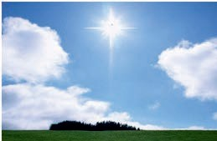Can we see anything in total darkness ?
2. What helps us to see the objects around us ?
3. What does the light in each one of the pictures originate from ?

The objects or materials which emit light, meaning those which themselves are a source of light, are called **luminous objects or materials.** The intensity of light is determined by the extent to which the objects emit light. For example, the light emitted by an electric torch is more intense than that obtained from a candle.

The objects or materials that are not sources of light themselves, are called **non-luminous objects or materials**.

Some man-made objects or materials also emit light. These are called **artificial sources of light.**

The Sun is the main natural source of light. Other stars seen in the night sky, fireflies, some anglerfish as well as honey mushroom are natural sources of light.

### The propagation of light

You may have seen in the afternoon, rays of light entering through a slit in a door or a small hole in the roof. As these rays of light from the slit or the hole move towards the floor, the dust particles in their way are seen clearly. Due to these particles, the path of the light becomes visible and we can see that their path is along straight lines.

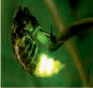

* 1. **: Sources of light**



**Use your brain power !**

Make a list of some luminous objects and substances and classify them into natural and artificial sources of light.

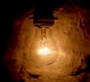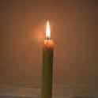

* 1. 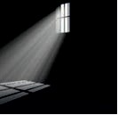**Light entering through a window**



**Let’s try this.**

Take three cardboards. Make a small hole in the centre of each cardboard using a thick needle. Arrange the cardboards in such a way that the three holes are in the same line, as shown in figure 14.3 on page 98. Stand a burning candle on one side of the cardboards and look at the flame of the candle from the other side.

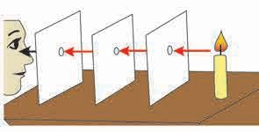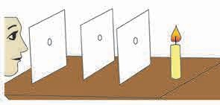

**Step 1**

Look at the flame of the candle

**Step 2**

Now move any one of the cardboards.

Do you see the flame ?

Why do you not see the flame ?

**14.3 How light travels**

Take a straight tube that can be bent easily. As shown in the figure, place a burning candle on a stand, and look at it through the tube. Then bend the tube and look at the candle again. What do you see ?

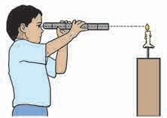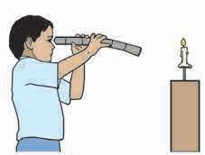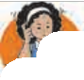

**Use your brain power !**

In which step is the flame of the candle seen clearly ? Why ?



**Let’s try this.**

#### Step 1

* 1. **: Looking at the candle**

**Step 2**

**Light travels in a straight line. This is called the linear propagation of light.**

### Reflection of light

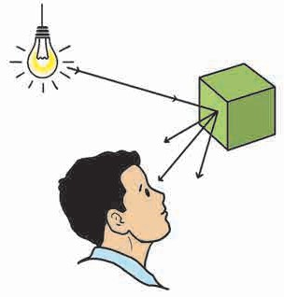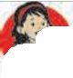

#### How do we see an object ?

The rays of light falling on an object from a source of light are thrown back from the surface of that object. This is called **reflection of light.** We see the object when the reflected rays reach our eyes.

**Source of light**

**Object**

#### Do you know ?

Stars are luminous. Planets, satellites are non-luminous. Sunlight reflected from the surface of the moon reaches us. That is how we can see the moon. We call this light moonlight.

* 1. **: How an object is seen**
     1. In which objects do we see a reflection?

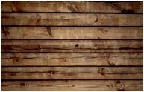

**Can you tell ?**

* + 1. What is the difference between an object and its reflection ? What causes the difference ?

Let us see how light is reflected from the three surfaces shown alongside.

When you see your face in a mirror, the light reflected from your face falls on the mirror, and gets reflected back again. That is why you see the image in the mirror.

Do you see your image in a glass pane ? You do, although it is somewhat faint. No image will be seen at all on a wooden surface.

You may have seen your image formed in surfaces such as a new steel dish, the glossy granite cladding of a wall and the still water in a lake. Make a list of other similar surfaces. Compare the images seen in them. Make a guess about the property of a surface due to which an image is formed. Discuss this with your teachers and parents.



**Let’s try this.**

### Images in a plane mirror

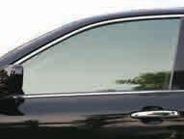

* 1. **: An image**

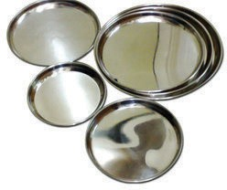

Stand in front of a plane mirror and look at your image in it.

* + 1. Raise your right hand. Which hand of the mirror image is raised ?
    2. What change do you see in the image if you decrease or increase your distance from the mirror ?

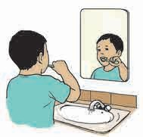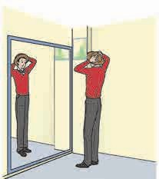

* + 1. Is there any difference between your height and height of the mirror image ?
* The left and right sides of the original object appear to be exchanged in the mirror image.
* The image is as far behind the mirror as the object is in front of it.
* The size of the image is the same as that of the object.
  1. **: The image in a plane mirror**

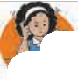

**Use your brain power !**

1. How will you light up a dark room using reflected light?
2. Try to start the TV by operating the remote control from behind it.

#### A pinhole camera



**Try this.**

Take an empty cylindrical box. Remove its cap on one side and paste a thin white paper in its place. Make a small hole at the centre

of the other cap. Light a candle and hold the box in such a way that the flame of the candle is in front of the hole. Now you will see an upside down or inverted image of the flame on the thin paper at the other end.

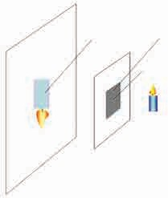

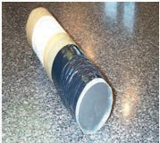

* 1. **: Pinhole camera**

**Thin paper**

**Inverted image**

**Cap Hole**

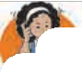

**Use**

**your**

**brain power!**

Why is the image on the diaphragm of the pinhole camera inverted ?

**Candle**

* + 1. What difference do you notice on looking through the windows in the picture ? What causes the difference ?



**Can you tell ?**

* + 1. The picture shows transparent, opaque, translucent window panes. Spot them.

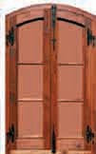Depending on the nature of the window pane, we may or may not see the objects on the other side through it. Identify the transparent, opaque and translucent objects from among the following : piece of a glass, wax paper, tinted glass, oil paper, white plastic, a tea kettle, a notebook, cloth, water, a wooden cupboard, sheet of a notebook.

* 1. **: Window**

What happens ?

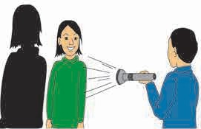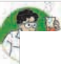

* The material through which light passes is said to be transparent.
* The material through which light does not pass is said to be opaque.
* The material through which light passes partially is said to be translucent.

**Formation of shadow**

**Let’s try this.**

Take an electric torch. Flash its light on a wall. Now make your friend stand in between the torch and the wall.

* 1. **: Formation of a shadow**



If an opaque object comes in the way of a light source, light does not pass through it. As a result, the light does not reach a wall or any other surface on the other side of the object. That part remains dark. This dark part is called the ‘shadow of the object’.

**Compare this.**

Compare the objects in your environment with the shadows they form.

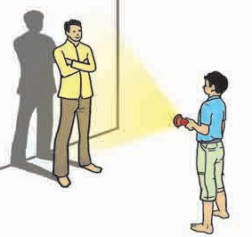Ask your friend to stand at a certain distance from you in a big room and obtain the shadow of your friend on the wall with the help of a torch. Now carry out the following actions. Observe and make a note of the changes taking place in the shadow.



**Try this.**

* + 1. Send the friend closer to the wall.
    2. Ask the friend to come towards you.
    3. Next, you move further away from him and towards him again.
    4. Hold the torch high and then low.
    5. Go toward the left and then to the right of the friend.

The shadow of an object is formed only when light does not pass through the object. The kind of shadow it forms depends upon the relative distances between the source of light, the object and the surface or the screen on which the shadow is formed.

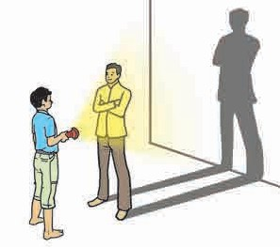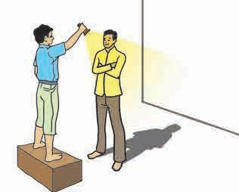

The shadow of an object formed due to sunlight is long in the mornings and evenings and short in the afternoon. We can easily note these changes if we observe the trees along the roadside. This change in the shadow depends on the source of light,

the object and also on the surface on which the shadow is formed.

#### Do you know ?

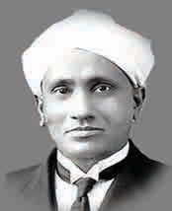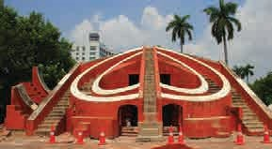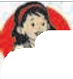

**A sundial :** A sundial is an instrument that indicates the time with the help of the extent and the direction of the shadow of an object formed in sunlight. Earlier, time was measured by placing a stick parallel to the axis of the earth and by noting the position of its shadow on the dial at different times of the day. The largest sundial is at Jantar Mantar, New Delhi.

The research work presented by the Indian scientist Sir C. V. Raman regarding scattering of light is known as the ‘Raman Effect’. He discovered this effect on 28th February 1928. To commemorate

this event, 28th February is celebrated

as ‘National Science Day’ since 1987 in India.

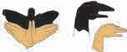

**A little fun !**

Use your hands and feet to make different shadow shapes of birds, animals, etc.



**Let**’**s try this .**

1. 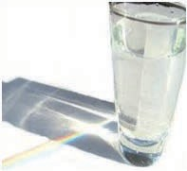Apparatus : A glass, water, a large white sheet of paper

Place a glass filled with water on a sheet of paper in the window so that it receives direct sunlight. What is seen on the paper ?

Can we do the same in a dark room with the help of a prism and a torch ? What do we learn from this ?

1. Apparatus – Soap water, a small loop of wire.

If you dip the wire loop in the soap water and then blow on it, soap bubbles are formed. The beautiful colours of the rainbow are seen in these bubbles.

1. What do you see on holding a CD in the sun ?

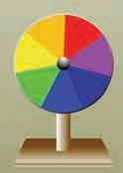

**In the past ...**

The British scientist Sir Isaac Newton made a special disc. One side of the disc was divided equally into seven petals of the seven colors - red, orange, yellow, green, blue, indigo and violet. The disc was fitted on a stand and rotated fast. As the disc rotated, the seven colours

disappeared and only white was seen. This proved that sunlight is made of seven colors. That is why, the disc is known as **Newton’s disc.**

Newton wrote a book called ‘Opticks’ about light.



**Always remember...**

The shape of a shadow depends upon the source of light, the object and the surface on which it is formed. We should not get frightened by the shadows we see at night because there is simple science behind that.

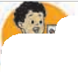

**What we have learnt-**

* A substance that emits light is a source of light.
* The natural sources of light are the sun, the stars, fireflies, etc. The lantern, the flame of a candle, an electric bulb, etc. are artificial sources of light.
* Light is propagated in a straight line.
* Light must be reflected from the surface of an object for the object to be seen.
* If an opaque object obstructs the path of light, it casts a shadow.
* White sunlight contains seven colours.

**Science watch ...**

Many questions arise in our mind while studying science; some easy, some difficult. Where can we find the answers to them?

Do not keep the questions to yourself. Keep asking those questions and look for the answers. The store of knowledge is enormous. Glean as many particles of it as you can.

**Did you ever wonder :**

* Why do we pucker our lips when blowing a candle out ?

When we pucker our lips, we leave only a small space for the air to come out.

That increases the pressure on the air and it helps to put out the candle.



**Exercise**

#### Choose an appropriate word and fill in the blanks.

* 1. A ........... is a natural source of light.
  2. A ……… is an artificial source of light.
  3. When light passes through a prism, it gets separated into colours.
  4. The image obtained in the pinhole camera is ……… .
  5. A shadow is formed when an

……….. object comes in the way of light.

* 1. When a ……….. object comes in the way of light, light passes

. it.

(options : seven, star, through, transparent, opaque, colors, shape, erect, inverted, luminous, candle)

1. **Write whether of the following objects are luminous or non-luminous.**

|  |  |
| --- | --- |
| **Object** | **Luminous/ Non-luminous** |
| A book |  |
| A burning candle |  |
| A wax cloth |  |
| A pencil |  |
| A pen |  |
| A light bulb |  |
| A tyre |  |
| A torch |  |

1. **Match the following.**

**Group A Group B**

* 1. Mirror (1) Non-luminous
  2. Firefly (2) Inverted image
  3. Pinhole camera (3) Reflection
  4. Moon (4) Luminous

#### Write the answers to the following.

* 1. What things are necessary for the formation of a shadow ?
  2. When can an object be seen ?
  3. What is a shadow ?

**Project :**

* Prepare a Newton’s disc.
* Find out how to save electricity with the help of the sunlight we receive during the day.
* Read a biography of Sir C. V. Raman and find out about the discoveries he made.







**15.**

**Fun with Magnets**



**Can you tell ?**

* + 1. Pins in a pin holder do not fall even when it is held upside down. Why is this so ?
    2. 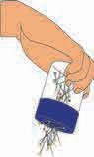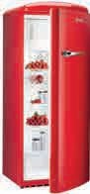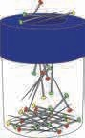While we are shutting the door of a fridge, we find that it closes automatically from a certain distance and does not open unless pulled again. Why is this so?

A magnet is used in these gadgets. A magnet is fitted in the cap of a pin holder and in the door of a fridge. Iron objects stick to a magnet.

#### What is a magnet ?

* 1. **: A pinholder and a fridge**

The material to which objects made from iron, nickel, cobalt, etc. get attracted is called a ‘magnet’. This property of a material is called ‘magnetism’.

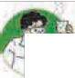

**Let**’**s try this.**

1. Take a magnet from the laboratory and bring it near various objects in your use. Which of them stick to the magnet ? What material is each of them made of ? Observe these things carefully. Classify the objects into two groups : those which stick to the magnet and those which do not.
2. Take a mixture of sand, pieces of paper, sawdust, iron filings and pins in a saucer and pass a magnet around the mixture. What do you see ?

The materials that stick to a magnet are called **magnetic materials**, while those that do not stick to a magnet are called **non-magnetic materials**. The metals iron, cobalt, nickel are magnetic materials.

* 1.** 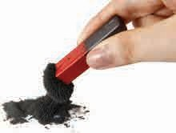: A magnet**

१५.३

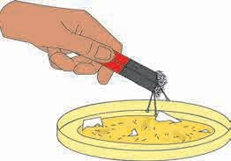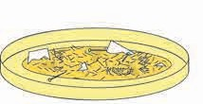

**15.3 : To identify the magnetic materials**

**we use**

### In the past...

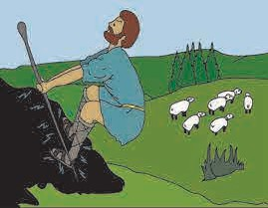

There is a legend about the discovery of magnets. It is said that a shepherd named Magnes lived in Greece. Once, while his sheep were grazing, he sat down on a big rock. But, what a surprise he got when he tried to get up ! His staff and his shoes were stuck to the rock. He had to use great force to pull himself away from the rock.

He realized that what had happened was

* 1. **: The story of Magnes**

because of the iron ferrule on his staff and the iron nails in his shoes. However, other rocks did not stick to his shoes or staff. Later, he showed the rock to everybody.

The rock was named magnetite after Magnes, the shepherd. Magnetite is a natural magnet. It is also possible that the name ‘magnet’ came from Magnesia, the part of Greece where magnets were discoverd.

How is a mariner’s compass used ?



**Find out.**

It was known quite long ago to the people in China and Europe that a piece of magnetite, hung freely, always settled in the north-south direction. These rocks then came to be used for finding the directions while travelling through unknown regions. That is why, they are also called **lodestones** (leading stones). This led to the invention of the mariner’s compass.

Magnets can have a variety of shapes depending upon their uses. Today, magnets are used in many machines and gadgets or devices. They are all man-made magnets. Find out where the magnets shown in the pictures below are used.

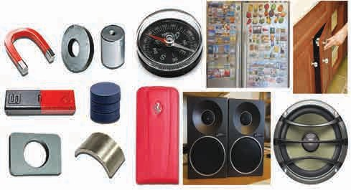Bar magnets, disc magnets, horseshoe magnets, ring-shaped magnets, cylindrical magnets as also small button magnets are the different shapes of magnets in everyday use.

* 1. **: Various man-made magnets**

### Magnetism

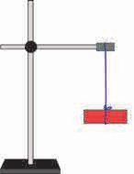When a magnet attracts an object, that object is displaced due to the magnetic force. In places like factories, ports, garbage depots, large objects are shifted from place to place. For this purpose, cranes with magnets are used. Work is done by magnetic force. This shows that magnetism is a kind of energy.

### Characteristics of a magnet



**Let**’**s try this.**

* + 1. Determine the directions in the class or laboratory. Tie a thread to the centre of a bar magnet and hang it from a stand. Note the direction in which the magnet settles and turn it around again. Let it settle and note the direction. Do this many times.

What do you observe ?

**A magnet always settles in the north-south direction.**

The end of a magnet that points to the north is called the **north pole** while the end that points to the south is called the **south pole**. The north pole is indicated by ‘N’ and the south pole, by ‘S’.

* + 1. Place some iron filings on a sheet of paper and pass a bar magnet over them. Pick up the bar magnet by holding it in the centre. What do you see ?

To which part of the magnet do most of the iron filings stick ? On which part do we see fewer filings ?

What can we conclude from this ?

**The magnetic force is concentrated at the two ends or poles of a magnet.**

* + 1. Take a bar magnet that can be cut with scissors or a knife. Take iron filings on a sheet of paper and place the magnet on it. Most of the iron filings will be seen to stick to its poles.

Now cut the magnet into two pieces as shown in the picture and place those pieces on iron filings. Pick up each of the pieces and observe them.

What do you find ?

**If a magnet is divided into two parts, two independent magnets are formed. It means that the two poles of a magnet cannot be separated from each other.**

* 1. **: Direction in which the magnet settles**

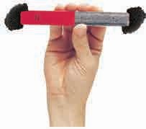

* 1. **: Magnetic power**

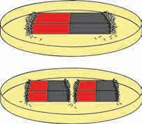

* 1. **: Characteristics of magnetic poles**

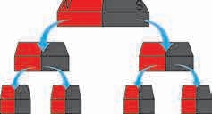

* 1. **: More magnets from one**

1. Fix a powerful bar magnet to a stand as shown in the figure. Fix an iron bar at a short distance below the magnet. Take iron filings near the iron bar. What do you see ?

After some time take the magnet away.

What happens now ?

Iron filings stick to the iron bar when the magnet is near it and fall off as soon as the magnet is taken away. That is, the magnetism in the bar vanishes.

**A magnetic material acquires magnetism when placed near a magnet. This magnetism is called induced magnetism.**

1. Fix a bar magnet to a stand as shown in the figure. Let it become steady. Take another bar magnet near the hanging bar magnet. Observe what happens. Do the same again and again, exchanging the ends of the magnet. What do you see ?

**There is repulsion between like poles of a magnet, while there is attraction between the opposite poles.**

1. Take a needle or nail. Place it steady on a table. Keep on rubbing a magnet over it from one end to the other. Do this 7-8 times. Now take a few pins near that needle/nail. What is seen ?

In this way, magnetic objects acquire magnetism. Magnetism of this kind is temporary. It lasts for a short while.

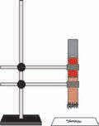 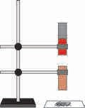

* 1. **: Induced magnetism**

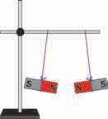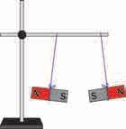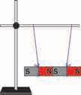

* 1. **: Attraction and repulsion in magnets**

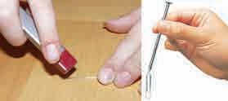

* 1. **: Artificial magnet**

**A little fun !**

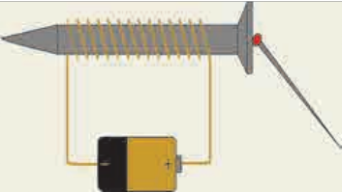

#### Make an electromagnet

Apparatus : An iron nail of about 10 cm length and a 1-metre long insulated copper wire, a battery cell, pins or other magnetic objects.

Wind the copper wire around the nail as shown in the figure. Join both the ends of the wire to the cell. Now take the pins near the head of the nail. What do you see ?

* 1. **: Electromagnet**

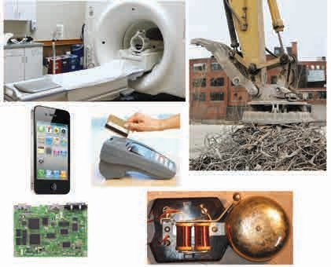During the above activity we saw that the pins stick to the nail. Now stop the electric current and see what happens. The pins sticking to the nail fall off. Why does that happen ? Magnetism is produced in the nail due to the electric current. When it is put off, the magnetism vanishes. Such a magnet is called an **electromagnet.** This magnetism is temporary.

Electromagnetism is used in many places in our day-to-day life.

For example, it is used in instruments such as a door bell and a crane.

On the other hand, the magnets fixed to a pin holder or the door of a cupboard are permanent magnets. Permanent magnets are made from a mixture of nickel, cobalt and iron. For example, the material alnico is a mixture of aluminium, nickel and cobalt.

* 1. **: Use of electromagnet**

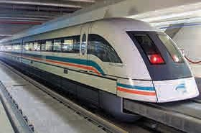

**15.15 : Maglev train**

The properties

of

electromagnetism and repulsion between magnets are used in a maglev train. Due to the repulsion between the train and the rail the force of friction does not come into play and the train slides over the rails with great speed. The magnets fixed on the two sides of the train help it to move forward.

To see how the maglev train works, visit [**www.youtube.com**](http://www.youtube.com/)type **maglev train, and click.**

**In the past...**

The British scientist Michael Faraday developed the technique of producing electricity with the help of a magnet.

Michael Faraday was born in a poor family. As a young boy, he had to work with a book seller. There, he read many books and developed an interest in science. Later, he went on to do research at the Royal Institution in London. It is due to Faraday’s research that today we can use electricity and electromagnetism in innumerable instruments in our day-to-day life.



**Do you know ?**

There is a strip of magnetic material in ATM cards, credit cards, etc. where necessary information about the user is stored.

Magnetic materials are also used to store data in the hard disk of a computer, an audio or video tape, etc.

### How is magnetism destroyed ?

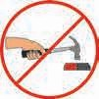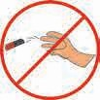Magnetism gets destroyed when a magnet is heated, thrown, knocked about or broken into pieces. Therefore, it is important to store magnets carefully. A piece of soft iron is placed in the box in which a magnet is kept. The bar of soft or pure iron protects a magnet, therefore, such a bar is called a **magnet keeper.**

**15.16 : Guarding a magnet**



**Always remember...**

Various scientific discoveries, the knowledge we gain through them, the various instruments or gadgets we develop with its help are all useful for the progress of man. They must be used for the good of mankind.

We have to take precautions while working with electricity or with important devices. We must use them under the guidance of our elders.

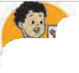

**What we have learnt-**

* Iron, nickel, cobalt are magnetic metals.
* Magnets settle along the north-south direction when suspended freely.
* Magnetism is concentrated near the poles.
* The poles of a magnet cannot be separated.
* Electromagnetic energy is used in our day-to-day life.

**Science watch ...**

Scientists have made many discoveries and inventions on which our life depends today. Can I become a scientist too ? How should I prepare to become a scientist ?

Read stories of scientific discoveries and inventions. Try out various activities and different ways of doing them. Ponder over your experiences.



**Exercise**

#### How will you do this ?

* 1. Determine whether a material is magnetic or non-magnetic.
  2. Explain that a magnet has a certain magnetic field.
  3. Find the north pole of a magnet.

#### Which magnet will you use ?

* 1. Iron is to be separated from trash.
  2. You are lost in a forest.
  3. A window shutter opens and shuts continuously in the wind.

#### Fill in the blanks with the appropriate word.

* 1. If a bar magnet is hung by a thread tied at its centre, its north pole becomes steady in the direction of the Pole of the earth.

(South, north, east, west)

* 1. If a bar magnet is cut into equal pieces by cutting it at right angles to its axis at two places, bar

magnets are formed, and a total of

. poles are formed.

(6,3,2)

* 1. There is repulsion between the

………. poles of a magnet, and attraction between its ………… poles.

(opposite, like.)

* 1. When magnetic material is taken close to a magnet, the material acquires …………… . (permanent magnetism, induced magnetism)
  2. If a magnet attracts a piece of metal, that piece must be made of

............. .

(any other metal but iron, magnetic material or iron, non-magnetic material)

* 1. A magnet remains steady in a

… direction.

(east-west, north-south)

#### Write the answers in your words.

* 1. How is an electromagnet made ?
  2. Write the properties of a magnet.
  3. What are the practical uses of a magnet ?

**Activity :**

* Collect information regarding how the various magnets used in our day-to-day tasks are produced.
* Collect information about the magnetism of the earth.





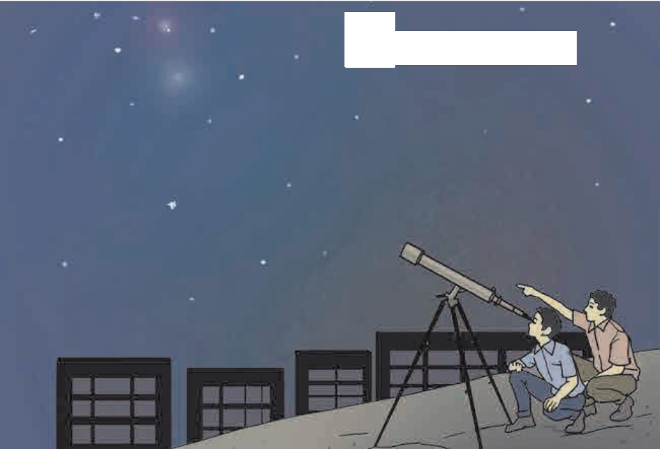

**16.**

**The Universe**

**Observe and discuss.**

Make use of a telescope to observe the sky on a clear night without clouds.

(Suggestion for teachers – Arrange such an observation session for all the students of the class. Carry with you some books on astronomy to consult during the session)

**16.1: Observation of the sky**

If you observe the clear sky on a dark night, you will see a smoky white band full of stars spreading north-south in the sky. This is the Milky Way. It is also known as ‘Mandakini’.

A group of innumerable stars and their planetary systems are together known as a ‘galaxy’. The Milky Way is the galaxy in which our solar system is located. The Milky Way is a part of the ‘Local Group’ of galaxies. There are many such galaxies in the universe.

The Milky Way includes many stars smaller than our Sun as well as many others that are thousands of times bigger than the Sun. It also includes many other celestial bodies such as clusters of stars, nebulae, clouds of gases, clouds of dust, dead stars, newly born stars, etc. The galaxy that is closest to our Milky Way is called Andromeda.

The universe includes innumerable galaxies, the space between them and also energy.

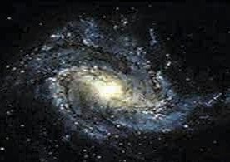

**Location of the sun**

* 1. **: The Milky Way**

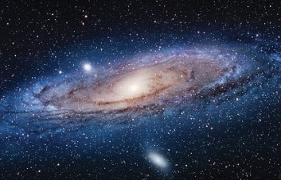

* 1. **: The Andromeda galaxy**

#### Types of galaxies : Various types identified according to their shapes

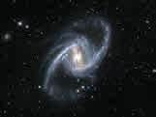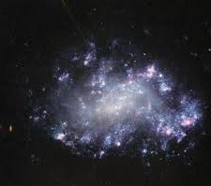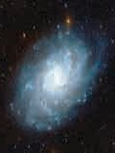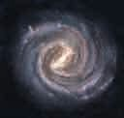

**Spiral Elliptical Barred spiral Irregular**

* 1. **: Various galaxies**

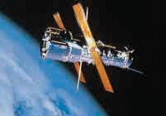

The scientist Edwin Hubble showed that there exist many galaxies beyond our Milky Way. In 1990, NASA, the American space agency launched the ‘Hubble Telescope’ in the orbit of the earth. The Hubble telescope has made it easier to look for stars, to take photographs and to obtain spectrums.

### Stars

The thousands of twinkling stars that we observe in the clear night sky are part of our Milky Way. Some of the stars that we see are bright whereas others are faint. Stars radiating different colours such as blue, white, yellow and reddish can be seen in the sky. We also see stars with varying brightness (luminance). The birth place of stars are the huge nebulae, made of dust particles and gases. Generally, the surface temperature of stars ranges from 3500°C to 50000°C. The colour of stars changes according to their temperature.

* 1. **: Hubble Telescope**

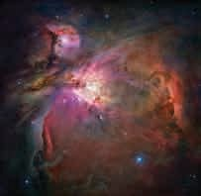

* 1. **: A nebula**

**Some types of stars**

* **Sun-like stars :** These stars can be slightly smaller or bigger than the sun. But there is a lot of difference in their temperatures. Examples : stars like Sirius, Alpha Centauri.
* **Red Giants :** The temperature of these stars ranges between 3000°C and 4000°C. But their luminance can be 100 times that of the sun. Their diameter is 10 to 100 times that of the sun and they are red in colour.
* **Super Nova :** These are even brighter and larger than the red giant stars. Their temperature is between 3000°C to 4000°C but their diameter can be more than a hundred times greater than that of the Sun.
* **Binary or Twin Stars :** More than half of the stars in sky are binary stars. They consist of two stars that revolve around each other. At times, three or four stars that revolve around each other have also been located.
* **Variable Stars :** The luminance and shape of these stars is not stable. They are constantly contracting or expanding. When a star expands, it emits less energy and at such times its brightness decreases. As against this, when a star contracts, its surface temperature increases and the star emits greater energy and appears brighter. For example, Polaris (Pole Star).



**Find out.**

Visit the sites of the institutes ISRO [(www.isro.gov)](http://www.isro.gov/) and NASA (www.nasa. gov) and collect information about the various celestial bodies in the solar system and universe, and discuss the same in the class.

**Can you tell ?**

1. Which celestial bodies form the solar system ?

The Mercury, Venus, Earth and Mars are the inner planets whereas the Jupiter, Saturn, Uranus and Neptune are outer planets.

Outer planets have rings around them. The crust of all the inner planets is hard. The outer planets

have gaseous outer cover.

1. What is the difference between stars and planets ?
2. How many planets are there in our solar system ?
3. What is to be found between Mars and Jupiter ?

#### The solar system

The solar system consists of the sun, the planets, asteroids, comets and meteors. The planets Mercury, Venus, Mars, Jupiter and Saturn can be easily seen.

#### The sun

The sun which is at the centre of the solar system is a yellow coloured star. Its surface temperature is around 6000°C. The size of the sun is so huge that around 13 lakh planets of the size of the earth can be easily placed within it. Due to the gravitational force of the sun, the celestial bodies in the solar system revolve around it. The diameter of the sun is approximately 13,92,000 km. The sun rotates around its axis and while doing so, it revolves around the centre of the Milky Way taking the solar system along with it.

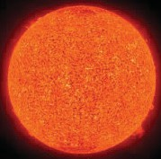**The sun**

#### Planets of the solary system - facts and figures

|  |  |  |  |  |  |  |  |
| --- | --- | --- | --- | --- | --- | --- | --- |
| **Name of the planet** | **Number of known satellites** | **Inclination of the axis (in degrees)** | **Period of rotation**\* | **Period of revolution**\* | **Magnetism** | **Atmosphere** | **Rings** |
| **Mercury** | 0 | 0.01 | 58.65 days | 88 days | No | No | None |
| **Venus** | 0 | 177.2 | 243.00 days | 225 days | No | Yes | None |
| **Earth** | 1 | 23.5 | 24 hours | 1 year  (365 days) | Yes | Yes | None |
| **Mars** | 2 | 25.2 | 24 hrs 37 mn | 1.88 years | No | Yes | None |
| **Jupiter** | 64 | 3.1 | 9 hrs 56 mn | 11.87 years | Yes | Yes | Yes |
| **Saturn** | 33 | 26.7 | 10 hrs 40 mn | 29 years | Yes | Yes | Yes |
| **Uranus** | 27 | 97.9 | 17 hrs 24 mn | 84 years | Yes | Yes | Yes |
| **Neptune** | 13 | 28.8 | 16 hrs 11 mn | 164 years | Yes | Yes | Yes |

|  |  |
| --- | --- |
| **Mercury :** This planet | **Venus** : It is the brightest planet in the solar system. It is seen in the sky in the east before the sunrise and in the west after the  sunset. It rotates around itself from east to west. It is the hottest planet. |
| is closest to the sun. It |
| is visible in the |
| morning and the |
| evening if it is away |
| from the sun. A |
| number of depressions, which look like |
| volcanic craters, but are actually caused |
| by meteoric falls can be seen on the surface |
| of Mercury. Mercury is the fastest moving |
| planet. |
| **Earth** : It is the | **Mars :** It is the |
| third planet of the | fourth planet in the |
| solar system. No | solar system. As |
| other planet other | the soil on Mars |
| than the earth has | contains iron, its |
| life on it. As the | colour is reddish. |
| earth is a magnet, | Hence Mars is also |
| there is a magnetic field around the earth. | called the Red Planet. The highest and |
| It diverts the harmful rays from the sun | longest mountain in the solar system |
| towards the polar regions of the earth. | ‘Olympus Mons’ is located on Mars. |
| **Jupiter** : This is the | **Saturn** : It is the sixth planet of the solar system and next only to Jupiter in size. It is considered to be a peculiar planet because of the rings  around it. Though its mass is 95 times that of the earth, its density is very low. If it were dropped into a sea large enough to hold it; it would actually float in it! |
| largest planet of the |
| solar system. It is so |
| huge that as many as |
| 1397 planets of the |
| size of the earth can |
| get accommodated in |
| it. Even though the planet is so huge, it |
| revolves around itself with a great speed. |
| As huge storms occur frequently on it, it |
| is also called the ‘Stormy Planet’. |
| **Uranus** : It is the seventh planet  in the solar system. It cannot be seen without a telescope. Its axis is so greatly inclined that it appears as if it is  rolling along on its orbit. | **Neptune** : It is the eighth planet in the solar system. A season on Neptune lasts for about 41 years. On this planet winds blow  with extremely high speed. |

**\* The periods of rotation and revolution of the planets are expressed relative to those periods on the earth (Page 114).**

115

|  |  |
| --- | --- |
| **Satellite** : The celestial bodies that revolve around a planet without independently revolving around the sun are called satellites. Like planets, satellites rotate around their respective axes. The Moon is the satellite of the earth. It does not have an atmosphere. Its periods of rotation and revolution are both of 27.3 days. Except for Mercury and Venus all other planets  have satellites but in varying numbers. **Satellite** | |
| **Asteroid** : A great number of small sized bodies could not turn into planets when the solar system was formed, but continued to revolve around the sun.  These bodies are known as asteroids. A belt of such celestial bodies has formed between the  planets Mars and **Asteroid**  Jupiter. | **Dwarf planet** : A small sized celestial body that revolves independently around the sun is called a dwarf planet. A celestial body like Pluto can  be classified as a dwarf planet. Pluto takes around 248 years to complete its revolution around the sun whereas it  takes around 6.38 **Dwarf planet**  days for one rotation. |

#### Use your brain power !

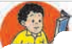

**Find out.**

Obtain information about the various asteroids and dwarf planets in the solar system and discuss it in the class.



1. Why do we see only one side of the moon?
2. Which planet has a day longer than its year?

#### Can you tell ?

**A comet**

Have you ever seen in the evening or in the predawn hours a large celestial body with a long tail? What is it called?

A comet is a celestial body that revolves around the sun. Comets are formed out of ice and dust particles. They are part of the solar system. Since olden times, the appearance of a comet has been considered to be an inauspicious event. Comets appear like points when they are far away from the sun. But when they are close to the sun, they become easily visible to us because of the shorter distance and the heat of the sun.

Comets are classified in two main groups.

**Long period comets** : These comets take more than 200 years to

complete one revolution

around the sun.

**Short period comets** : These comets take less than 200 years to complete one revolution around the sun.

Comets are made up of frozen matter and dust particles. When they are close to the sun, this frozen matter gets converted into gas due to the solar heat. These gases get thrown in a direction away from the sun. As a result, certain comets appear to have a long feathery tail. Due to their long elliptical orbits, their appearance in the sky is very rare. They reappear in the sky after very long periods of time.

#### Do you know this?

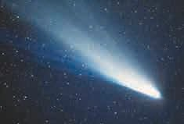

Halley’s comet appeared in the year 1910 and reappeared in 1986. Its central part or nucleus was found to be 16 km long and 7.5 km wide. Halley’s comet takes 76 years to complete its revolution around the sun.

**Halley’s comet**

#### A bit of fun !

Material required - a table fan, a bangle, a piece of light cloth, twinned string and thread.

As shown in the picture, sew the cloth around the bangle. Take a string as long as the length of the cloth and tie it to the bangle. Now hold the bangle in front of the fan and put on the fan.

#### In the past ...

Fred Whipple, an American astronomer, proposed that comets consist of an icy cluster of various constituents. That is why, comets came to be called ‘dirty snowballs’. By 1950, Whipple had discovered six comets.

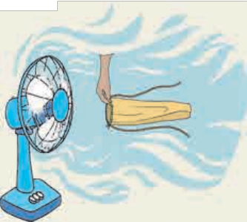

#### A meteor

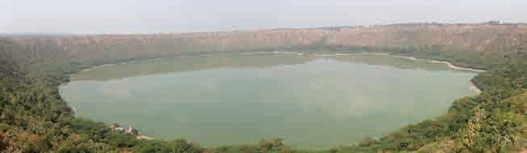At times, we see a falling star. This event is called a meteor fall. Mostly these meteors are rocky pieces originating from the asteroid belt. Smaller rocky pieces get completely burnt due to friction with air after they enter the earth’s atmosphere. Sometimes the meteors do not burn completely and fall to the surface of the earth. These are called meteorites. It is believed that the Lonar lake in Maharashtra has been formed by the impact of such a meteorite. Meteors or meteorite falls occur on other celestial bodies, too.



**Always remember...**

Science tries to

different events

explain

occurring

in the universe. We should study phenomena like meteor falls, eclipses, etc. rather then attach any blind faith or

superstition with them.



**What we have learnt-**

* There are innumerable galaxies in the universe. Our solar system, various star clusters are part of the Milky Way.
* Various types of stars like the sun can be seen in the Milky Way.
* Different planets in the solar system have peculiar characteristics. Some planets have satellites whereas others do not have any.
* Comets have a characteristic structure but their appearance keeps on changing.



**Exercise**

#### Name these -

* 1. Birth place of stars
  2. Biggest planet in the solar system
  3. The galaxy which is our neighbour.
  4. Brightest planet in the solar system
  5. Planet with largest number of satellites
  6. Planets without a single satellite
  7. Planet with a rotation different from other planets.
  8. A celestial body that carries a tail along.

#### Fill in the blanks.

* 1. The group of galaxies of which our Milky Way is a part is called

............. .

* 1. Comets are made of ............. .
  2. The planet appears as if it

is rolling along its orbit.

* 1. is a stormy planet.
  2. The Pole Star is the best example of a type of star.

#### Say if the statements given below are right or wrong. Rewrite the statements after correcting them.

* 1. Venus is the planet closest to the sun.
  2. Mercury is called a stormy planet.
  3. Jupiter is the biggest planet.

#### Answer the following.

* 1. What is a special characteristic of the planet Mars ?
  2. What are the types of galaxies ?
  3. Which celestial bodies does a galaxy include ?
  4. Name the different types of stars.
  5. What are the types of comets and on what basis are they classified ?
  6. What is the difference between meteors and meteorites ?
  7. What are the characteristics of the planet Neptune ?

#### Match the following.

**Group A Group B**

1. Galaxy (a) From east to west
2. Comet (b) 33 satellites
3. Sun-like star (c) Spiral
4. Saturn (d) Sirius
5. Venus (e) Halley

**Activity :**

* Using the material you can find in your house, prepare a model of the solar system.
* Collect information about different aspects of each planet such as its distance from the sun, its diameter, its volume, etc. and present it in a science exhibition.



**Glossary**

amphibian - उभयचर

annual - वार्षिक

appendicular skeleton - उपांग सांगाडा

aquatic - जलचर asteroids - लघुग्रह autotrophic - सवयंपो्ी

axial skeleton - अक्ीय सांगाडा

balanced diet - संतुरलत आहार

ball and socket joint - उखळीचा सांधा

bar magnet - पट्ी चुंबक biennial - द्विवार्षिक blood vessel - रक्तवारहनी boiling - उतकलन

boiling point - उतकलनांक brittleness - रिसूळपणा cartilage - कूचाषि

cellular structure - पेशीमय रचना chemical energy - रासायरनक ऊजाषि circular motion - वतुषिळाकार गती comet - धूमकेतू

complex machine - गुंतागुंतीचे यंत्र compound leaf - संयुक्त पान condensation - संघनन

conventional resource of energy - पारंपररक ऊजाषि साधन

deficiency diseases - अभावजनय आजार

density - घनता dermis - तवचा disaster - आपतती

displacement - रवस्ापन ductility - तनयता elasticity - द्स्रतस्ापकता

electric energy - रवद्ुत ऊजाषि electrical conductivity - रवद्ुतवाहकता electrostatic force - द्स्रतक रवद्ुत बल epidermis - बाह्यतवचा

excretion - उतसजषिन

fat, fatty subtance - द्सनगध पदा्षि

fibrous - तंतुमय first aid - प्र्मोपचार fluidity - प्रवारहता

food adulteration - अन्नभेसळ

force - बल

freezing point - गोिणांक (गोिणरबंदू) frictional force - घ्षिण बल fulcrum - टेकू

funnel - नसराळे

galaxy - दीरघषिका

gravitational force - गुरुतवाक्षिण बल

groundwater - भूजल hardness - किीणपणा heterotrophic - परपो्ी hinge joint - रबजागरीचा सांधा

horseshoe magnet - नालाकृती चुंबक

humus - कुर्त मृदा immovable joint - अचल सांधा inclined plane - उतरण

inert gas - रनरक्रिय वायू insectivorous - कीटकभक्ी invertebrate - अपृष्ठवंशीय joint - सांधा

kinetic energy - गरतज ऊजाषि

lever - तरफ

lifespan - आयुमाषिन linear motion - रे्ीय गती load - भार

lustre - चकाकी

magnetic field - चंुबकीय क्ेत्र magnetic force - चंुबकीय बल magnetic substance - चुंबकीय पदा्षि magnetism - चुंबकतव

malleability - वधषिनीयता

malnutrition - कुपो्ण mechanical energy - यांरत्रक ऊजाषि melting - रवलयन

melting point - रवलयरबंदू meteor - उलका meteorite - अशनी

Milky Way, the - आकाशगंगा

minerals - खरनजे

motion - गती

movable joint - चल सांधा

multicellular - बहुपेशीय

natural substance - नैसरगषिक पदा्षि

nebula - तेजोमेघ

non-conventional energy resource-

अपारंपररक ऊजाषि साधन

nutrients - पो्कतत्वे

oscillatory motion - आंदोरलत गती

oviparous - अंडज

perennial - बहुवार्षिक

periodic motion - रनयतकारलक गती

Pole Star - ध्ुव तारा

potential energy - द्स्रतज ऊजाषि

prism - लोलक

propagation of sound - धवरनप्रसारण

proteins - प्रर्ने

pulley - कपपी

random motion - यादृद््छिक गती reflection of light - प्रकाशाचे परावतषिन reproduction - पुनरुतपादन/प्रजनन satellite - उपग्रह

sensory organ - ज्ानेंररिय shadow formation - छिायारनरमषिती simple machine - साधे यंत्र Sirius - वयाध तारा

skeletal system - अद्स्संस्ा

skull - कवटी

solubility - रवरिावयता

states of substances - पदा्ाां्या अवस्ा

sterile - रनजांतुक sternum - उरोद्स् sublimation - संप्लवन sunstroke - उक्माघात taproot - सोटमूळ terrestrial - भूचर

thermal conductivity - उक्णतावाहकता transparency - पारदशषिकता unicellular - एकपेशीय

uniform motion - एकसमान गती universal solvent - वैद््वक रवरिावक vacuum - रनवाषित

variable star - रूपरवकारी तारा vertebral column - पािीचा कणा vertebrate - पृष्ठवंशीय vibration - कंपन

viviparous - जरायुज vocal cord - धवरनतंतू volume - आकारमान weathering - अपक्य wedge - पाचर worm - कृमी



